The Influence of Social Media on Collaborative Learning in a Cohort Environment

Silas Wandera, Natasha James-Waldon,
Debbi Bromley, and Zandra Henry
Wilmington University, New Castle, Delaware, USA

swand11164@wildcats.wilmu.edu; Natasha.r.James@wilmu.edu;
dbron13923@wildcats.wilmu.edu; zhenr32235@wildcats.wilmu.edu

Abstract
This paper provides an overview of the impact that social media has on the development of collaborative learning within a cohort environment in a doctoral program. The researchers surveyed doctoral students in an education program to determine how social media use has influenced the doctoral students. The study looked at the following areas: a) the ability of social media use to develop a collaborative learning environment, b) access to social media content which supports learning, and c) whether social media use has contributed to the enhancement of the doctoral students’ academic achievement and learning progress. As social media use and on-line learning become more prevalent in education, it is important to continue to understand the impact that social media has on improving students’ ability to achieve their academic goals. This study provides insight on how doctoral students used social media and how social media use has influenced academic development in their cohort environment. In addition, this paper provides a discerning view into the role social media plays when developing a collaborative learning environment in a cohort.
Keywords: Social media; Collaborative learning; Learning environment; Doctoral program; Cohort

Introduction
In the quest to understand the influence of media and its benefits on education, researchers have historically looked at media as one component of learning and achievement with mixed reactions. As the concept of media evolved to include the phenomenon known as social media, studies have focused on this one particular aspect of media. Faraj, Jarvenpaa, and Majchrzak (2011) assert that there is a shift from centralization to decentralization of social media. This shift has allowed the knowledge sharing process to move from users consciously populating pre-constructed repositories to emergent knowledge contributions while unplanned connections evolve as individuals use social media to share knowledge (p. 40).
Material published as part of this publication, either on-line or in print, is copyrighted by the Informing Science Institute. Permission to make digital or paper copy of part or all of these works for personal or classroom use is granted without fee provided that the copies are not made or distributed for profit or commercial advantage AND that copies 1) bear this notice in full and 2) give the full citation on the first page. It is permissible to abstract these works so long as credit is given. To copy in all other cases or to republish or to post on a server or to redistribute to lists requires specific permission and payment of a fee. Contact Publisher@InformingScience.org to request redistribution permission.
This research study began as a group project in the Disciplined Inquiry I & II courses of the Wilmington University, Doctorate of Education program. The evolving interest in examining the influence of social media on learning and the building of learning communities prompted four of the students at Wilmington University to develop the assignment into a research study. The study investigated the influence of social media on building collaborative learning communities. The research team conceptualized that the study would identify and reinforce the usage and purposes of social media (sharing documents, team building, sharing information, resources, and teaching others). The team also wanted to fulfill a component of the Organizational Leadership Professional Learning Community, established in their EDD 7000 course, Experiential Learning: Leadership Issues, by exporting cohort collegiate collaborative learning to new cohorts through a connection between social media and collaborative learning.
The study addressed three research questions:
- How does the use of social media affect collaborative learning in a doctoral cohort environment?
- Are there significant differences between cohort groups regarding social media accessibility?
- To what extent do doctoral students think social media has an impact on their grades?
The research team defined social media as “Web based services that allow individuals to construct a public or semi-public profile within a bounded system, articulate a list of other users with whom they share a connection, and view and traverse their list of connections and those made by others within the system” (Boyd & Ellison, 2007, p. 211). The definition for “collaborative learning” was as an instructional method in which students at various performance levels work together in small groups toward a common goal. The students are, in part, responsible for facilitating each other’s learning and their own. Thus, the success of one student helps other students to be successful (Gokhale, 1995). The research team defined cohort as, “…a small group of learners who complete an entire program of study as a single unit” (Lawrence, 2002, p. 83). At Wilmington University, the Ed.D program cohorts are defined by track (OL, EL, & HL) and geographic location (Dover, Georgetown and New Castle).

Literature Review
Although there is an increasing amount of literature about the use and effectiveness of social media in higher education, it is still an emerging area of study with much to explore. Selwyn (2011) suggests that educators have traditionally been in the role of playing catch up when it comes to technology. The study notes that educators must consider, not if, but how they plan to include social media platforms into their current systems. Studying the effects of the virtual learning environment (VLE) for engineering students at Riyadh College of Technology in Saudi Arabia, BenSalah, Benselama, and Hennache (2009) posit that there is an ease of access to information in virtual learning but ultimately conclude, “There is no doubt that nothing will replace synchronous learning through face to face interaction but it is not always feasible for students to attend conventional classes” (p.69). Friedman and Friedman (2013) cite evidence that online learning or partial online learning can produce the same or better results as traditional, classroom-style learning.
Studies examining student perceptions of social media use within the academic environment offer varied results. A study conducted at Bournemouth University in six academic schools found that the use and application of social media differed amongst the different academic disciplines, where the Media School and the School of Tourism adopted much wider use of social media than did The Business School or The School of Applied Sciences (Kalashyan et al., 2013). McCarthy (2010) studied Facebook as an academic tool to blend virtual and real classroom environments for first year students at the University of Adelaide. This blending was observed in the study findings as responsible for “…increased peer interaction and academic engagement, two key factors in a positive first year experience” (McCarthy, 2010, p. 738). YouTube, as an educational enhancement, was studied by Buzzetto-More (2014). The researcher conducted a study of YouTube use in the learning environment, surveying 221 students at an eastern Maryland college. The study found that YouTube enhanced instruction, especially by students who prefer on-line courses. The study also concluded that mobile devices were most likely used in accessing the videos and that video length was also a determinant of use; however, frequency of social media use was not a determinant of student acceptance of YouTube for academic use (Buzzetto-More, 2014).
The use of Twitter in the educational environment was shown to engage both students and faculty “into a more active and participatory role” (Junco, Heilbergert, & Loken, 2010, p. 119). Although the study concluded that Twitter had a positive effect on engagement in students, it did not find the use of Twitter to have any effect on grades (Junco et al., 2010). Stollak, Vandenberg, Burklund, and Weiss (2011) studied the impact of social media use and grades, finding that students with smart phones spent more time engaged in social media but that there was not a negative relationship between GPA and social media use.
Beyond the effect social media may have on student grades or student perceptions, there is also the question of its impact in a collaborative learning environment. A study conducted at the University of Seville in Spain analyzing the influence of social media networks in collaborative learning found there was no relationship between the two constructs (Lopez-Bonilla & Lopez-Bonilla, 2013) but it was noted that this was an exploratory study and more research was needed. Studying the impact of social media on student engagement, Rutherford (2010) invited students in a pre-service teacher education program to complete an online survey that mirrored the National Survey of Student Engagement, a well-known instrument. The findings noted, “There was a positive correlation between the frequency of student use of social media and their relationships with their peers and instructors as well as how they describe the overall quality of instruction and the pre-service program” (Rutherford, 2010, p. 10). However, results did not indicate a significant relationship between frequency of social media use to discuss or complete school assignments (Rutherford, 2010).

Methodology
This study focused on the use of social media in the development of a cohort learning environment at Wilmington University in the Doctorate of Education program. The researchers wanted to study whether the doctoral cohorts were using any forms of social media in their interaction with each other, and if social media added value in meeting their academic requirements. The intent of the study was to provide valuable research on the use of social media and its impact on cohort success to future doctoral students and Wilmington University. The study was designed to answer the following research questions:
- How does the use of social media impact collaborative learning in a doctoral cohort environment?
- Are there significant differences between cohort groups regarding social media accessibility?
- To what extent do doctoral students think social media has an impact on their grades?

Research Design
The survey (see the Appendix) was designed to gather both quantitative and qualitative data on how Ed.D doctoral students at Wilmington University use social media. Likert Scale questions were developed, with some open-ended questions included. The data collected looked at variables, which included age, gender, location, and doctoral track. There were some thematic questions posed to investigate the attitudes towards social media, collaborative learning, and comparative differences. The researchers worked collaboratively to develop a survey. The team met twice a week, via WebEx and GoToMeeting for several months to develop the questions. These questions were then reviewed, discussed, and after several iterations, a total of 47 questions were created. The researchers created the survey using the electronic survey tool Google Forms. The researchers piloted the survey to twelve (12) students in one program, in one location, and in one cohort (OL Program, Wilmington, Cohort 24). In addition, the survey questions were presented to the program chairperson to get feedback on the reliability and the validity of the survey.
There were 229 students enrolled in the Wilmington University Ed.D program, which consisted of 151 women and 78 men from Cohorts 22, 23, and 24. The 229 students represent all the students in the Educational Leadership, Higher Educational Leadership, and Organizational Leadership and Innovation tracks for the Ed.D program. In addition, this number also represented all the students on each of the three campuses – Dover, Georgetown, and New Castle – where the Ed.D program is housed. Cohort 22 began their doctoral studies in 2012, Cohort 23 in 2013, and Cohort 24 in 2014. With the assistance of the administrator for the Ed.D program, the survey was distributed, via email, to all the doctoral students in Cohorts 22, 23, and 24. The students were provided with an incentive for their participation. In the email distribution, the participants were informed that everyone was eligible to win one of five Amazon gift cards at $20 per person. The researchers later increased the incentive to six winners, with two at each of the three locations where the program was offered.
The data were analyzed using SPSS, descriptive statistics, and correlational statistics. In the original analysis, the researchers determined that the Likert scale that was originally developed had too many categories to enable the researches to form conclusions with the data. The researchers decided to collapse the data categories to provide a better review of the data. The categories went from five to three – (1) strongly agree/agree, (2) neutral, and (3) strongly disagree/disagree. This provided the researchers with results that will be discussed in the results section of this paper.
Wilmington University’s Human Subject Review Committee granted the researchers permission to conduct the study. Professors who were teaching the various participants at the time the study was being conducted were asked to encourage the members of their classes to participate. This study was done in conjunction with two course requirements for the Ed.D. Program, and was overseen by the Chair of the Ed.D program’s Organizational Leadership and Innovation track, Dr. Lynne Svenning.

Results
Table 1 outlines the demographics of the survey participants by gender, age, marital status, cohort, track, and location. Two hundred twenty-nine (229) were invited to participate in the study. One hundred nineteen (119) students responded (response rate 52%), of which seventy-one percent (71%) of respondents were female students. Eighty percent (80%) of the participants classified their relationship status as living with someone or in a shared household, only thirteen percent (13%) were single or in non-shared household.

Table 1. Demographics of Survey Participants (n=119)
Characteristics | %
Track
Education Leadership (EL) | 44
Organization & Innovation Leadership (OL) | 33
Higher Education Leadership (HL) | 23
Campus Location
New Castle | 56
Georgetown | 20
Dover | 24
Characteristics | %
Gender
Male (N = 35) | 29
Female (N = 84) | 71
Age
23-44 (N = 64) | 54
45+ (N = 55) | 46
Relationship Status
Shared household | 87
Non-shared household | 13
Cohort
22 (N = 49) | 41
23 (N = 33) | 28
24 (N= 37) | 31

Table 2 lists the different social media tools and the percent of use for each social media tool. Online meeting tools (WebEx/GoToMeeting), Wikis, Instagram, and Twitter were the most rarely used social media tools. Only 20% of the respondents used them sometimes or frequently while 80% rarely used them. Conversely, Blackboard and YouTube were social media tools that were either sometimes or frequently used, with a combined total of sixty percent (60%) in this category.
Table 2. Social Media Use by Cohort in Program (Survey Questions 7-17)
 | Do you use any of the following social media?
Social Media Tools | Rarely % | Sometimes % | Frequently %
Facebook | 48 | 24 | 28
Google+ | 50 | 29 | 21
Blackboard | 33 | 22 | 45
Online Meeting tools (WebEx/GoToMeeting) | 80 | 10 | 10
Wikis | 86 | 13 | 1
Skype | 79 | 17 | 4
YouTube | 28 | 42 | 30
Instagram | 88 | 4 | 8
LinkedIn | 64 | 18 | 18
Twitter | 88 | 8 | 4
Other (e.g., Pinterest, Vine, Tumblr, WhatsApp) | 80 | 10 | 10

Research Results
Research Question 1: How does the use of social media impact collaborative learning in a doctoral cohort environment?
Social Media’s impact on collaborative learning was assessed by multiple survey response questions that thematically fell into the collaboration and teamwork category. A chi-square test of independence was performed to examine the differences between Cohorts 22, 23 and 24 in relationship to their perceived response on listed questions on Table 3. The findings within the cohorts indicated that over sixty percent (60%) of all respondents agreed that social media made it easier to share work with their team members and there was a significant difference (X² [4, N = 119] = 9.96, p < 0.05).
Table 3. Chi-Square Test Analysis for Social Media and Collaboration
Survey Question | X² Test Results
1. Social media sites make it easier to share work with team members | X² (4, N = 119) = 9.96, p < 0.05
2. Social media usage is an essential part of developing a collaborative learning communities | X² (4, N = 119) = 13.36, p < 0.05
3. My use of social media as a collaborative tool has increased my access to information | X² (4, N = 119) = 14.80, p < 0.05
4. Social Media increases my engagement in the collaborative learning process. | X² (4, N = 119) = 15.00, p < 0.05
5. Collaborative learning would be impacted if social media was not utilized | X² (4, N = 119) = 14.37, p < 0.05
There were significant differences in determining whether social media usage is an essential part of developing a collaborative learning community. Sixty-eight percent (68%) of the Cohort 24, forty-two percent (42%) of Cohort 23 and twenty-nine percent (29%) of Cohort 23 agreed social media develops collaborative learning. Similarly, when we examined the relationship between the track and the ease social media provides to share work with the team members the relationship was also significant, X² (4, N = 119) = 10.15, p < 0.05. Seventy-seven percent (77%) of the sub group of OL track students in all three cohorts agreed that social media allows participants to share academic work.
Research Question 2: Are there significant differences between cohort groups regarding social media accessibility?
Seventy-three percent (73%) of respondents agreed that social media was accessible and cost effective. However, there was some significant difference within the groups X² (3, N = 119) = 11.04, p < 0.05. Sixty-five percent (65%) of the Cohort 24, Eighty-five percent (85%) of Cohort 23 and Seventy-one percent (71%) of Cohort 22 agreed that social media was cost effective. Chi-square tests were also used to determine the relationship between the cohorts. Similarly, the same result was evident on the analysis of social media’s ability to provide information that may not be as quickly accessible by other means, the relationship was also deemed significant, X² (4, N = 119) = 12.57, p < 0.05.
In examining the relationship between age and the cost effectiveness (cheaper access) of social media, over seventy percent (70%) of the participants agreed that social media is cost effective. Eighty-percent (80%) of the participants between ages 44 and below agreed social media is cost effective compared to Sixty-six percent (66%) of the participants between ages 45 and above.
Research Question 3: To what extent do doctoral students think social media has an impact on their grades?
The respondents were asked their perception of whether social media had a direct impact on their grades (See the Appendix). Fifty-six percent (56%) disagreed with the question that social media has had a direct impact on their grades. The relationship between the cohorts was significant X² (4, N = 119) = 10.53, p < 0.05.
The open-ended responses posited two questions:
Question 1: Describe how social media provides information that enhances your learning as a doctoral student?
Eighty-eight (88) open-ended responses were received, of which, seventy-seven percent (77%) of the participants felt that social media enhanced their learning experience as doctoral students.
Comments
Enhanced
“Social Media helps to communicate across boundaries”
“Social Media provides connection and encouragement”
Not-Enhanced
“Social Media is not an educational tool”
“Social Media has no impact on my studies”

Question 2: Describe how the use of Social Media within your cohort has enhanced the development of the collaborative learning community.
Eighty-six (86) open-ended responses were received, of which fifty-eight percent (58%) felt Social Media enhanced collaborative learning communities.
Comments
Enhanced
“Social media has allowed me to work within my small group on projects at a more effective time and location. By that I mean, that instead of having to schedule a phone conference or an additional face to face meeting in our already busy schedules, we can collaborate in real-time by scheduling a convenient meeting time (usually the middle of the night), or we can share our materials and then comment at our own convenience. Drop articles for consideration. Stay in touch via smartphone, Surveys, Calendar programs. Shout outs for assistance. Support. Social aspects.”
Not-Enhanced
“I think it has had the opposite effect because some members are not comfortable with it, and some members are attempting to force members to use it when they don’t want to.”

Discussion
The study produced results on the impact that social media has on the development of collaborative learning within a cohort environment in a doctoral program. The study revealed that the doctoral students perceived that social media had no significant impact on academic success. However, social media did provide students a platform to share ideas efficiently. Junco et al. (2011) had similar findings that student engagement was positive but students did not perceive a positive impact on academic success. Despite, the perception that social media had little impact on academic success, what was unique about the doctoral students is the selection of the social media they used. The doctoral students did find it beneficial to use social media that had some meaningful relationship with their academic work. Blackboard, which is Wilmington University’s Learning Management System (LMS) and YouTube, which offers both academic and entertainment content, were prevalent among students. Students reported that these two social media forums enhanced their learning and understanding.
Amongst the cohorts, the most recent (newest) cohort, Cohort 24, was more engaged in social media than Cohorts 22 and 23. Research has continued to indicate past experiences with social media or technology affects the perceptions about technology in general (Burke & Moore, 2003). Since the technology influx is the norm in today’s world, access to social media was a non-issue among all the doctoral students who participated in the research.

Conclusion
In this study, the use of social media within a cohort group was reported by students to enhance the ability of the cohort to collaborate and share information. Social media was also seen as an effective learning tool. Newer cohorts are using social media more frequently than the older cohorts. However, social media was not seen as a tool that enhances student grades or academic achievement even though it worked well as a collaborative tool. If social media is able to enhance collaboration among cohort members, perhaps its value need not rest in grade enhancement or academic achievement. Lawrence (2002) suggests that, “Co-creating knowledge through collaborative learning and experiential knowing is identified as an important outcome of cohort learning” (p. 83). Perhaps some of social media’s strength lies in its ability to create additional opportunities for learners to gather and share.

Limitations of the Research
This study was conducted across three distinct programs (OL, HL, and EL) within the Doctorate of Education program in the College of Education at Wilmington University, and there are some differences among that student population. However, a limitation of this research is the narrow focus of the participant population. This study was not administered across the entire university nor was it given to any other doctoral program within the university. In addition, the responses were only self-reports and the actual performance of academic achievement was not measured. It was also noted by the research team that some of the survey questions were ambiguous to the population surveyed and that ambiguity may have affected their responses.
Future research surveys should be presented to people who are familiar with social media use and those who are not. In addition, future studies might benefit from a broader based student population in different colleges and different fields of study within a university or among several different universities.

References
BenSaleh, M. S., Benselama, A. S., and Hennache, A. S. (2009). Designing and evaluating the effectiveness of the virtual learning environment (VLE) in Saudi Arabia: A review and recommendations. Conference of the International Journal of Arts and Sciences, 1(20), 59-69.
Boyd, D., & Ellison, N. B. (2007). Social network sites: Definition, history, and scholarship. Journal of Computer-Mediated Communication, 13(1), 210-230. doi 10.1111/j.1083-6101.2007.00393.x
Burke, L. A. & Moore, J. E. (2003). A perennial dilemma in OB education: Engaging the traditional student. Academy of Management Learning & Education, 2(1), 37-53.
Buzzetto-More, N. A. (2014). An examination of undergraduate student’s perceptions and predilections of the use of YouTube in the teaching and learning process. Interdisciplinary Journal of E-Learning and Learning Objects, 10, 17-32. Retrieved from http://www.ijello.org/Volume10/IJELLOv10p017-032Buzzetto0437.pdf
Faraj, S., Jarvenpaa, S. L., & Majchrzak, A. (2011) Knowledge collaboration in online communities. Organization Science, 22(5), 1224-1239.
Friedman, L. W., & Friedman, H. H. (2013). Using social media technologies to enhance online learning. Journal of Educators Online, 10(1), 1-22.
Gokhale, A.A. (1995). Collaborative learning enhances critical thinking. Journal of Technology Education, 7(1). Retrieved from http://scholar.lib.vt.edu/ejournals/JTE/v7n1/gokhale.jte-v7n1.html
Junco, R., Heibergert, G., & Loken, E. (2010). The effect of Twitter on college student engagement and grades. Journal of Computer Assisted Learning, 27(2), 119-132. doi: 10.1111/j.1365-2729.2010.00387.x
Kalashyan, I., Kaneva, D., Lee, S., Knapp, D., Roushan, G., & Bobeva, M. (2013). Paradigm shift – Engaging academics in social media – The case of Bournemouth University. Proceedings of the International Conference on E-Learning, 662-665.
Lawrence, R.L. (2002) A small circle of friends: Cohort groups as learning communities. New Directions for Adult & Continuing Education, 2002(95), 83-92.
Lopez-Bonilla, J., M., & Lopez-Bonilla, L., M. (2013). Exploring the relationship between social networks and collaborative learning. British Journal of Educational Technology, 44(5), E139-E1-42. doi:10.1111/bjet.12003
McCarthy, J. (2010). Blended learning environments: Using social networking sites to enhance the first year experience. Australasian Journal of Educational Technology 26(6), 729-740.
Rutherford, C. (2010). Using online social media to support preservice student engagement. Journal of Online Learning and Teaching, 6(4), 703-711.
Selwyn, N. (2011). Social media in higher education. The Europa World of Learning 2012. Retrieved from www.worldoflearning.com.
Stollak, M., Vandenberg, A., Burklund, A., & Weiss, S. (2011). Getting social: The impact of social networking usage on grades among college students. In Proceedings from ASBBS Annual Conference, 18(1), 859-865.

Appendix
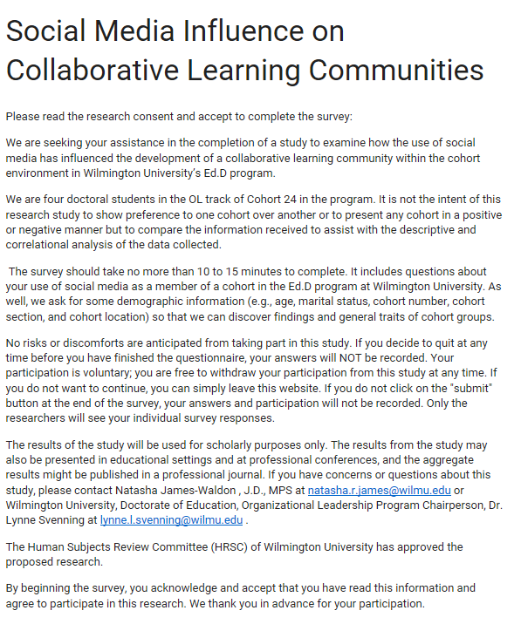
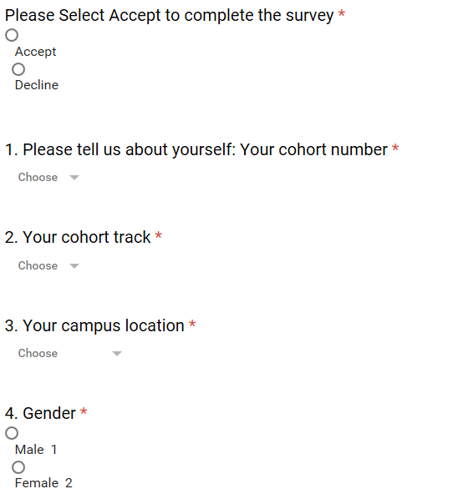
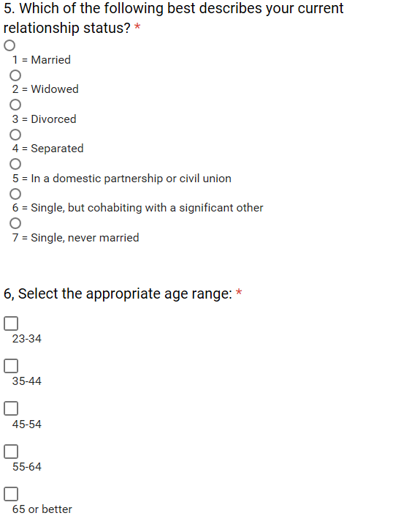

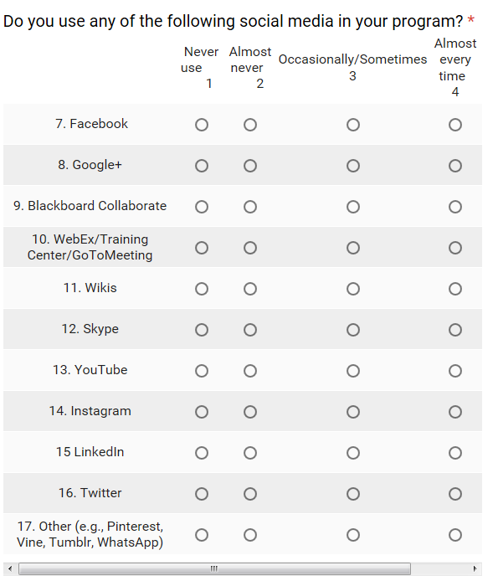
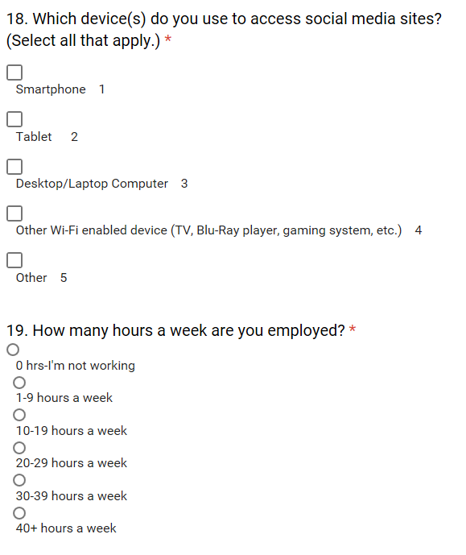
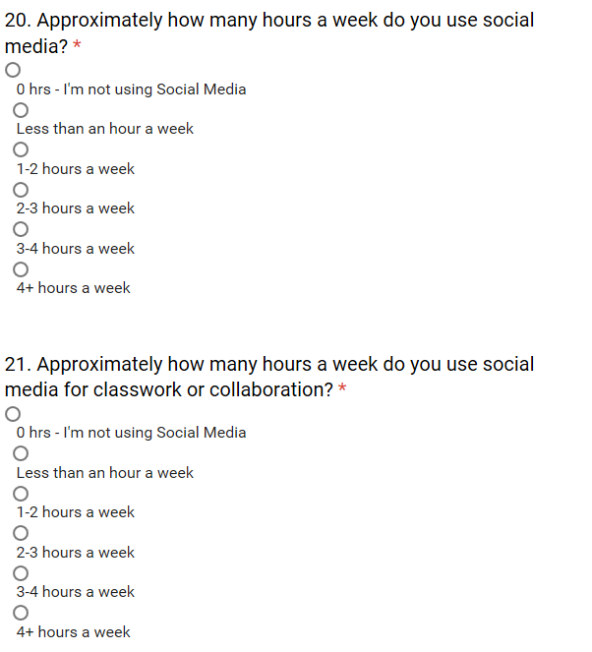
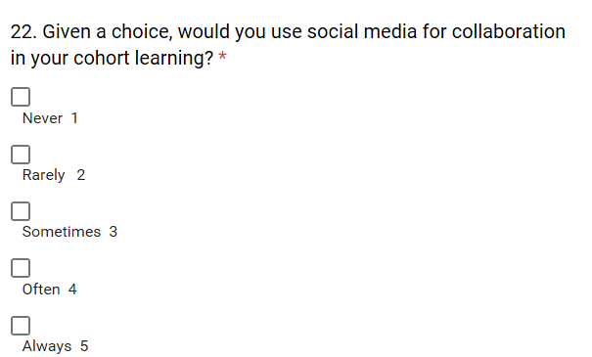
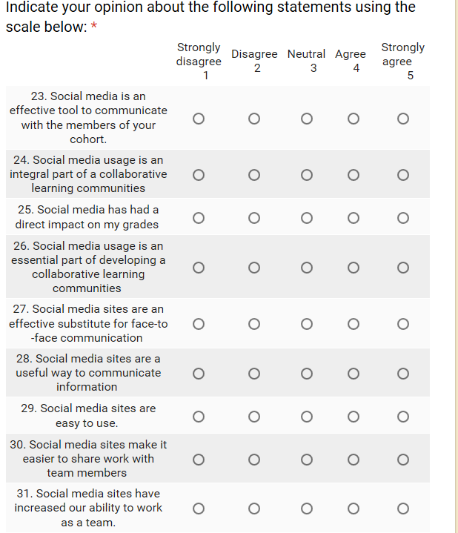
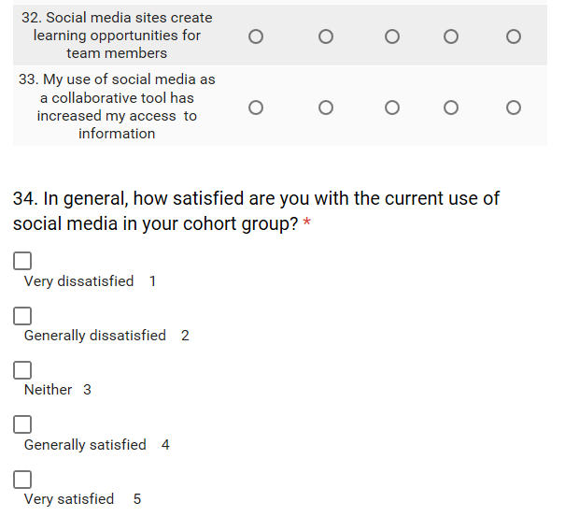
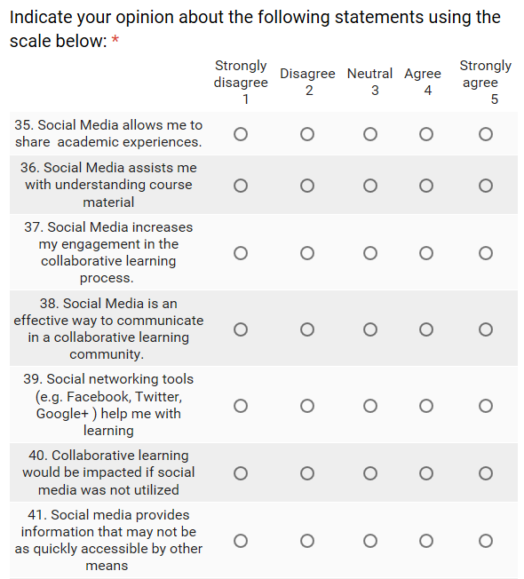
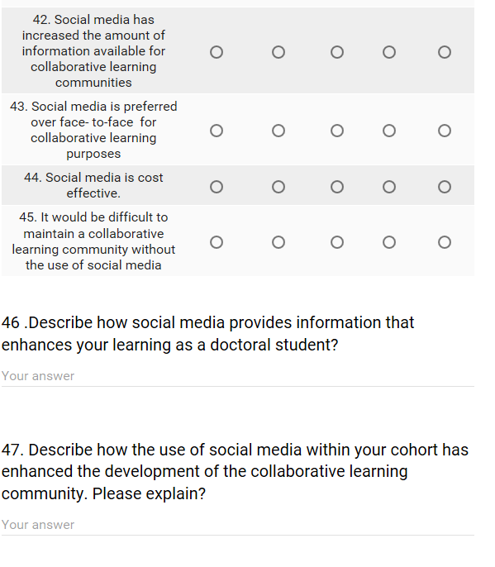

Biographies
Silas Wandera, MS, is currently, an Implementation Success Manager at an Online Digital Curriculum provider based in Seattle, WA. Mr. Wandera has managed and implemented digital online programs for over 100 learning institutions, delivered over 500 professional development sessions and professional developed over 2000 teachers. He resides in NJ, USA. Mr. Wandera also holds a Masters of Science in Education and BSc in Computer Science from City University of New York (CUNY). He is also a second year doctoral student at Wilmington University in Delaware. He has had experience in teaching mathematics and computer technology for over 8 years.


Natasha James-Waldon, J.D., MPS, is the Director of Compliance and Community Engagement for the Jewish Renaissance Foundation. She is also an adjunct faculty member at Wilmington University. Ms. James-Waldon holds a Juris Doctorate and a Masters of Professional Studies in Media Administration from Syracuse University. She also holds a BA in Journalism from Temple University. Ms. James-Waldon is currently a second year doctoral student in the Ed.D, Organizational Leadership and Innovation program at Wilmington University, New Castle DE.


Debbi D. Bromley, MS, is the Senior Vice President of Human Resources at Genex Services, LLC. in Wayne, PA. She joined Genex in January of 2007 and is responsible for the development and management of the human resources and corporate administration functions. In addition to her experience in healthcare, Ms. Bromley has also held human resources leadership roles in broadcasting, technology and retail. Ms. Bromley holds a BA degree from Fairleigh Dickinson University where she majored in Psychology and Sociology and an MS degree in Organization Development and Leadership from the Philadelphia College of Osteopathic Medicine. She is currently a second year doctoral student in the Ed.D, Organizational Leadership and Innovation program at Wilmington University, New Castle, DE.

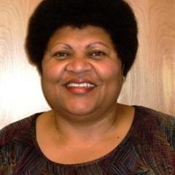
Zandra Henry, MS, is the Program Operation’s Director for First State Community Action Agency, Inc. Ms. Henry is an alumnus of the University of Delaware in Newark, Delaware and Wilmington University of New Castle, Delaware having received her Bachelors of Science, Major: Sociology /Education from the University of Delaware and Masters of Science Community Counseling from Wilmington University. She serves as a mediator for the Center for Community Justice at People’s Place II in Milford, Delaware. Ms. Henry is currently a second year doctoral student in the Ed.D, Organizational Leadership and Innovation program at Wilmington University, New Castle, DE.

