Let’s Tell a Story Together
Karishma Kelsey | Whitireia Polytechnic, Auckland, New Zealand | Karishma.Kelsey@Whitireia.ac.nz
Andrew Zaliwski* | Whitireia Polytechnic, Auckland, New Zealand | Andrew.Zaliwski@Whitireia.ac.nz
* Corresponding author

Abstract
Aim/Purpose | The teaching solution presented in this paper was implemented to overcome the common problems encountered by authors during years of practice of applied business studies teaching.
Background | In our school, we have deep multicultural environments where both teachers and students are coming from different countries and cultures. The typical problems encountered with students include: not reading the case studies, language problems, different backgrounds and cultures, a different understanding of leadership in teamwork related to various management traditions, lack of student participation, and engagement in teamwork.
Methodology | The above problems were solved on the basis of the novelty use of several tools usually used separately: a combination of case studies with visualization and current representation of knowledge related to the case study. The visualization context is provided by “rich picture” (as a part of SSM methodology) to create a shared understanding among students. Another ingredient of the proposed solution is based on Pacific storytelling tradition and the Pacific methodology of solving problems.
Contribution | It was suggested the new delivery model strengthening advantages of case studies.
Findings | Studies and surveys made from 2009 to the present are promising. There is a visible improvement in students’ grades and observed changes in students’ behavior toward more active in-class participation.
Recommendations  for Practitioners | This paper focuses on implementation and technical aspects of the presented method. However, the application of the presented method needs robust and time-consuming preparation of the teacher before the class.
Recommendation  for Researchers | The current results show that the proposed method has the potential to improve students’ experience in applied business courses. The project is ongoing and will undergo progressive changes while collecting new experiences. The method may be applied to other types of courses. By focusing on the storytelling and rich picture, we avoid technological bias when we teach business problem-solving. We focus instead on teaching students the social-organizational interactions influencing the problem solution.
Impact on Society | Implementing of cultural sensitivity into the teaching process. Making teaching process more attractive for multicultural students.
Future Research | Reducing teacher overload when using the method presented by the development of computerized tools. This is undergoing through utilizing Unreal Engine. Also, it is planned to enhance our team by artists and designers related to computer games.
Keywords | case study visualization, Pacific storytelling tradition, teaching methodology, computers in teaching, knowledge transfer, knowledge representation

Introduction
The method of instruction presented in this paper was primarily used for teaching project management courses (Kelsey, & Zaliwski, 2014; Zaliwski, & Kelsey, 2015). However, we also successfully tested it on Strategic Human Resource courses. The presented method can be implemented successfully at any applied business course and is not only limited to business.
The research question addressed in this paper is: How to teach effectively applied business in a multicultural environment?
The characterization of the problem is twofold. On the one hand, any business course inherits its complexity from the business domain as most business problems may be characterized as so-called “wicked” or non-structured problems, meaning problems where it is hard to define the problem itself. Additionally, this kind of problem may not have “the” best solution but some more, or less, satisfactory solutions.
On the other hand, the multicultural environment adds additional complexities such as the co-operation among individuals coming from different cultures and various ethnic backgrounds. The students bring to their team's various traditions of problem-solving (if correctly utilized this may be a source of creativity), and the different traditions of doing business. The students often have experienced various social and business traditions in their home countries (e.g., authoritarian style of management and leadership). Frequently the students do not feel obligated to be creative due to their country traditions, so they leave problem solutions to their leaders. Additionally, even if students read the business cases independently of our efforts, international students still have some difficulties with the English language. Surprisingly, the English language is not the same in each country.
Initially, to find the solutions for the above problem, we considered many factors influencing student behavior like student laziness, the influence of NZ climate, and student difficulties in adapting to a new place. But with deeper research, we find deep cultural reasons as the background to the difficulties. Thus, we started to think in categories of deep cultural differences and cultural sensitivity applied to teaching.
The proposed solution is based on the effective fusion of the following:
- Storytelling – practical, interesting, and deeply embedded in historical and cultural contexts. Suitable for human’s way of reasoning. Storytelling is important in the Pacific area because of the special meaning of stories in Pacific traditions. The stories are the connective tissue that keeps the facts together and makes them memorable (Kosara & Mackinlay, 2013). We refer to the Pacific tradition (e.g., Samoan, Tongan) independently, as the Pacific learners are about 11% of students of our school (Thompson, McDonald, Talakai, Taumoepeau, & Te Ava, 2009). The Pacific cultural tradition is suitable for teaching other students from different cultural areas since most our students come from India and China.
- Case Studies – multiple intertwined stories with an additional twist. The case study idea itself is not new. Probably the case study first was used at the Harvard Business School Lecture on “Commercial Law” scheduled 1908 (Kersten, 2014). A good case tells a story (Herreid, 2007, p. 46) with an interesting plot related to audience experiences. It must have a beginning and a middle. The end may not exist until students create it at the end of discussion. Case Studies are naturally intertwined with storytelling (Herreid, 1997, p. 93): “Humans are story-telling animals. Thus, the teacher using the case method has an immediate advantage. It is the advantage of gaining the attention of the audience.”
- Common Visual Language – symbols and methodology used to realize in-class visualization.
- Knowledge Perspective – building knowledge through the constructivist learning process. Knowledge is retrieved from the case study and enriched by the additional knowledge required to solve the case problem. In this way, addressing the problems gives teachers the opportunity to inject additional teaching material.
- Visualization (drawing pictures like Rich pictures) – through the creation of a map visualize where the members of the group are at a given moment (in the weeds or closer to the solution). The map, displayed on the large screen, delivers to the instructor-facilitators control over the discussion. They represent the current knowledge about the problem and guarantee that students focus after any distractions to the correct point. They introduce discipline into the teaching process. The map illustrates the current progress of the discussion, and it is dynamically updated during the debate – creates a center and a central repository core for the discussion. Most of all it is the communication tool.
- The process of instruction where students can tell and create stories together with us.
These six factors above are further elaborated below in the sections following, and how the factors are interrelated is explained in the section “Putting Everything Together.” The section is then followed by an explanation of our research methodology, and the paper closes with the results and conclusions reached.

A Storytelling Approach
A storytelling approach connects facts together into a logical stream to present information and to make a memorable conclusion seem like an aspect of human nature. Stories entertain, educate, and teach us moral values. “Human knowledge is based on stories, and the human brain consists of cognitive machinery necessary to understand, remember, and tell stories” (Mileski, Schneider, & Bruegge, 2015).
According to Pacific storyteller Emil Wolfgang (2010; 2015), stories are used both as a way of sharing knowledge about the environment and cultural identity. Deans et al. (2002) suggest that for many Pacific cultures, oral tradition and storytelling is a part of everyday life and endemic to the cultures. Further, they point that “All Art is about stories. All forms of Art are narratives and contain the stories of Humanity” (Deans et al., 2002). Storytelling plays a significant and central role within cultural value systems. To Deans et al. (2002), stories, then, are enablers of social interaction: “they are the “glue that binds us.” The sharing of stories creates a bond between the teller/writer and the listener-reader. Stories can entertain, teach, facilitate the exchange of knowledge, introduce the listener to another language and another culture, and give authority to the teller.
Stories have found wide applications in education, science, and business. Several authors (Deans et al., 2002; Hill, 2001; Koki, 1998; O’Brien, 2002; Salas & Indelacio, 2000) argue that teaching curricula should embed more storytelling tradition. Scientific applications comprise using stories as narratives to research data visualization (Kosara & Mackinlay, 2013; Rodríguez, Nunes, & Devezas, 2015). From the other side, technology is more often used to preserve the ancient stories, arts, culture, and heritage to provide cultural sustainability for indigenous people. Some digital heritage projects exist that use digitalization or augmented reality (Irving & Hoffman, 2014; Kutay, Howard-Wagner, Riley, & Mooney, 2012; Leavy, Wyeld, Hills, Barker, & Gard, 2007; Wyeld, 2007; Wyeld et al., 2007).
Business applications of storytelling are thus far comprised of marketing applications to raise customer interest in new products and to improve advertising (Monarth, 2014). Our approach to storytelling is different from the approaches discussed above. Rather, we use the ancient tradition of storytelling as a vehicle to embed cultural sensitivity into our teaching.
In the Pacific Islands, and in any other areas of the Pacific Rim, stories were used for the passing of life lessons long before the development of the written word. The Pacific Island’s culturally-related storytelling is best expressed by the concept of Talanoa (Chu, Abella, & Paurini, 2013; Vaioleti, 2006), where stories are part of the cultural storyteller frame and are related to the concepts of the storyteller’s language. The Talanoa can be understood as a type of a face-to-face conversation, a talk, or an exchange of ideas both formal and informal. Tala means to inform, tell, relate, to ask, or to apply, and Noa means ordinary, nothing special, imaginary, or void. Talanoa, then, means talking about nothing in particular and interacting without a rigid framework (just like “rich picture” discussed below). On a good Talanoa meeting, noa creates the cultural space and context. Tala holistically merges researchers’ and participants’ emotions, their knowledge, and experiences. The Talanoa allows participants to engage in social conversations, eventually leading to the critical discussion or knowledge creation, which may allow “rich contextual and inter-related information” to flow and to be extracted from the surface of the meeting, creating a base for constructing stories (Vaioleti, 2006, 2011). Talanoa additionally describes the attitude of teachers and directions to build relationships with students in terms of cultural sensitivity. Culturally responsive teaching accepts students’ previous experience and knowledge relating to their culture (Sheets, 2005), where cultural references are used for the creation of innovative teaching strategies. This approach enforces a role swap between the teacher and the student wherein the student becomes a storyteller, and the teacher is a moderator and person representing the process in graphic form.
Another related concept utilized is the “learning village,” which is a safe, culturally strengthening place appreciated by virtually all Pacific ethnicities (see Chu et al., 2013; Vaioletti, 2006, 2011)). Both concepts, talanoa and learning village, provide the context of cultural sensitivity for our teaching. Culturally responsive teaching includes validation of prior student knowledge and prior experiences using cultural references (Sheets, 2005), helping students engage in their learning (Meyers, 2003), and facilitating students coming together to share their knowledge with each other and helping other students to learn (Samu, Mara, & Siteine, 2008).

Use of Case Methods for Applied Business
Case studies are a common tool for learner-centered teaching (Herreid, 2014; Ickis, 2013; Strachan, 2013). The benefits of active involvement of students into learning process are widely recognized (e.g., Sivan, Leung, Woon, & Kember, 2000).
Case studies immerse students deep into real problem situations. Case studies give students the opportunity to struggle with real life concerns, give them more confidence about their own skills, and allow students to obtain real life experience, faster. In a real job, they can apply experience based on several potentially similar situations and gain a potential competitive advantage in the workplace. Students can show their ability to apply theory to real-life situations, identify problems and challenges, analyze and review facts, analyze the “big picture,” and develop analytical and problem-solving skills.
A case study is not just a story, however; it may contain some intertwined stories, where not everything is clear, and not all information is accessible from the beginning. Case studies immerse students into typical real-life business situations and reflect the compound nature of the business. Business problems are not well defined in opposition to mathematical or technical problems (Table 1). A significant problem in business is a diagnosis of the problem from symptoms with incomplete information, making it difficult to make correct decisions. Business problems are usually complex and may not have a single best solution, but several satisfactory solutions instead. The teaching process of solving business problems must closely resemble the real-life problem-solving process. The case study usually presents ill-defined (e.g. Gill, 2010) or so-called wicked (or hard, or unstructured) problems (Table 1).
Table 1. Non-structured vs. structured problems.
Technological/Technical/Mathematical Problems (structured or well-structured). | Business Problems (not well structured or non-structured, wicked, or ill-defined).
Usually, full necessary data accessible (or it is possible to obtain these data by experiments).  Clear objectives – this is evident from the beginning what we want to achieve.  The problem is how to achieve the final result from input situation.  There is usually only one best solution. | Incomplete data. Lack of full data necessary to solve the problem but also is difficult to define the problem itself. Something is wrong but what and why? What is the problem?  (Wrong communication also can make difficult to understand the problem). Sometimes it’s hard to define the problem correctly.  Usually, many satisfactory solutions exist. It’s hard to see immediately that a selected solution will work. Results of actions are delayed.
A full case story depicts a decision-maker (a Hero), who faces a problem situation that needs to be solved (Figure 1). This hero has antagonists and protagonists (case actors) and must operate in each organizational context creating margins for decisions or enforcing utilization of a specific business knowledge (related to the previous material of the course or injected during the case processing). Stories of this type have begun with an introduction to the situation, middle, and end (Segel & Heer, 2010). Literature theory suggests that the story should follow the Freitag pyramid (Figure 2). The frame schema is used for drama design in literature theory (Dobson, Michura, Ruecker, Brown, & Rodriguez, 2011) to keep the audience highly attentive from the beginning to the end of the story.

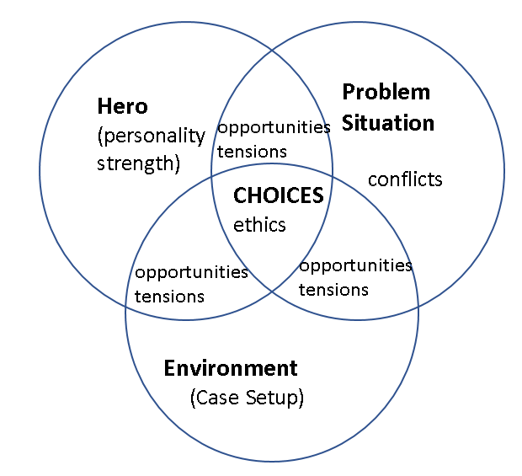
Figure 1. Typical building blocks for each story and case study.
The case study additionally may need professional domain characteristics knowledge to resolve existing conflicts. An additional difference is that typical storytelling contains one stream which must be delivered as one stream. However, from a case study, several storytelling streams may be extracted.
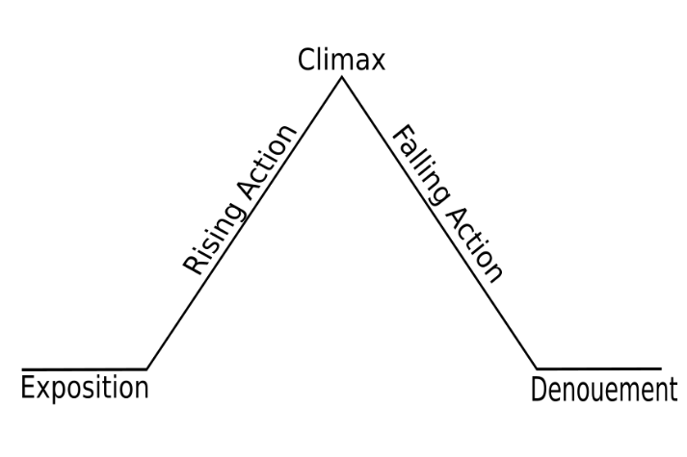
Figure 2. Freytag Pyramid (Source: public domain).
Christensen and Hansen (1987) note three major levels of student’s involvement in the case study:
Level one. Students explore a problem, collect relevant facts, and develop logical conclusions that are presented to other students and the instructor (Christensen & Hansen, 1987). The students are only commentators or observers, observing a case situation and keeping their psychological distance
Level two. Students start to identify with the case characters, and, when arguing, students adopt the selected character’s point of view and perspective.
Level three. Students fully identify with the case situation and behave as if they are fully immersed in a real-life situation.
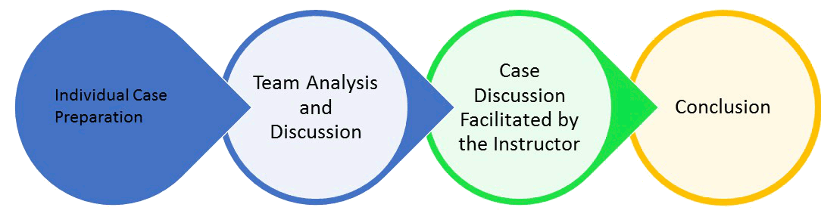
Figure 3. Traditional Case Study usage on a Business Courses
Figure 3 shows the traditional use of case methods in MBA courses and business schools. After reading an individual case, students are divided into small teams that prepare and undertake analysis and discussion. Team members present results of the debate in the plenary session of all teams, where the teacher acts a facilitator. Next, teams finalize and present their main results that have often been corrected by the teacher.

Common Visualization Language and Teaching Methodology
“Stories also provide the connective tissue between facts that make them memorable” (Kosara & Macinlay, 2013; Page 2). “The use of elements from storytelling is, therefore, the next logical step in visualization research, specifically, because storytelling can offer an effective way to present data” (Kosara & Macinlay, 2013, p. 1).
In our case, graphical visualization is used to perform the role of common interactive communication language. The authors re-purpose the so-called “rich picture” (often mistaken with mind maps) usually used along with Soft Systems Methodology (SSM). The Soft System Methodology (SSM) was developed by Checkland (1981, 2000) (Armson, 2003; Checkland & Scholes, 1990). The methodology was initially designed for IT analysis of not well-defined business and social systems to avoid technological bias that can overcome human-oriented or social-oriented solutions.
The “rich picture” was primarily designed for system analysis and design of information systems but was also later adapted for teaching, including business education (e.g., Fogliasso, Baack, & Box, 2007). However, there are only a few examples of utilizing this method for single specific non-IT projects or teaching non-IT courses.
The rich pictures are used in our approach to putting everything together (e.g., storytelling, case studies, and visualization).

Knowledge Management Perspective
The next item of the solution is the knowledge management perspective of teaching. In addition to being up-to-date with presented/transferred knowledge, the teacher should be looking for the best method of knowledge transfer to avoid a situation where the lecture may be defined as a transfer of a professor’s notes to students’ notes with omissions of all brains. A learning process must be two-fold. First, teachers must keep their own knowledge up-to-date; teachers should learn themselves. Second, the teacher, besides transferring knowledge, should implement in students’ minds the need for the creation of “knowledge hungry” structures. S/he should, following Chris Argyris (1991), teach intelligent people how to learn for themselves. Teaching from this perspective is not only a matter of transferring facts but also showing the students a way of thinking. The whole project management teaching process may be thought of as a knowledge creation process facilitated by the teacher and supported by the computer based tools.

Putting (All) The Story Together
The case study process conducted on our lesson generally follows the standard schema presented in Figure 3. However, in our case, the discussion of a case study in teams (Figure 4; Phase 2) is repeated several times along with following its overall analysis of partial results and visualization (Figure 4; Phases 3-4). In phase 4 what we already know (facts) is represented in a formal way to avoid ambiguity.
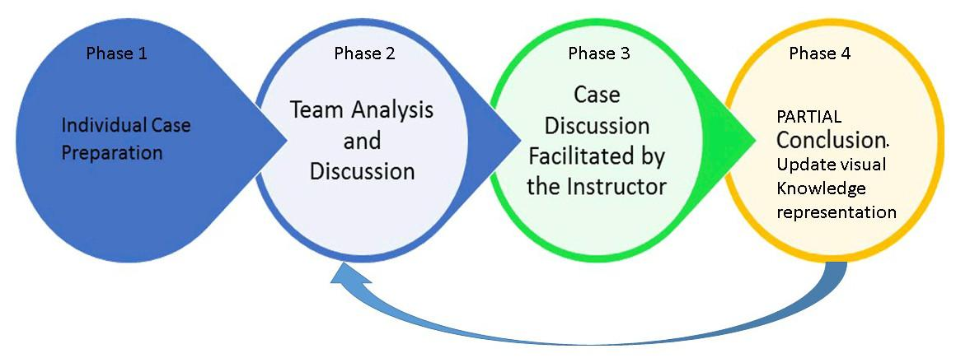
Figure 4. Modified case study (Multisession with instant visualization).
The more detailed process from Figure 4, involving all items discussed earlier, is presented in Figure 5.

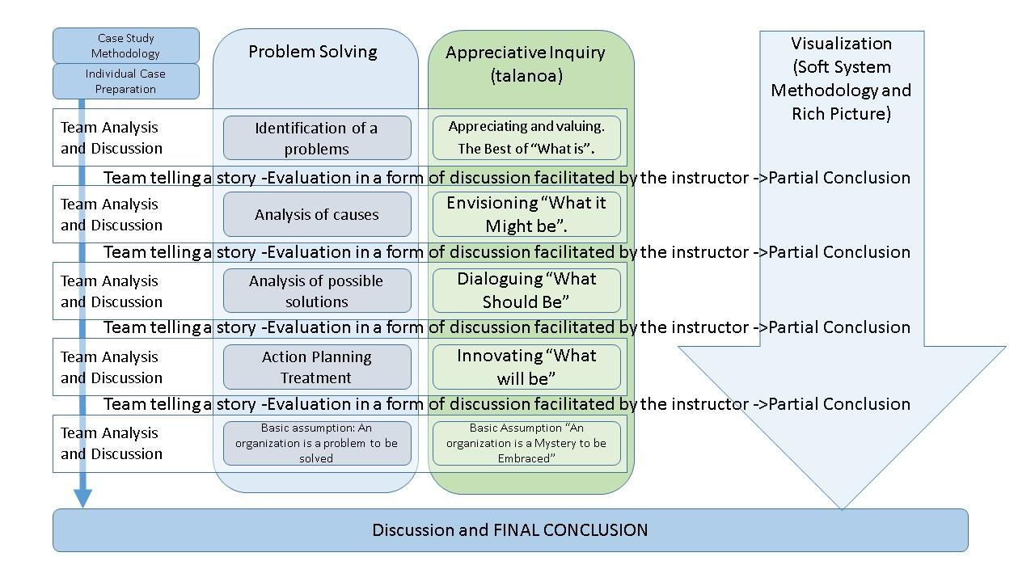
Figure 5. A further development of the case study approach proposed in Figure 4.
The middle part of the picture “Problem Solving” vs. “AI” is based on Cooperrider and Srivastva (1987).
As it was mentioned before the Phase 2, (Figure 4) (the session Team Analysis and Discussion – later referred as TAD) is repeated several times. Each repetition of the TAD is shown in Figure 5 as a row. Each TAD has different topic presented on the right side in the column “Problem Solving” and next column entitled “talanoa” (e.g., the first one has topic “Identification of problems” and “Appreciating and valuing” respectively, the second one “Analysis of Caused” and “Envisioning” respectively, etc.).
After each TAD is a joint session of “Team telling a story – Evaluation in the form of discussion…” (referred later as TTS and containing partially overlapped phases 3 and 4 from Figure 4), where teams present their own results and participate in the general discussion while building the relationship between teacher and students (storytellers) leads to the realization of a “learning village” - a safe, culturally strengthening place appreciated by Pacific communities (Chu et. al., 2013). What we learn together from a story and discussions is instantly reflected as pictorial knowledge representation (marked as “Partial Conclusion” in column rich picture on Figure 5).
Stories are predefined and delivered as one complete piece without interaction in opposition to the analysis process (Kosara & Mackinlay, 2013). Stories naturally lead to questions that lead to discussions, which then leads to deeper analysis. Kosara and Mackinlay (2013) also note that data analysis is faster and more efficient due to interactivity during visualization. During TTS, the instructor is documenting this ongoing process in a way visible to students. The documentation is a visualization of the current knowledge state retrieved from the case, a map showing where we are, and a background for further discussion. The map is an initial base knowledge structure that is extended by incorporating, piece by piece, new information retrieved from multiple teams and full discussions, and information coming from all interactions of the instructor with the students. With time, and along with the discussion, the picture becomes more accurate and more refined. The picture becomes a knowledge base for the knowledge collected from the verbal case. The fact that there are no rules related to rich picture methodology allows students to have their own interpretation and enables their creativity. Pictures give a common understanding shared among all group members of where the problem is, with space for team members’ individual opinions.
Each TAD session is a combination of two approaches (Figure 5): traditional formal problem-solving method (column “Problem Solving” on Figure 5), and so-called Appreciative Inquiry (AI). The AI approach has been added to make a whole discussion less formal and allows culturally sensitive teaching. Appreciative Inquiry (Chu et al., 2013; Coghlan, Preskill, & Tzavaras Catsambas, 2003) is an alternative approach to traditional action research because it starts from imagination or verbal visualization of the best situation for system stakeholders, with the subsequent step identification of the problem. AI is based on qualitative, narrative analysis, and storytelling (Whitney & Trosten-Bloom, 2003). AI is also frequently criticized (Bushe & Khamisa, 2005), for example, Appreciative Inquiry does not directly address the problems (Coghlan et al., 2003) and may lead to the unrealistic perception of the problem (Rogers & Fraser, 2003). We believe that some negative consequences may be prevented by fusion of AI (third column in Figure 5) with the problem-solving method – second column on Figure 5 entitled “Problem Solving.”
As many cases are complex, it is good to first extract the basic facts together with the students. Those basic facts are, for example, organization details, actors of the drama, problem outline, and additional data, and set up the scene (the story context). In our approach, these facts when visually represented create a basic frame for in-class discussion. When we agree on the interpretation of most of the basic facts, we can proceed to the more advanced issues. More detailed information on visualization contains the next section.

The Experiences with Computerized Tools
As mentioned in the previous section, the way of building living interactive and iterative visual representation of the knowledge retrieved from the case requires a particular style of visualization. The visualization process should allow creating a new story, by placing elements, things, relationships between items, to see hidden connections not normally seen after only reading the text. A case study is not a linear, sequential story. It is a bunch of stories, related problems, hidden connections, and not immediately visible dependencies; some items even may be linked to individual experiences of audience members.
There is no one right solution for the case, but instead, there may be several satisfactory solutions. Just simply a reflection of real life. That way of understanding the case study process is about shared experiences of the group making an analysis. The visualization of results should be non-linear similarly to the nature of the case study. It is not just a sequential MS PowerPoint presentation illustrating static facts from the case study. This is also not prepared previous infographics.
The non-linear presentation is partially created by the class and teacher (mostly ad-hoc), what enables discussion, creating a solution together, showing the internal structure of knowledge, and the way of the knowledge construction. The application of this process in practice requires an infrastructure. This may require picture or slide preparation, entering new slides during the presentation, and providing corrections on the fly that are the result of interactions between presenter and audience.
The computerized tool was used at Phase 4 (Figure 5) for documenting the case solving process and creating a visual representation of the actual state of the knowledge collected from the case. The proposed methods require using the appropriate tool for the task. The basic core of the method is the use of continuously updated visualization.
The in-class discussion is parallel to discussion visualization. The tool supporting this process must allow for quickly representing, in graphic form, the result of the discussion to prevent breaks in the stream of the discussion.
Initially, the authors used standard tools like MS Visio (Figure 6) and later Prezi. MS Visio was too slow for quickly representing interaction changes in the structure. Later, when Prezi first appeared, it allowed for the creation of new possibilities for making visualization.
To achieve the advantage and to bring new quality to the classroom, it is necessary to pull up a deep structure of the presented lesson topic to make it visible to the audience by showing the structure of the subject or, even better, to allow students to discover it by themselves, which allows seeing deeper relationships in the presented material. Prezi’s advantage is the ability to present knowledge structure in the form of a rich picture from a “bird’s eye view” and going in closer at a given point of the structure to see more details. This is possible because Prezi uses the concept of the zoom (or zoom-able) interface that dynamically scales the picture from an overall view of the details, and back and forth.
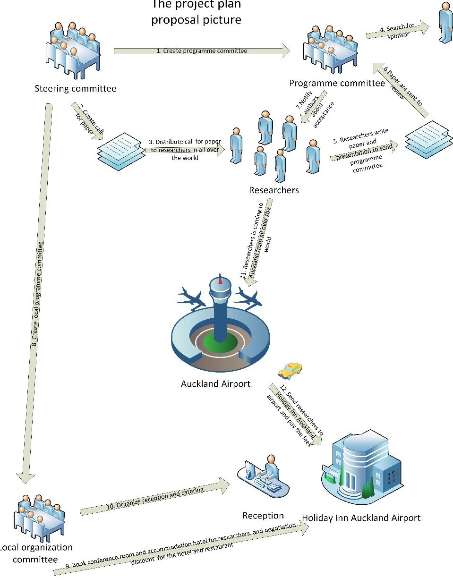
Figure 6. A part of the rich picture for conference organization project made together with students using MS Visio (Zaliwski, 2013)
The zoomable Interface allows users to change the scale of the viewed area to see details. This is a graphical user interface that uses “infinite” virtual desktop and vector graphics for presenting various items on the desktop. The user may move freely in two dimensions, plus zoom the elements on the desktop to see additional details. However, the idea of zoom-able interface dates from1962, an idea by I. E. Sutherland (2003) that does not exist in many applications. The most known are EagleMode (http://eaglemode.sourceforge.net/), which thus far is without practical application, Big Picture (http://bigpicture.bi/demo), Topicscape (http://www.topicscape.com/topicscape-wiki/index.php?title=Topicscape_3D_mind_mapping_structure_explained), and Prezi (http://prezi.com), a potential competitor of MS PowerPoint.
Prezi’s advantage lies not in the attractive form of changing slides because most presentation tools can do that. Most MS PowerPoint users who switched to Prezi still make presentations using the MS PowerPoint’s same sequential philosophy with some additional special effects provided by Prezi. Prezi’s advantage that we sought to exploit is its ability to make the non-linear presentation because of zooming. This allows creating presentations (case visualization) in the form of the layered network, which we need to modify on the fly during case discussion facilitated by the instructor. We can go up to more general concepts or go down to see the details. However, to fully exploit these new features it is necessary to see the taught knowledge area as a network of concepts and build-up the new concept upon existing structures. Updating the current state of visualization becomes a problem as we need to switch Prezi from presenting to edit mode, together with picture update; this takes time. If it takes more than a few seconds, students will lose their focus on the discussion topic and make the whole debate (along with instant visualization of current results) less smooth. Similarly, current graphical editors are unusable or tough to use for the visualization purpose. In fact, all of them have two distinctive modes: presentation mode and editing mode. For the update of displayed information, therefore, one must switch back and forth between the modes. To address this problem, we are developing a new tool based on procedural objects generation on Unreal Engine 3D (https://www.unrealengine.com/what-is-unreal-engine-4 ). This tool will not require differentiation between edit and presentation mode.

Methodology
In 2009, the initial research on two classes of the non-compulsory project management course was undertaken with one group of business students and with one group of IT students. However, both groups took the same project management course. Students in both groups received the same project assignment to realize in 4-5 member teams in about a four weeks’ time frame.
Before the assignment, one group was presented a case study where the problem was solved using rich picture methodology visualization created interactively with the participation of all students. (This column is marked as “using the practice” in Tables 2 and 3). The second group was a control group, and the case study was delivered to them in the way usually used to deliver content on MBA courses. The IT group in Table 2 was the “using the practice” group, and the business group was the control group. The next trimester, the business group was the “using the practice group,” and IT students the control group (Table 3).
In the year 2009, we searched only for temporary solutions for our current problems without desire to further development of the presented method, so all the results were based only on the comparison of assignment grades (for the groups who used the described practice during the class against the groups which was not used) several weeks after the assignment. On the early years of using the practice also there was no way to create different experimental setup due to lack of enough number of students enrolled.
The research was repeated in 2015, this time in the form of an extensive survey repeated several times, and covering 80 students each time. So far, we use presented practice in a limited manner. Ten weeks (8 hours a week) of a compulsory course in project management was repeated each trimester for about 50-80 students. Each time we made a traditional case study session, after which a survey was done. A week later we made two 2-hours sessions (on two consecutive days) using learning practice described in this paper. For testing purposes, we used the popular “Woody 2000” (Wideman, 2017) case study as this case contains many intertwined streams and allows for the discussion to start on variety topics related to project management. During the sessions, students fill in a team dynamic survey (10 questions). After the second session, students also fill-in a survey containing 53 questions (Likert-type) about individual learning style, teamwork, a way of co-operation and communication, information about the level of understanding of the material, and overall impressions. For the traditional case session and new proposed case session, the same student’s groups and teachers were used. The results for some selected questions are presented in Figures 7 and 8 in the next section.

RESULTS
The following results (Tables 2 and 3) are from the 2009 preliminary research based only on the grades achieved by the students after using the suggested practice against the groups of students who didn’t use the practice.
Table 2. June 2009 Trimester 2
 | Information Technology group (using the practice) | Business Group (not using)
Number of students | 14 | 29
Average grade for the project | 78.5 | 56.5
Standard deviation | 3 | 25.4
Minimum | 75 | 13
Q1 | 75 | 52
Median | 79 | 62
Q3 | 82 | 80
Max | 82 | 86

Students of information technology learn many various diagrams; it was possible that this skill worked as an advantage for IT students and biased the results. So, the experiment was repeated (Table 3) with reversed initial conditions. All results in Tables 2-4 are based on the students’ assignment project grade and stored in our computer system.
Table 3. Sept 2009 Trimester 3
 | Business group (using the practice) | Information Technology group (not using)
Number of students | 21 | 14
Average project grade | 63.2 | 57.9
Standard deviation | 8.3 | 5.2
Minimum | 55 | 50
Q1 | 55 | 50
Median | 68 | 60
Q3 | 71 | 62
Max | 74 | 62

Students’ results in the third-trimester results were worse than those of students in the second trimester. However, the difference in results for students using the practice was still visible. IT students even without proposed practice, already do better in various diagramming techniques due to IT courses specific. However, IT students do not have better grades than business students using the practice. So, the difference in result is related to use of the proposed practice, not to previous diagramming skills possessed by the students. Results for the second research made in 2013 are presented in Table 4. The research compared this time only two groups of business students. A project given to students this time was individual – the same project for each student in this semester.
Table 4. Only Business students. 2013
 | Traditional way | Using the practice
Number of students | 50 | 41
Average project grade | 60.8 | 65.6
Standard deviation | 16.2 | 13.2
Minimum | 32 | 50
Q1 | 50 | 53.5
Median | 58.5 | 64
Q3 | 74 | 77.5
Max | 100 | 95

The results of 2015 research are presented below. These results were based on extensive surveys described in the previous section. Among the overall improvement of grades of about 5-6%; we also noticed some interesting results like the improved perception of a teachers’ knowledge. The students would perceive the teacher as more qualified more often than before, even if the teacher had not made any progress with his/her qualifications in the meantime. And, we observed the relationship between hearing stories as a child and greater sensitivity of a student for our method. The processing of a large amount of survey data is still in progress, and results will be soon published. Similar results were obtained for human resource courses delivered in 2015.
The selected questions from the survey and their results are shown in Figures 7 and 8. (Five points is the best. The scale is 1-5.)
Questions 1-5 (out of 53):
- The instructor encourages the student to think.
- The Instructor is knowledgeable about the subject matter.
- Freedom to ask questions and express opinions.
- The effectiveness of instructor in demonstrating the significance of the subject matter.
- The response from instructor to student’s questions.
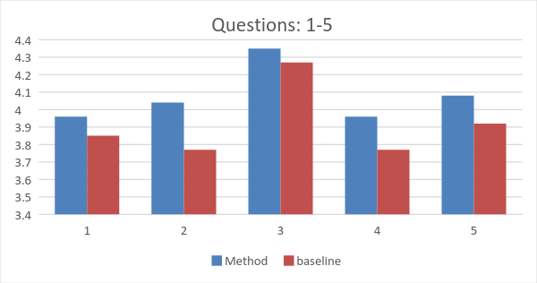
Figure 7. Survey Results (Part 1) (Scale from 1 to 5. Five points are the best).

Questions 7-13 from the same study as above:
- Not used in this research.
- I feel satisfied when our team performs well.
- Working on the team expands my personal knowledge and skills.
- Team members are too different to work together. (In team environment differences of opinions and conflicts becomes more visible, but at the same time appreciation for multiculturalism is visible in the results of the next question).
- This is a diverse team of people who bring different perspectives and experiences.
- Finishing the group assignment requires excellent communication and co-ordination (There is no difference because students were told from the beginning about the importance of communication in project management).
- I learn better when I work or study with others than by myself.
- I remember things better if I discuss them with someone.
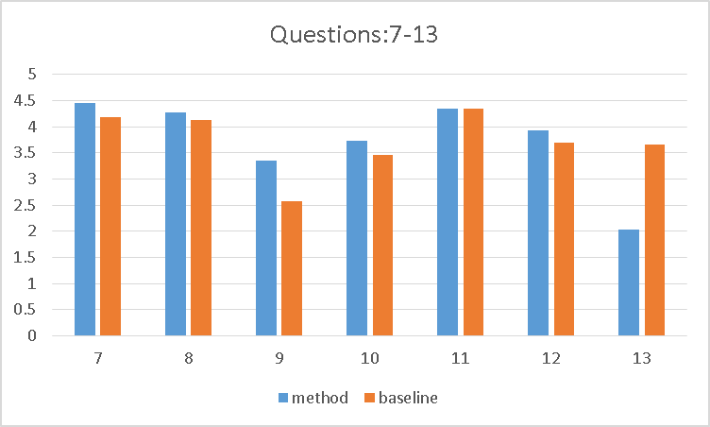
Figure 8. Survey Results (Part 2)
In the list below are presented the experiences and the further development plans collected when using our proposed practice for the last several years:
- Using zoomable user interfaces like Prezi to allow non-linear presentation where the topic is represented as a network of concepts is too slow and too complicated to make it parallel with in-class discussion. We started to develop our graphical tool for in-class visualization where there is no difference between edit and presentation mode.
- Preparation of teaching material to allow for non-linear presentation and knowledge construction together with the audience is difficult and time-consuming for the teacher. In our case to provide a proper dynamic of class work, we delivered the practice using two teachers at the same time. What looks like teacher’s improvisation during the class is in fact well prepared before the class. We started work on graphical computerized tools helping teachers with in-class preparation. However, “Current technology is changing the nature of stories, but it is not going to make us all a Mark Twain or Steven Spielberg” (Jain & Slaney, 2013, p. 90).
- We are going to examine in greater depth the potential for blended learning and flipped learning.
- Few case studies are suitable as background for presented teaching practice. The case study should contain many threads and allow the teacher to be flexible in selecting topics and driving the case discussion. These case studies must be written in further practice.
Further research will describe the presented teaching practice in the context of the theoretical framework provided by the Informing Science discipline. The presented practice will fit to the Informing Science definitions given by Cohen (1999), “the field of inquiry that attempts to provide a client with information in a form, format, and schedule that maximizes its effectiveness”, by Gackowski (1982) “informing systems are a class of work systems whose basic output is information that affects recipients’ actions”, and, “the essence of the Informing Science philosophy is the transfer of knowledge from one field to another: breaking down disciplinary boundaries that hinder the flow of knowledge” (Cohen, 2009). The Informing Science perspective also fits teaching business as in many cases it is teaching decision-making in ill-defined situations.

Conclusion
The presented teaching method is not a new way of in-class presentation; rather, it is about controlling and driving the interaction between students and teachers that consider culturally related aspects of the audience behavior. This is about the most efficient realization of teaching goals, improvement of student’s educational experience, and improving the employability of our students.
The task is to create a living presentation which will evolve together with our knowledge about the problem and will reflect our struggle with the issue and our position on the way to a solution. The structure should allow seeing both the detailed view of selected fragments and “bird’s eye view.”
Preparation of education material to allow for non-linear presentation and knowledge construction together with the audience is difficult and time-consuming for the teacher. What looks like a teacher’s improvisation during the class should be the result of proper preparation prior to the start of class. The teacher should analyze different variants of rich pictures and choose the most suitable for the given audience, which requires a guess at the range of possible discussion tracks and the imagining of interactions with the public.
The current results show that the proposed method has the potential to improve students’ experience in applied business courses. The project is ongoing and will undergo progressive changes while collecting new experiences.
By focusing on the storytelling and rich picture, we avoid technological bias when we teach business problem-solving. Instead, we concentrate on teaching students the social-organizational interactions influencing the problem solution.
Additionally, the proposed teaching solution embedding the cultural sensitivity into teaching process builds upon previous knowledge structures of cultural contexts. Also, using graphical language makes it possible for everyone to understand and to visualize the knowledge creation process and shows where we are now. We apply a Pacific social concept, e.g., Talanoa, to teaching business and later technological issues. These concepts together with SSM allows for keeping the balance between the social and technical approach to the system to avoid technological bias. Otherwise, strict application of the IS methodology to business problems may be risky due to technological bias in proposed solutions.

References
Armson, R. (2003). A quick sprint through soft systems methodology. Workshop materials. Retrieved from: http://technology.open.ac.uk/cts/spmc/2003july-armson-quicksprint-day1.pdf
Argyris, C. (1991). Teaching smart people how to learn. Harvard Business Review, May-June, 99-109.
Bushe, G. R., & Khamisa, A. (2005). When is appreciative inquiry transformational? A meta-case analysis. The Journal of Applied Behavioral Science, 41(2), 161-181. Retrieved from http://www.gervasebushe.ca/aimeta.htm
Checkland, P. (1981). System thinking. systems practice. Chichester: John Wiley & Sons.
Checkland , P., & Scholes, J. (1990). Soft system methodology in action. Chichester: John Wiley & Sons.
Checkland, P. (2000). The emergent properties of SSM in use: a symposium by reflective practitioners. Systemic Practice and Action Research, 13(6), 799-823.
Christensen, C. R., & Hansen, A. J. (1987). Teaching and the case method. Boston: Harvard Business School.
Chu, C, Abella, I. S., & Paurini, S. (2013). Educational practices that benefit Pacific learners in tertiary education. Wellington. Ako Aotearoa. National Centre for Tertiary Teaching Excellence. Retrieved from https://www.akoaotearoa.ac.nz/mi/download/ng/file/group-5330/fr-educational-practices-that-benefit-pacific-learners-in-tertiary-education.pdf
Coghlan, A. T., Preskill, H., & Tzavaras Catsambas, T. (2003). An overview of appreciative inquiry in evaluation. New Directions for Evaluation, 2003(100), 5-22.
Cohen, E. B. (1999). Reconceptualizing information systems as a field of the transdiscipline informing science: From ugly duckling to swan. Journal of Computing and Information Technology, 7(3), 213–219. Retrieved from http://inform.nu/WhatsIS.htm
Cohen, E., B. (2009). A philosophy of informing science. Informing Science: the International Journal of an Emerging Transdiscipline, 12, 1-15. Retrieved from https://www.informingscience.org/Publications/425
Coghlan, A. T., Preskill, H., & Tzavaras Catsambas, T. (2003). An overview of appreciative inquiry in evaluation. New Directions for Evaluation, 2003(100), 5-22. Retrieved from: http://blogs.ubc.ca/evaluation/files/2009/02/appreciative20inquiry.pdf
Cooperrider, D. L., & Srivastva, S. (1987). Appreciative inquiry in organizational life. In R. Woodman & W. Pasmore (Eds.), Research in organizational change and development, Vol. 1, pp. 129-169. Greenwich, CT: JAI Press. Retrieved from: http://www.margiehartley.com/home/wp-content/uploads/file/APPRECIATIVE_INQUIRY_IN_Orgnizational_life.pdf
Deans, J., Flood, A., Head-Tuariki, P., Thaman, H., K., Hindmarsh, G., & O’Brien, A. (2002). Story telling in schools – Promoting identity, unity and harmony and economic sustainability in diverse cultures. UNESCO Regional Pedagogical Conference on Arts Education in the Pacific in Fiji, 2002. Retrieved from http://docplayer.net/25368803-Story-telling-in-schools-promoting-identity-unity-and-harmony-and-economic-sustainibility-in-diverse-cultures.html
Dobson, T., Michura, P., Ruecker, S., Brown, M., & Rodriguez, O. (2011). Interactive visualizations of plot in fiction. Visible Language, 45(3), 169. Retrieved from http://blogs.ubc.ca/lled4492015/files/2015/07/Interactive-Visualizations-of-Plot-in-Fiction.pdf
Fogliasso, C., Baack, D., & Box, T. M. (2007). The rich picture pedagogy for business professors and assignments for students. Decision Science Institute. Proceedings of 2007 Meeting. San Diego, CA March 13-17, 2007. Retrieved from http://www.swdsi.org/swdsi07/2007_proceedings/papers/363.pdf
Gackowski, Z. J. (1982). An approach to categorization of information systems. Proceedings of the ASIS (American Society for Information Science). Annual Meeting, October 17-21, 1982, Volume 19, Columbus, OH.
Gill, T. G. (2010). Informing business: Research and education on a rugged landscape. Santa Rosa, CA: Informing Science Press.
Hill, D. L. (2001). Holistic learning: A model of education based on Aboriginal cultural philosophy. National Library of Canada= Bibliothèque Nationale du Canada. Retrieved from http://www.nvit.ca/docs/holistic%20learning%20a%20model%20of%20education%20based%20on%20aboriginal%20cultural%20philosophy.pdf
Herreid, C. F. (1997). What is a case? Journal of College Science Teaching, 27(2). Retrieved on 28 May 2017 from http://sciencecases.lib.buffalo.edu/cs/pdfs/What%20is%20a%20Case-XXVII-2.pdf
Herreid, C. F. (2007). What makes a good case? In C. F. Herreid (Ed.), Start with a story: The case study method of teaching college science. NSTA press. Retrieved from https://books.google.co.nz/books?hl=en&lr=&id=HdXcYhThxoIC&oi=fnd&pg=PR5&dq=Business+Case+Study+teaching&ots=5-xE5jMGYq&sig=NHyeXvUSjxDx6gwQfTRLs1X2MZQ#v=onepage&q=Business%20Case%20Study%20teaching&f=false
Herreid, C. F. (2014). The use of case studies and group discussion in science education. University at Buffalo, State University of New York. Retrieved on 12th Nov. 2014 from http://sciencecases.lib.buffalo.edu/cs/training/videos/Group_Discussion.pdf
Ickis, J. C. (2013). The role of case studies in informing systems: Introduction to the special series. Informing Science: the International Journal of an Emerging Transdiscipline, 16, 187-195. Retrieved from https://www.informingscience.org/Publications/1905
Irving, L., & Hoffman, J. (2014). Nyungar place stories pilot: Using augmented reality for Indigenous cultural sustainability. Rhetoric and Reality, 367-378.
Jain, R., & Slaney, M. (2013). Micro stories and mega stories. MultiMedia, IEEE, 20(1), 86–90. doi: 10.1109/MMUL.2013.6
Kelsey, K., & Zaliwski, A. (2014). Applied business education: The cultural impact on interactive teaching in a multi- cultural learning environment. Weltec-Whitireia Research Symposium. Wellington, New Zealand, 20th Nov. 2014.
Kersten, S., (2014). Case study and problem solving. Fakultät Erziehungswissenschaften, Institut für Berufspädagogik und Berufliche Didaktiken. Technische Universitat Dresden. Retrieved Jan 2017 from http://rcswww.urz.tu-dresden.de/~kersten/CSC%20VocEd/case%20study%20and%20problem%20solving.pdf
Koki, S. (1998) Storytelling: The heart and soul of education. PREL Briefing Paper. Pacific Resources for Education and Learning, Honolulu, HI. Office of Educational Research and Improvement (ED), Washington, DC.
Kosara, R., & Mackinlay, J. (2013). Storytelling: The next step for visualization. Computer, 46(5), 44–50. http://doi.org/10.1109/MC.2013.36
Kutay, C., Howard-Wagner, D., Riley, L., & Mooney, J. (2012). Teaching culture as social constructivism. In Conference on Advances in Web-Based Learning-ICWL 2012 (pp. 61-68). Springer Berlin Heidelberg.
Leavy, B., Wyeld, T. G., Hills, J., Barker, C., & Gard, S. (2007). Digitizing the arts, culture and heritage landscape of Aboriginal Australia. In Y. Kalay, T. Kvan, & J. Affleck (Eds.), New heritage: New media and cultural heritage, (pp. 294-303).
Meyers, M. A. (2003). Ho’oulu: Our time of becoming: Hawaiian epistemology and early writings (1st ed.). Hawaii: Hawaii Native Books Inc.
Mileski, D., Schneider, F., & Bruegge, B. (2015, July). Visual storytelling. Proceedings of the 18th European Conference on Pattern Languages of Program (p. 12). ACM, 1–7. doi:10.1145/2739011.2739023
Monarth, H. (2014). The irresistible power of storytelling as a strategic business tool. Harvard Business Review, March 11^{th,} 2014. Retrieved from: https://hbr.org/2014/03/the-irresistible-power-of-storytelling-as-a-strategic-business-tool/
O’Brien, A., (2002). Many voices, one country: Story-telling and creative writing in Australian education. UNESCO Conference on Arts Education in the Pacific Region. Fiji, November 25 – 29, 2002.
Rodríguez, M., Nunes, S., & Devezas, T. (2015). Telling Stories with Data Visualization, 7–11. doi:10.1145/2804565.2804567
Rogers, P. J., & Fraser, D. (2003). Appreciating appreciative inquiry. In H. Preskill & A. T. Coghlan (Eds.), Using appreciative inquiry in evaluation. San Francisco: Jossey-Bass.
Salas, M. C., & Indelacio, A. R., (2000). Storytelling in the Pacific. PIALA 2000 10th Pacific Island Association of Libraries and Archives Conference. Tumon. Guam.
Samu, T. W., Mara, D., & Siteine, A. (2008). Education for Pacific peoples for the 21st century. In V. Carpenter, M. Stephenson ,& J. Jesson (Eds.), Nga Kaupapa Here: Connections and contradictions in education. Melbourne: Cengage.
Segel, E., & Heer, J. (2010). Narrative visualization: Telling stories with data. IEEE Transactions on Visualization and Computer Graphics, 16(6), 1139-1148.
Sheets, H. R. (2005). Diversity pedagogy: Examining the role of culture in the teaching-learning process. Boston: Pearson Education.
Sivan, A., Leung, R. W., Woon, C. C., & Kember, D. (2000). An implementation of active learning and its effect on the quality of student learning. Innovations in Education and Teaching International, 37(4), 381- 231.
Strachan, H. W. (2013). Case method management. Informing Science: the International Journal of an Emerging Transdiscipline, 16, 197-201. Retrieved from https://www.informingscience.org/Publications/1906
Sutherland, I. E. (2003). A man-machine graphical communication system. In N. Wardrip-Fruin & N. Montford (Eds.), The NewMediaReader (Vol 1), (pp. 109-126). The MIT Press.
Thompson, S., McDonald, F., Talakai, M., Taumoepeau, V., & Te Ava, A. (2009). Training manual for teaching working with pacific students: Engaging pacific learners. Good Practice Publication Grant scheme 2009. https://akoaotearoa.ac.nz/download/ng/file/group-3300/training-manual-for-teachers-working-with-pacific-students.pdf
Vaioleti, T. M. (2006). Talanoa research methodology: A developing position on Pacific research. Waikato Journal of Education 12(1). 21-34. Retrieved from http://www.wje.org.nz/index.php/WJE/article/view/296/310
Vaioleti, T. M. (2011). Talanoa, Manulua and Founga Ako: Frameworks for using enduring Tongan educational ideas for Education in Aotearoa/New Zealand. Ph.D. Thesis University of Waikato. Retrieved from http://researchcommons.waikato.ac.nz/bitstream/handle/10289/5179/thesis.pdf?sequence=3&isAllowed=y
Whitney, D., & Trosten-Bloom, A. (2003). The power of appreciative inquiry: A practical guide to positive change. San Francisco, California: Berrett-Koehler.
Wideman, M. (2017). Project management case study. The Woodworking Company Woody 2000. Retrieved from: http://www.maxwideman.com/papers/woody2000/intro.htm
Wolfgang, E. (2010). Interview #099 Emil Wolfgang - Carrying the Pacific Island Storytelling Culture Forward. Retrieved Dec. 2015 from http://podbay.fm/show/254225786/e/1267030800
Wolfgang, E. (2015). Carrying the Pacific Island Storytelling Culture Forward. Website: http://www.artofstorytellingshow.com/2010/03/09/emil-wolfgang-pacific-island-storytelling-culture/
Wyeld, T. G. (2007). Visualising Australian indigenous knowledge practices using the game engine. Proceedings of Information Visualization, 2007. IV ‘07. 11th International Conference, Zurich, 2007, pp. 395-396. doi: 10.1109/IV.2007.128.
Wyeld, T. G., Carroll, J., Ledwich, B., Leavy, B., Gibbons, C., & Hills, J. (2007). The ethics of indigenous storytelling: Using the torque game engine to support Australian Aboriginal cultural heritage. Proceedings of Digital Games Research Association, 261-268.
Zaliwski, A. J. (2013). Engaging audiences by the non-linear presentation and case studies. Paper presented at the Whitireia Auckland Research Symposium. Auckland, New Zealand, Oct. 2013.
Zaliwski, A. J., Kelsey, K. (2015). Building interaction with multicultural students - A fusion of multiple ancient and modern teaching technologies. Paper presented at The Third European Conference on Technology in the Classroom. IAFOR. Brighton, UK. 1st -5th June 2015.

Biographies

Karishma Kelsey has her Bachelors of Technology (Honors) in Design and Business from the Durban University of Technology in South Africa, a postgraduate in education from the University of South, and postgraduate work in the English language as a foreign and second language.
She is also an active entrepreneur, who runs the fair-trade women empowerment Design Company, where the focus is on the ethical production and sustainable practice of clothing whilst building communities through skills development and several other sustainable practices.
She has successfully created two workshops for women in Thailand and South Africa and is currently creating a workshop in Sri Lanka. She has been an educator of primary and secondary education in six different countries and has been challenged by many of the learning issues discussed in this paper. For the last 16 years, Kelsey has been researching and implementing creative methods of teaching and is passionate about the improvement of education for the empowerment of people. She is currently teaching e-Commerce and previously “Strategic Human Resource Management” at Whitireia NZ. Her current research interest includes analysis of supply chains in fashion industry companies, research commercialization, 3D graphics, and the adoption of game technologies into blended learning.


Andrew J. Zaliwski received an M.Sc. in Mathematics from the M.C. Sklodowska University (Poland) in 1986, and a Ph.D. in Computer Science from the University of Mining and Metallurgy (AGH), Krakow (Poland) in 1992. 1984-1990 he worked at UMCS Lublin (Poland), 1990-2000 as a lecturer at the Computer Science; the University of Economics, Krakow (Poland), and he worked 2000-2001 as the lecturer at the Computer Science Dept., University College Cork (Ireland). 2001 - 2006 he worked at the CUNY New York (CSI) as the business information systems lecturer.
He is currently teaching “Project Management” and “Mobile Applications” at Whitireia NZ (Auckland, New Zealand). His current research interests include combining 3D graphics with computerized support for teaching and education and new STEM teaching solutions.

