Yours Virtually: Advanced Mathematics and Physics in the Israeli Virtual High School
Yaniv Biton | Shaanan College, Haifa Center for Educational Technology, Tel Aviv, Israel | yanivb@cet.ac.il
Sapir Fellus | University of Alberta, Edmonton,  Canada | fellus@ualberta.ca
Dafna Raviv | Center for Educational Technology,  Tel Aviv, Israel | dafnar@cet.ac.il
Osnat Fellus | University of Ottawa, Ottawa,  Canada | osnat.fellus@uottawa.ca

Abstract
Aim/Purpose | The increasingly growing number of virtual high schools around the world has engendered new modes for teaching and learning and a promising area of research. While research in this emerging field has mostly taken a comparative lens that highlights differences between traditional modes of teaching and online teaching, research on high school students’ and teachers’ perspectives has remained dearth.
Background | This study identifies students’ and teachers’ perceptions of their learning and teaching advanced level mathematics and/or physics in the first Israeli virtual high school (VHS), which was launched five years ago.
Methodology | A survey of 41 questions was disseminated to the first graduating cohort of 86 Grade-12 students as well as to 22 VHS teachers. Additional data sources include students’ essays on what it means to be a student in a VHS and field notes from a pedagogical development day.
Contribution | The purpose of this study is to highlight the workings of the Israeli VHS and in particular its important building blocks that include a teacher-tutor model, an ongoing gauging of students’ work through a Learning Management System (LMS), and a continual teacher-developer interaction for the purpose of developing cutting-edge, technology-based course content.
Findings | Given the unique features of the Israeli VHS, both teachers and students report on feelings of unit pride, motivation, and investment in teaching and learning in the VHS.
Recommendation  for Practitioners | The Israeli VHS uses a combination of a teacher-tutor format, together with tools for gauging students’ work and ongoing interaction between the teachers and the course content designers. Such a context creates new, fertile ground for technology-based, fully online teaching and learning of school mathematics and physics that may contribute to alleviating the problem of decreasing numbers of learners who are interested in taking advanced-level courses.
Recommendation  for Researchers | Further exploration of aspects for improvement in the teaching model of the VHS, its design, and its support system and for finding out factors that impact attrition lay down important research trajectories that have not yet been trodden.
Impact on Society | Issues of equity and the democratization of learning of advanced STEM subjects are now possible to be seriously considered in a principled manner within the context of the VHS.
Future Research | Future research may focus on the affordances, possibilities, and limitations of learning within a VHS to ensure a more robust process that will allow more students to learn advanced mathematics and physics.
Keywords | virtual high school, teachers’ perspectives, students’ perspectives, mathematics, physics

Introduction

Virtual Learning
The term virtual learning environment has been used interchangeably with terms such as distance education, e-learning, and web-based instruction (Rice, 2006). For the purposes of this paper and to reflect a current perception of what virtual learning environment is, we draw on the definitions of Crean Davis, Gaines, Paul, and Rukobo (2014), Rice (2006), and Schlosser and Simonson (2002) to define a virtual learning environment as a system that provides technology-mediated information spaces; facilitates synchronous and asynchronous teacher-student and student-student interaction that is independent of geographical proximity; harnesses pedagogically rich teaching approaches; and promotes state-wide or district-wide curricula through ongoing tests, homework, and evaluation and assessment of students’ progress. Given the multifarious aspects of this definition, we use the term virtual learning environment as a referent of more recently developed technological learning systems rather than as a reflection of how online programs looked like a quarter of a century ago. Looking back, it is important to note that the first online programs were launched about twenty-five years ago in the United States (Watson, Murin, Vashaw, Gemin, & Rapp, 2011) and in Canada (Barbour, 2011). To date, there are about 200,000 students in Canada (Murphy, Rodríguez-Manzanares, & Barbour, 2011) and 700,000 students in the US who learn in different virtual environments (Picciano, Seaman, Shea, & Swan, 2012).
Research that focuses on online programs highlights several possibilities and limitations that are experienced in virtual learning environments. For example, it was found that learners in virtual environments have higher levels of motivation (Barbour, 2011; Tunison & Noonan, 2001), and that such environments generate wider accessibility for learning (Hughes, McLeod, Brown, Maeda, & Choi, 2007), provide quality-learning environments, improve learning skills (Clark & Berge, 2003), and enable interaction with other students and teachers who are located in distant geographical areas (Barbour, 2008). Some of the limitations identified in the literature concern the overwhelming amount of work required from the students, limited interaction with other students (Blau & Barak, 2009), and technical problems (Barbour, 2008). In comparative research that looked into students’ perspectives in traditional versus virtual environments, it was found that students who learn in virtual environments are more satisfied with their learning experience (Summers, Waigandt & Wittaker, 2005), obtain higher academic achievements, and receive higher teacher support (Hughes et al., 2007). However, other research found opposite results indicating that there are no significant differences in learners’ satisfaction between students who learn in virtual environments versus students who learn in traditional settings (Cavanaugh, Gillan, Kromrey, Hess, & Blomeyer, 2004; Rivera & Rice, 2002; Ungerleider & Burns, 2003) thus indicating inconclusive findings. Given these findings and with the exponentially increasing numbers of virtual learning programs worldwide, the extent of research that focuses on learning in virtual K-12 environments remains dearth (Barbour, 2010). It is not surprising then that there are repeated calls for continued research in virtual K-12 learning programs in general (Barbour, Siko & Simuel-Everage, 2013) and in high school programs in particular (Barbour, 2017; Rice, 2006). The purpose of this paper is to contribute to the field of virtual learning by providing a snapshot of students’ as well as teachers’ perceptions of their experience in the first Israeli virtual high school that offers features which include the teacher-tutor format that, as far as we know, is unique to the Israeli VHS; the LMS, which is required in light of the fact that the courses are fully on line, and a continual interaction between developers and course teachers to identify technological and pedagogical tools that can be introduced into the environment to more efficiently and effectively teach and learn mathematical and/or physics concepts.

Israel’s First Virtual High School
In September 2012, the Center for Educational Technology (CET) together with the Trump Foundation and the Israeli Ministry of Education launched the first VHS in Israel. The purpose of the VHS was to address the problem of alarmingly decreasing numbers of students who opt for advanced level mathematics and physics classes. The VHS was set to make advanced courses in mathematics and physics available to students in peripheral areas where schools could not provide these classes because of shortage of qualified teachers. In addition, the VHS was set up to make these courses available to students in schools that could not form a large enough class to justify opening advanced courses at school. To date, the Israeli VHS offers advanced courses in mathematics, physics, and civic studies. The unique model of the VHS is that of a fully online platform, which essentially means that there are no face-to-face meetings and that all communication modes between the teachers and the students are situated within the virtual environment. The fully online program is free of space-related constraints—as such, students can access the course content anytime, anywhere. This paper focuses on the Israeli VHS teachers’ and students’ perceptions of their experience. Specifically, the research questions, discussed in later sections, are aimed at shedding light on how students and teachers experience the unique teacher-tutor format, the LMS, and the technological tools available through the VHS to the teachers and students.
The first cohort of the Israeli VHS graduated in the summer of 2015. The graphs in Figures 1 to 3 reflect the growth and development of the VHS. Figure 1 shows the number of participating home schools that had students enrolled in the VHS. (In this paper, this term home schools refers to the high schools where the students attend regular classes) Figure 2 reflects the number of classes in the VHS in the first four years of its operation. Figure 3 points to the number of students who studied in the VHS.
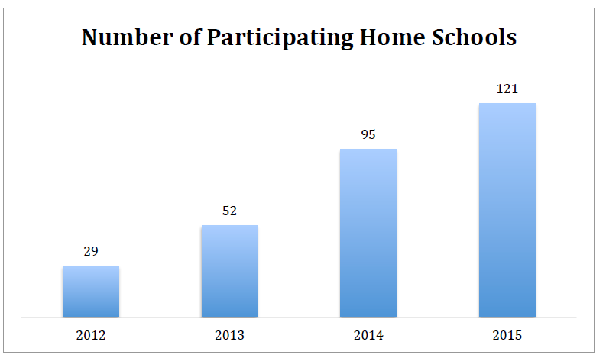
Figure 1: Number of participating home schools
Figure 1 indicates the growing number of participating home schools starting at 29 in 2012 when the VHS was launched and reaching 129 within the first four years of the school’s operation.
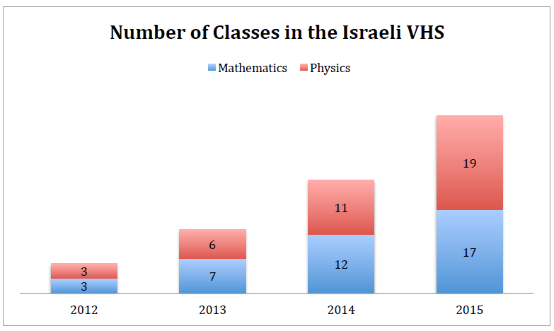
Figure 2: Number of classes in the Israeli VHS
Figure 2 demonstrates the number of classes that started off with six in 2012 and got to 36 within the school’s first four years of operation.
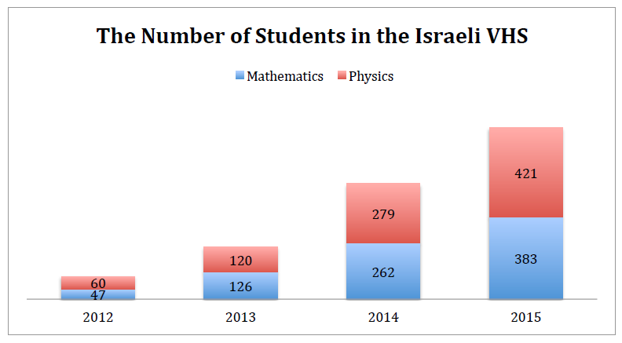
Figure 3: Number of students in the Israeli VHS
Figure 3 illustrates the increasing number of students enrolled in the VHS starting off with about 100 students in its first year and reaching about 800 students in its fourth year.
In order to better understand how the VHS courses are incorporated in the students’ high school schedule, we will next describe its structure and design. In mathematics, for example, the model employed in the Israeli VHS is comprised of five to six synchronous lessons with a teacher of a class that has about 27 students from different schools across Israel. In addition to these weekly six hours of synchronous lessons, each student also logs on for two to three hours of virtual tutoring that takes place in groups of up to four students. Each tutoring group works with a university student who majors in a STEM-related field. Each student is also expected to electronically submit homework assignments, quizzes, and tests. The learning environment in the Israeli VHS provides content that is highly interactive and rich with media. Feedback is almost always instantaneous and ongoing support to ensure accommodation to emerging needs is always available.
During the synchronous classes, the students sit in their respective home school, in front of computers. Other students in the same school who are also enrolled to the VHS may also be present in the room sitting at their own computer. During the online class, the teacher uses videos, PowerPoint presentations, and other digital tools and applications such as a white screen (see Figure 4)—an interactive tool where the students and the teacher write on a writing pad that translates the content onto the screen.
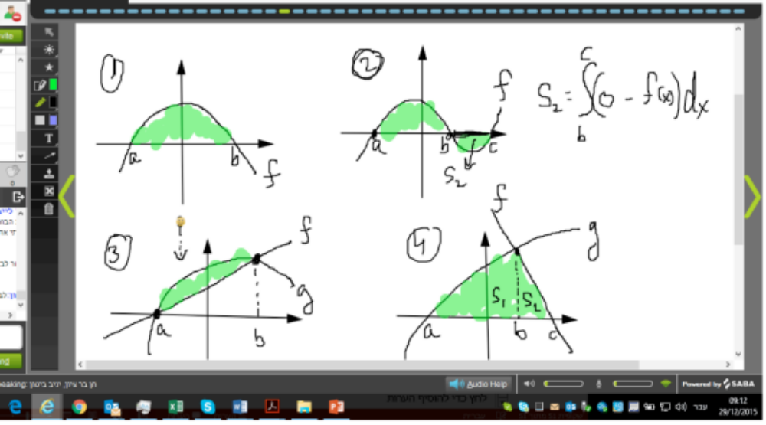
Figure 4: White screen
Figure 4. The students and the teacher use the white screen to share ideas and discuss them.
The use of dynamic software and simulation tools allows for interactive construction and visualization of concepts in mathematics and physics. This includes tools that allow for a manipulation of geometric shapes as is seen in Figure 5. Both the teacher and the students continually use the available software, features, and applications as they engage in dynamic and visual representations of concepts and configurations in mathematics and physics. In addition to the above-mentioned tools, the VHS platform also includes features that are oriented toward the facilitation of teacher-student, and student-student interaction. The polling feature and the chat feature, for example, provide a sense of democratization in the learning process, as they yield an opportunity for all participating students to interact, thus eliminating issues related to turn-taking as well as allowing all students to initiate and respond to emerging queries. Specifically, the use of these features disrupts the Initiation, Response, Evaluation model of interaction and classroom discourse (Cazden, 2001) that is prevalent in traditional classrooms where the teacher initiates the question, the student responds, and the teacher evaluates the response. Furthermore, unlike traditional settings, where teacher-student interaction is visible and audible for all, the VHS chat feature allows student-teacher interaction that is private. Alternatively, this same feature allows students to interact with others in the class without interrupting the lesson. This may take place when a student consults with other students during the lesson. In a similar vein, the polling feature allows for a quick gathering of students’ input. This feature can provide an indication to the teacher of how well the students understood material presented and taught previously.
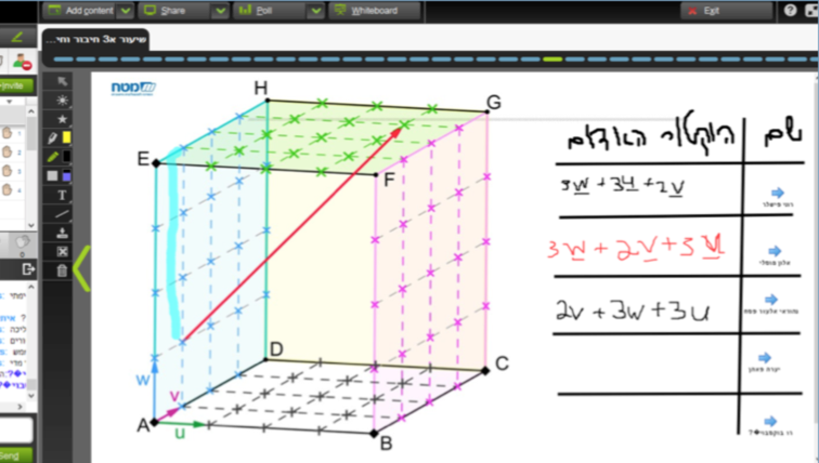
Figure 5: Dynamic software
Figure 5. The use of animated software that makes it possible to provide accurate construction and manipulation of geometric shapes
In addition to the above-mentioned tools and features that the VHS platform provides, there is also an integrated camera that allows the teacher and the students to see each other in a small frame in the corner of the screen. The student has a microphone that remains mute during the lesson unless the student speaks, asks or answers a question, takes part in a discussion, and so on. Importantly, one of the most distinguished aspects of the Israeli VHS is its transparency in teaching as all the classes are recorded and kept in an online repository. This online repository is open for all teachers, students, and tutors to listen to and view previously recorded lessons. Over and above, this transparency encourages a culture of collaboration and teamwork among and between teachers and tutors. In addition to the affordances embedded in the online repository of recorded lessons, teachers and tutors keep an online journal where they add their insights, queries, dilemmas, and teaching and pedagogical tips after each lesson thus creating and fostering a community of practice (Wenger, 1998).

Methodology

Participants
Eighty-six Grade-12 students who took advanced level mathematics and/or physics in the VHS in 2015 participated in the research. Forty-one were females; forty-five were males. Among the 86 students, 50 began their studies at the VHS in September 2012, which means they attended the VHS for three full school years. The rest had one or two years of learning experience within the VHS. The study also included 22 teachers (ten mathematics teachers and 12 physics teachers) that teach advanced-level mathematics or physics in the VHS.
In regard to the demographics, the VHS services a population of students that comes from diverse cultural and ethnic backgrounds. The student population comprised of 79% Jewish students, 8% Arab students, 3% Druze students, and 10% Bedouin students. Figure 6 reflects the students’ home schools, which in Israel are arranged according to ethnic and religious sectors.
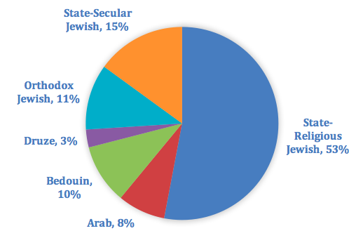
Figure 6: The VHS students according to sector
In regard to the different educational sectors that are highly diverse and disparate in Israel, Figure 6 reveals that whereas 53% of the students come from state-religious Jewish schools, 15% from State-Secular Jewish schools, and 11% from Orthodox Jewish schools, 21% of the students come from the different Arab sectors.
In addition, students enrolled in the VHS come from diverse geographical areas as shown in Figure 7.
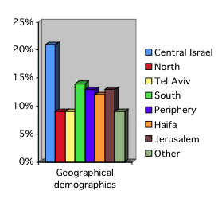
Figure 7: Geographical demographics
Figure 7: The VHS has students from all over Israel. Notably, about 50% of the student population comes from the north, south, periphery, and other areas in Israel.
In regard to the diversified socioeconomic background of the VHS students, it is important to note that the VHS has maintained a balanced distribution of high, middle, and low socioeconomic status (SES) levels that reflected the distribution in the general public as shown in Figure 8.

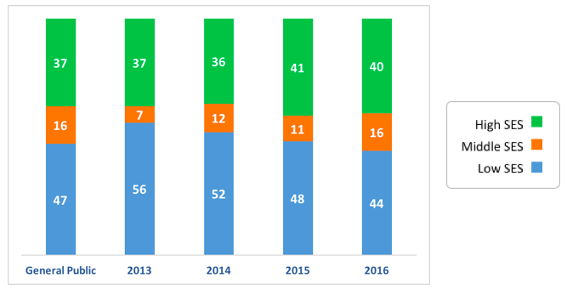
Figure 8: VHS students according to their family’s socioeconomic status (SES)
We now turn to the research questions attended to for the purpose of this paper.

Research Questions
This paper brings forth an extensive and ongoing research that is conducted on the teaching and learning in the Israeli VHS. Specifically, it focuses on several research questions pertaining to students’ and teachers’ perceptions of the VHS and describes the tools that were used to collect the data. The following questions were formulated:
- What are the students’ perceptions about virtual learning in general and the virtual high school in particular?
- What context-specific aspects do students highlight in their experience of the VHS and traditional learning environments?
- What are the teachers’ perceptions of their experiences in the VHS?
- What are the teachers’ perceptions of the affordances and challenges occasioned in the VHS?

Research Tools and Data Analysis

Students’ perspectives data collection
A variety of tools were used to collect data that will reflect the students’ perception of their experiences of the VHS. Data were collected through a questionnaire, student essays, and SWOT (explained in a later section). The survey questions were developed by the Research and Analysis Unit in the CET. The questions were formulated to collect students’ and teachers’ perceptions of the teacher-tutor format, the features of the LMS, and the teaching and learning tools available through the platform used by the VHS. The questionnaire was posted in Google Docs. It had 41 questions. Thirty-eight of the items in the survey were 5-point Likert-scale questions (1 indicating Strongly Disagree, 5 indicating Strongly Agree); three were open-ended questions. The Likert-scale questions focused on a wide range of aspects related to learning in a virtual environment in general and in the VHS in particular. Questions included reference to the year the student began his or her studies in the VHS, the class they took, the experience of learning in the VHS, aspects of the different available tools and modes of teaching, and their contribution to learning.
The three open-ended questions were the following:
- Looking back at your school years in the VHS, please note what things you were most pleased with.
- Please note the things you would like to see changed in the VHS. These can be recommendations to the VHS team as to the general treatment of students, the virtual meetings with the teacher, the tutoring, the homework, or any other aspect that you think is relevant.
- Some think that face-to-face learning is preferable to virtual learning in preparing students for the future. Others believe that virtual learning is necessary to prepare students for the job market. What is your opinion?
The combination of Likert-type questions and open-ended questions was aimed to garner deeper insights about learning in the VHS from the students’ perspectives. As is acceptable in studies that rely on qualitative and quantitative analyses of data, the students’ responses to the Likert-type questions were analyzed with descriptive statistics. The responses to the open-ended questions were analyzed using inductive analysis in order to identify key themes (Patton, 2002) and typical patterns (Bogdan & Biklen, 1982).
Students’ essays on what it means to be a virtual student in a VHS were another data source. Students were encouraged to share their experience of learning in the VHS and their thoughts of the differences between virtual learning and face-to-face learning. Eight essays were submitted and analyzed.
In addition, data included fully recorded synchronous lessons from the VHS repository of lessons. As noted before, the lessons in the VHS are recorded and are readily available to the VHS students as well as teachers and tutors. Furthermore, all homework assignments, solutions to the exams, and students’ tests are scanned and kept in the repository so that they are readily available to the students’ teacher at any given moment. This repository of data is conducive to our efforts in better understanding the experiences of students and teachers in the VHS.
In order to make sense of the data, we employed the SWOT analysis framework of Strengths, Weaknesses, Opportunities, and Threats. Historically, the SWOT analysis was put together in the second half of the 20th century by a group of researchers in the Harvard Business School (Chermack & Kasshanna, 2007) and has been since used as a research tool in various contexts (e.g., Westhues, Lafrance, & Schmidt, 2001). We imported the SWOT analysis framework for the purpose of this study in order to construct a legible picture of what the VHS offers and how it is experienced.

Teachers’ perspectives data collection
A variety of both quantitative and qualitative tools were used to compile data on teachers’ perspectives about their teaching in the VHS. A questionnaire that comprised 45 Likert-type questions and 10 open-ended questions was administered to the teachers through email. Globally, the questionnaire aimed to explore the teachers’ perspectives on a variety of aspects associated with online teaching in general and with teaching in the VHS in particular. The closed-ended questions mostly pertained to the extent of utilization of the tools and features available to the teachers in the VHS, as well as to general details about the teacher’s seniority and number of years teaching, his or her process of becoming an online teacher, their use of teaching tools and techniques, and their perspectives on the virtual infrastructure and the VHS’s model of instruction. Additional sources of data such as field notes collected throughout the years of operation of the VHS, as well as notes from the end-of-year pedagogical development day were also included. Similar to the students’ perspectives, recurrent themes emerging from the qualitative data were organized using the SWOT analysis framework.
Some open-ended questions that were given to the teachers included:
- From your point of view, what was particularly successful this year?
- What was particularly difficult this year?
- What helps you advance the students?
- What teaching techniques and tools are missing in your instructional field?
- Do you attempt to increase your students’ motivation and to improve their confidence in being able to succeed? If so, in what ways do you act to accomplish these goals?

Results and Discussion

Students’ Perspectives
The questionnaire included several topics that could provide some insights as to what students thought about the subject they chose to learn in the VHS, the teaching and learning process, their academic achievements in the VHS, the usefulness of the learning tools in the VHS, and the content of the subject learned. In light of the extent of the questionnaire, we chose to focus on selected statements in each of the topics. The selection of the statements was done to provide more insights about the teaching and learning model employed in the VHS as they were perceived by the students. Students’ positions were collected through a five-point Likert-type scale (from 1=strongly disagree to 5=strongly agree). Table 1 illustrates students’ perspectives about the instructional resources in the VHS while Table 2 shows the extent of usefulness students attribute to the available teaching and learning tools in the VHS. Table 3 illustrates students’ general perceptions about learning in a virtual environment.
Table 1 shows that while the majority of students reported that the VHS prepared them well for the advanced level mathematics and/or physics matriculation exams and that they understood the content taught by the teacher, 26% and 33%, respectively, did not think the course they took prepared them well for the matriculation exam or that they understood the content taught by the teacher. Interestingly, the tutoring sessions was especially appreciated in helping students understand material and address difficulties because the percentage of students who expressed some level of dissatisfaction in relation to learning with the teacher decreased to about 15%. This finding indicates that the unique structure in the VHS of working with tutors is effective in providing the support students need in learning in the VHS as it mitigates difficulties students may experience understanding the content when they learn with the teacher in the larger group. In regard to homework, the question pertaining to the efficacy of homework in improving achievement had a comparatively lower average agreement rate of 3.62. In fact, while about 60% of the students reported that they thought homework helped them better understand the material at hand, 40% of the students believed it did not. As well, the question pertaining to garnering a meaningful experience from learning with students from all over Israel had an average agreement of 3.52. That is, 47% of the students did not believe they benefited from learning with students from other locations. These results may indicate that there is a need to attend to the contribution of homework to the learning of advanced mathematics and physics in the VHS and to the added value in forging student-student connections within the VHS. We now turn to the students’ perceptions of the available tools in the VHS as shown in Table 2.

Table 1. Students’ Likert-type rating of their perceptions of the teaching and learning
in the VHS (n=86) (Numbers in the top row indicate Likert scale response)
Statement | 1 | 2 | 3 | 4 | 5 | Mean | Standard Deviation
The VHS prepared me well for the matriculation exam | 0 | 4 | 19 | 35 | 28 | 4.01 | 0.86
I understood the content taught by the teacher | 1 | 8 | 20 | 34 | 23 | 3.81 | 0.98
Tutoring helped me to better understand the material at hand | 1 | 4 | 9 | 22 | 50 | 4.35 | 0.93
Tutoring addressed the difficulties I was experiencing | 2 | 4 | 7 | 28 | 45 | 4.28 | 0.97
Homework in the VHS is treated more seriously than in traditional classes | 7 | 6 | 13 | 25 | 35 | 3.87 | 1.25
Homework helped me better understand the material at hand and improve my achievements* | 5 | 8 | 21 | 31 | 20 | 3.62 | 1.12
Learning with students from other locations in Israel was a meaningful experience for me* | 6 | 14 | 20 | 20 | 25 | 3.52 | 1.27
*n=85
Table 2. Students’ Likert-type rating of their perceptions of the available tools in the VHS (n=85) (Numbers in the top row indicate Likert scale response)
Statement | 1 | 2 | 3 | 4 | 5 | Mean | Standard Deviation
PowerPoint Presentations | 1 | 4 | 16 | 38 | 26 | 3.99 | 0.89
Recorded lessons | 9 | 14 | 13 | 23 | 26 | 3.51 | 1.36
Geogebra and dynamic simulations | 11 | 21 | 30 | 14 | 9 | 2.87 | 1.16
Writing and speaking tools in the synchronic environment (chat, voting, writing) | 2 | 2 | 20 | 29 | 32 | 4.02 | 0.96
Virtual labs (for students of physics)* | 2 | 5 | 8 | 11 | 11 | 3.65 | 1.21
*n=37 as this question applied only to those who took physics in the VHS
Table 2 shows that, overall, the students felt that the available tools in the VHS helped them learn the advanced mathematics and physics. Note specifically the 75% and the 72% of students who reported that the PowerPoint presentations and the available tools of interaction, respectively, were perceived as contributing to their experience learning in the VHS. While students note that they learned most from the PowerPoint presentations, the results reveal that fewer students (58%) took advantage of the recorded lessons accumulated in the repository. This may indicate a need to demonstrate the potential benefits of using the repository to remind students of this available tool and how they may use it. Notably, the difference in the efficient use of dynamic simulations such as Geogebra and virtual labs can be attributed to between-teachers’ differences in teaching styles. This is an important finding as more attention needs to be put in providing guidance and support to the VHS teachers to increase the utilization of the dynamic tools that the platform offers. The contribution of the interactive tools available in the VHS indicates a cohesive cluster of satisfied students who see these tools are effective in contributing to their learning in the VHS.
Table 3. Students’ Likert-type rating of their perceptions of learning in the VHS (n=86) (Numbers in the top row indicate Likert scale response)
Statement | 1 | 2 | 3 | 4 | 5 | Mean | Standard Deviation
If I had a chance, I would prefer to learn the subject at my home school | 8 | 13 | 18 | 25 | 22 | 3.47 | 1.28
If I had a chance, I would learn more subjects in the VHS | 15 | 23 | 19 | 13 | 16 | 2.91 | 1.37
While learning in the VHS, I have acquired skills that are vital for the job market* | 3 | 7 | 29 | 29 | 17 | 3.59 | 1.02
I will encourage others to take a course at the VHS* | 4 | 9 | 17 | 24 | 31 | 3.81 | 1.18
I recommend every high school student takes a course at the VHS* | 6 | 19 | 24 | 15 | 21 | 3.31 | 1.26
I am pleased with my joining the VHS | 3 | 4 | 17 | 25 | 37 | 4.03 | 1.07
*n=85
Table 3 reveals students’ perceptions of learning in the VHS. While the majority (72%) of the students expressed satisfaction with studying in the VHS, 46% of them wished they could take the course in their respective home schools. Indeed, while 33% of the students expressed interest in taking another course in the VHS, the majority of them (67%) reported that given a chance, they would not take another course at the VHS. Specifically, we noted a wider span of students’ responses in the questions relating to their choice of learning in the VHS or recommending it to others. Whereas 64% of the students reported that they would encourage others to take courses at the VHS, only 42% noted they would recommend everyone (italics added) take courses in the VHS. This may indicate an interesting phenomenon as the latter specifically relates the possibility of having every (italics added) student take a course at the VHS. In regard to applying skills beyond the purposes of the courses taken in the VHS, students were divided in almost in half. One half of the students noted that they have learned skills they deemed useful for the job market; however, the other half noted that they did not deem the skills they have acquired in the VHS as essential for their future careers. These results may indicate some potential challenges with students maximizing a somewhat new, unfamiliar learning environment. Further research may shed light on these challenges and potentially help identify additional supporting mechanisms that students may need.
Table 4. Students’ Likert-type rating of their level of satisfaction in the VHS (n=86)
(Numbers in the top row indicate Likert scale response)
Statement | 1 | 2 | 3 | 4 | 5 | Mean | Standard Deviation
I am pleased with my achievements in the subject I chose to learn in the VHS | 3 | 5 | 21 | 30 | 27 | 3.85 | 1.05
I think I can do well on the matriculation exam in the subject I chose | 0 | 3 | 15 | 42 | 26 | 4.06 | 0.79
My achievements in the VHS reflect my utmost efforts | 5 | 15 | 25 | 22 | 19 | 3.41 | 1.18

Table 4 demonstrates students’ levels of satisfaction of their achievements in the VHS, their expectations of succeeding in the matriculation examination in advanced level mathematics and physics, and their perceptions of maximizing learning in the VHS. While the majority of students report a high satisfaction with the VHS, some report that their level of satisfaction is not maximized. That being said, overall, students’ expectations to succeed in the matriculation examinations are high. It seems that the diverse answers can be further explored through garnering additional input from the students that may shed light onto the factors that may hinder their satisfaction of the subject they chose to learn in the VHS.
To corroborate our understanding of students’ perspectives of the VHS, an analysis was conducted of students’ essays and their responses to the following two open-ended questions:
- Looking back at your school years in the VHS, please note what things you were most pleased with.
- Please note the things you would like to see changed in the VHS. These can be recommendations to the VHS team as to the general treatment of students, the virtual meetings with the teacher, the tutoring, the homework, or any other aspect that you think of.
Students’ responses were categorized into the SWOT framework. We then noticed that each of these categories generated three subcategories. Table 5 shows the different categories and provides statements from students’ input.
Table 5 demonstrates what strengths and opportunities versus weaknesses and threats the students attribute to learning in the VHS. In regard to the open-ended question, recurring themes that were framed as strengths and opportunities pertain to the high quality of teaching in the advanced-level mathematics and physics taught in the VHS, the advanced technology that the platform offered in learning the advanced-level courses, and the sense of the collective unit pride the students felt by attribution. In identifying recurring themes that pertain to weaknesses and threats, three main themes emerged. One was the issue of homework—heavy load and technical problems in submitting them electronically on a regular basis—the other was the challenge of using digital technology for long stretches of time, and the third the lack of school support and technological problems that were caused due to inadequate equipment. We find that these findings add important insights as to the VHS context-dependent challenges to be addressed and the affordances to be fostered.

Table 5: Analysis of students’ written input using the SWOT model
Category |  | Statement
Strengths and Opportunities | The quality of the teaching staff (teacher and tutor) and teaching practices | - The teacher taught us in a way that makes it difficult to forget even after graduation, which allows us to understand everything in depth. The tutor was phenomenal. The way solutions were explained and the investment in making sure we do well and the solutions of exercises in addition to those presented in the lesson.  - Learning in small groups so that you get personalized attention, taking homework seriously and giving constructive and to-the-point feedback on your homework
Strengths and Opportunities | Technology and teaching materials | - No matter where you are, you can log on and simply attend the class even when you are sick at home or on a trip (with a laptop), and the lessons are recorded so that you can make up for missed material or refresh your knowledge  - The use of advanced programs, like Geogebra, that help in better understanding the material
Strengths and Opportunities | Unit pride | - The opportunity to get to know amazing teachers and new friends that I would have never met were it not for the course at the VHS  - I am most pleased with the exposure to scientific environment that my home school does not provide
Weaknesses and Threats | Homework (heavy load, technical difficulties uploading assignments electronically | - The way we had to submit homework was very frustrating. Each exercise had to be written in an orderly manner, scanned, and submitted with so many technical problems in the process
Weaknesses and Threats | The management of the lesson and the tutorial | - I wish the lessons were more to the point so that students would be fully engaged because it’s very easy to lose your concentration when you sit at the computer
Weaknesses and Threats | Technology and the learning environment | - Put more emphasis on the responsibility schools have to provide an adequate learning environment such as computers and quiet classes to their students

While the strengths and opportunities highlight the positive aspects of the experiences of the VHS students that can also be built upon in times of increased pressure to work, the weaknesses and threats identified as such can be catalysts to identifying ways to redress emerging problems or to change pedagogical practices. For example, teachers may want to consider allowing students to submit group work or author and construct their own mathematical problems as group projects. This may not only mitigate the pressure associated with the heavy workload in the VHS, but also contribute to the sense of unit pride that has been positively viewed among some students.
In regard to the following open-ended question: Some students think that face-to-face learning is preferable to virtual learning in preparing students for the future. Others believe that virtual learning is necessary to prepare students for the job market. What is your opinion? Students’ responses were categorized into three groups: 1. Strong preference to face-to-face learning; 2. A combination of face-to-face and virtual learning; 3. Strong preference to virtual learning, Table 6 illustrates the three categories and an example for each is provided from the data.
Table 6. Learning virtually versus face-to-face
Category | Students’ statements
Strong preference to face-to-face learning | - I think that the interactions among the students and between the students and the teacher are very important and it’s far easier to manage a face-to-face discussion when you have multiple participants, this is why I think that face-to-face lessons are irreplaceable
A combination of face-to-face and virtual learning | - On the one hand, learning in a virtual environment is very convenient. If I missed a lesson, it’s recorded. There is an organized repository of the whole material. On the other hand, if I find something difficult to understand, I have no one to turn to for explanations because I’m the only one from my homeschool enrolled in the VHS. In addition, it’s hard to learn about things that require tangible demonstrations (like labs…). However, thanks to the VHS, I developed habits of individual work and personal responsibility. After all, this is also important for the future.
Strong preference to virtual learning | - I see virtual learning as preferable to face-to-face learning because of the advantages it carries: 1. The student can go over recorded lessons for missed classes; 2. Extensive support and an experienced staff that is there for the student all the way; 3. It’s more convenient and allows to learn anywhere, anytime

The insights garnered from the students’ responses are useful as they provide input about the students’ beliefs about the utilization of each mode of rendering the material and thus can be used in directing and guiding students’ work toward their preferences in working with others.

Teachers’ Perspectives
Teachers’ perspectives in regard to their experience of the VHS were equally revealing. Data were collected through a questionnaire that was emailed to the teachers. Twenty-two out of 28 (79%) of the VHS’ teachers filled out the questionnaire and provided responses for analysis. In order to yield an initial impression of the teachers’ perspectives, we coalesced the responses into two groups: agreeing with the given statement versus disagreeing with the given statements.
Table 7 shows the percentage of teachers who selected Agree, Strongly Agree, or Very Strongly Agree.
Table 7. Percentage (n=22) of teachers who agree with statements regarding pedagogical tools and instructional experiences in the VHS
Statement | Percentage (%) of teachers who Agree/ Strongly Agree/ Very Strongly Agree
During the lesson, I allocate time for students’ questions | 91%
During the lesson, I lead discussions over problems and solutions | 77%
I notice which students are active during the lesson | 59%
During the lesson, I used virtual labs, simulations, videos, or dynamic applications available on the VHS website | 55%
I hear about students’ difficulties and advancements from the tutors | 64%
I am satisfied with the integration of the tutors as an inseparable part of the instructional team | 77%
I am satisfied with my work as a VHS teacher | 96%
I believe that my teaching in the VHS allows me to express my professional abilities | 82%

Notably, while 91% of the teachers noted that they allocate time for students’ questions during the synchronous lessons, 77% of them reported on leading discussions over problems and solutions, and only 59% noted that they gauge students’ engagement during the lesson. To increase teachers’ noticing of students’ engagement, it may be beneficial to elicit students’ input using the polling feature embedded in the platform and used by some of the VHS teachers on a regular basis.
In regard to using available tools, such as virtual labs, videos, and dynamic applications, only 55% of the teachers noted that they do so on a regular basis. This may reflect a need to provide added support and guidance to teachers in the utilization and the efficiency of using these tools. Such support may generate increased awareness of the affordances of the available tools and features that are embedded in the VHS platform or are readily available through the Internet. A principled utilization of available tools and features may substantially increase students’ awareness of the context-specific benefits of learning in the VHS that are not readily available in traditional classrooms and potentially maximize their utilization of the affordances the learning environment provides.
An important input in regard to working closely with the tutors, who are university students majoring in STEM-related fields, sheds light onto the unique component that the Israeli VHS provides to its students. As mentioned above, the VHS students themselves identify the tutoring sessions as paramount to their learning—more than their learning with the course teacher. While most of the teachers (77%) acknowledge the indispensable contribution of the tutors in providing the much needed support and help to the students, only 64% of them work closely with the tutors to discuss students’ progress, successes, and challenges. This may indicate a need to underscore the benefits of working in a principled manner with this extra manpower to ensure more effective learning of the material. Ongoing interaction between the teachers and the tutors builds upon the unique features that the Israeli VHS provides. All in all, the VHS teachers are satisfied with their role teaching in the VHS and in their professional resources.
The SWOT method was additionally used to organize and analyze the responses yielded from the open-ended questions and the field notes (Table 8).
Table 8. SWOT analysis of data collected from teachers
Main category | Sub-category | Representative statement
Strengths and opportunities | Fostering motivation and a can-do mindset among students | - “[I] foster a supportive atmosphere that encourages students to present their ideas, even if they are wrong, and discuss them.”
Strengths and opportunities | Developing awareness to the students | - “[I] sharpened my attentiveness and sensibility to the students especially because I do not see them.”
Strengths and opportunities | The design of and instruction in the VHS | - “The combination of teacher, tutor, coordinators, and administration gives a feeling that everything focuses on the students and their learning.”
Strengths and opportunities | Quality of instruction | - “I managed to reach accomplishments with some of the students that seemed impossible at the beginning of the year.”
Strengths and opportunities | Diversity of teaching methods | - “It’s important to recognize that each student sits in front of the computer during the lesson with an expectation for an opportunity to experience dynamic simulations”
Weaknesses & Threats | The interface between the different elements in the VHS program | - “Homeschools do not attend to the special needs of the VHS students: Classes remain locked, there is no technical support.”
Weaknesses & Threats | The teaching model in the VHS | - “Reviewing homework is done by tutors some of whom have no pedagogical experience, which can act against us.”
Weaknesses & Threats | The technological system | - “The technological system was not always stable. Sometimes it even crashed in the middle of a lesson, or was really slow at both my end and the students’.”

In organizing teachers’ responses into the SWOT’s framework of strengths, opportunities, weaknesses, and threats some themes emerged. A recurring theme among the teachers was the perception of the VHS environment as conducive to fostering motivation. Teachers noted that the structure and design of the VHS allowed them to pay close attention to the students and, in fact, get to know their students better than they do in a traditional classroom. The unique design of the VHS and the high quality of the teaching materials seem to be intertwined with increased awareness to the diversity in teaching tools and pedagogical practices.
In regard to the weaknesses and threats that were generated from the teachers’ input, it was found that teachers identified some difficulties with working with homeschools in light of problems allocating quiet spaces and problem-free equipment. A recurring theme was also teachers’ input concerning the need to ensure that the tutors gain some understanding of pedagogical practices before working with the high school students on mathematics and physics.
These findings shed light on the VHS teachers’ perspectives of the unique affordances and challenges that are associated with the VHS. Specifically, while the teachers find pride in working in such a technologically and pedagogically advanced environment, they underscore the need to work more closely with the tutors and to ensure maximized support to the students in the homeschools.

Conclusion
The Israeli VHS was launched to address two very specific needs in the educational system. One was the shortage of qualified teachers who could teach advanced level mathematics and physics in the peripheral areas of Israel; the second was that many schools simply did not open advanced level mathematics and physics classes due to the small number of students who were interested in taking such courses. Since it was launched, the Israeli VHS has been growing steadily providing the much-needed classes to students in remote areas and in schools that do not provide the courses. In order to gain insight as to the perspectives of students and teachers of their experiences of the VHS, data were collected and analyzed. Some of the data comprised students’ essays. While the analysis of the essays yielded important information about students’ experience of the VHS, given the small sample size of the essays collected (see Onwuegbuzie & Leech, 2005) we suggest that further research needs to be conducted to explore how students experience the structure, design, and support system of the VHS following the implementation of some solutions to challenges that were identified in this paper.
In this context, we have reported students’ perspectives on being a student in a VHS, as well as teachers’ perspectives on their work. Our data tell the story of students and teachers who are cognizant of the privileges and the advantages of the non-conventional, country-wide online classrooms, but who are also aware of the difficulties and potential for improvement. The use of technology not only allows for a variety of teaching methods through the use of different digital applications such as Geogebra and virtual labs, but also provides students with diverse ways of expression during lessons, tutorial sessions, and assignments—ways of expressions that are different than those allowed or practiced in traditional classrooms.
Similar to current knowledge of virtual education (Clark & Berge, 2003; Hughes et al., 2007), the students in the Israeli VHS reported that the school modeled high-quality teaching and that they felt supported by their teachers and tutors through the small-group sizes and individual care that was provided to them. Keeping in mind the objective of enhancing the number of students opting in for advanced mathematics classes, we are interested in identifying the very mechanisms that can contribute to the realization of this objective through the use of the technological tools employed by the VHS. A recurrent challenge that arose in both the students’ and teachers’ data is the context-specific difficulty of orchestrating online education with the students’ homeschools, as well as the technical and logistical challenges that come with conducting a virtual classroom. From the teachers’ data, it appears that there is space for growth in terms of utilizing all the virtual tools available to teachers, and fully exploring the advantages that characterize the online classroom compared to the traditional classroom. Future research would need to focus on the use of available tools by teachers, and how a more flexible and varied use of technology affects student performance. In addition, future research may yield a better understanding of how the learning of the professional community of teachers and tutors helps keep students motivated to take the advanced course in mathematics and physics.

Acknowledgement
The authors warmly acknowledge the Center for Educational Technology staff, students, and administration of the VHS.

References
Barbour, M. K. (2008). Secondary students’ perceptions of web-based learning. Quarterly Review of Distance Education, 9(4), 357-371.
Barbour, M. K. (2010). Researching K-12 online learning: What do we know and what should we examine? Distance Learning 7(2), 7-12.
Barbour, M. K. (2011). The promise and the reality: exploring virtual schooling in rural jurisdictions. Education in Rural Australia, 21(1), 1-15.
Barbour, M. K. (2017). K–12 online learning and school choice: Growth and expansion in the absence of evidence. In R. A. Fox & N. K. Buchanan (Eds.), The Wiley handbook of school choice (pp. 421-440). Hoboken, NJ: Wiley Blackwell. https://doi.org/10.1002/9781119082361.ch29
Barbour, M. K. Siko, J. P., & Simuel-Everage, K. (2013). Pictures from an exhibition... of online learning: A creative representation of qualitative data. The Qualitative Report, 18(23), 1-15.
Clark, T., & Berge, Z. (2003). Virtual schools and elearning: Planning for success. In Proceedings from the 19th Annual Conference on Distance Teaching and Learning. Retrieved from https://pdfs.semanticscholar.org/c949/3f2687230bbcb66b48175a17339c3d37ddf7.pdf
Blau, I., & Barak, A. (2009). Synchronous online discussions: Participation in a group audio conferencing and textual chat as affected by communicator’s personality characteristics and discussion topics. In CSEDU, the International Conference on Computer Supported Education (1), (pp. 19-24).
Bogdan, R. C., & Biklen, S. K. (1982). Qualitative research for education: An introduction to theory and methods. Boston: Allyn and Bacon, Inc.
Cazden, C. (2001). Classroom discourse: The language of teaching and learning. Portsmith, NH: Heinemann.
Cavanaugh, C., Gillan, K. J., Kromrey, J., Hess, M., & Blomeyer, R. (2004). The effects of distance education on K-12 student outcomes: A meta-analysis. Learning Point Associates/North Central Regional Educational Laboratory (NCREL).
Chermack, T. J., & Kasshanna, B. K. (2007). The use and misuse of SWOT analysis and implications for HRD professionals. Human Resource Development International, 10(4), 383-399. https://doi.org/10.1080/13678860701718760
Crean Davis, A., Gaines, J., Paul, A., & Rukobo, E. Z. (2014). Virtual learning program rubric. Philadelphia, PA: Center on Innovations in Learning.
Hughes, J. E., McLeod, S., Brown, R., Maeda, Y., & Choi, J. (2007). Academic achievement and perceptions of the learning environment in virtual and traditional secondary mathematics classrooms. The American Journal of Distance Education, 21(4), 199-214. https://doi.org/10.1080/08923640701595365
Murphy, E., Rodríguez‐Manzanares, M. A., & Barbour, M. (2011). Asynchronous and synchronous online teaching: Perspectives of Canadian high school distance education teachers. British Journal of Educational Technology, 42(4), 583-591. https://doi.org/10.1111/j.1467-8535.2010.01112.x
Onwuegbuzie, A. J., & Leech, N. L. (2005). The role of sampling in qualitative research. Academic Exchange Quarterly, 9(3), 280-285.
Patton, M. Q. (2002). Qualitative research and evaluation methods (3rd ed.). Thousand Oaks, CA: Sage
Picciano, A. G., Seaman, J., Shea, P., & Swan, K. (2012). Examining the extent and nature of online learning in American K-12 education: The research initiatives of the Alfred P. Sloan Foundation. The Internet and Higher Education, 15(2), 127-135. https://doi.org/10.1016/j.iheduc.2011.07.004
Rice, K. L. (2006). A comprehensive look at distance education in the K–12 context. Journal of Research on Technology in Education, 38(4), 425-448. https://doi.org/10.1080/15391523.2006.10782468
Rivera, J. C., & Rice, M. L. (2002). A comparison of student outcomes and satisfaction between traditional and web based course offerings. Online Journal of Distance Learning Administration, 5(3), 151-179.
Schlosser, L., & Simonson, M. (2002). Distance education: Definition and glossary of terms. Bloomington, IN: Association for Educational Communications and Technology.
Summers, J. J., Waigandt, A., & Whittaker, T. A. (2005). A comparison of student achievement and satisfaction in an online versus a traditional face-to-face statistics class. Innovative Higher Education, 29(3), 233-250. https://doi.org/10.1007/s10755-005-1938-x
Tunison, S., & Noonan, B. (2001). On-line learning: Secondary students’ first experience. Canadian Journal of Education/Revue Canadienne de l’Education, 495-511. https://doi.org/10.2307/1602179
Ungerleider, C. S., & Burns, T. C. (2003). A systematic review of the effectiveness and efficiency of networked ICT in education: A state of the field report to the Council of Ministers of Education, Canada and Industry Canada. Unpublished report.
Watson, J., Murin, A., Vashaw, L., Gemin, B., & Rapp, C. (2011). Keeping pace with K-12 online learning: An annual review of policy and practice, 2011. Evergreen Education Group.
Wenger, E. (1998). Communities of practice: Learning, meaning, and identity. Cambridge University Press. https://doi.org/10.1017/CBO9780511803932
Westhues, A., Lafrance, J., & Schmidt, G. (2001). A SWOT analysis of social work education in Canada. Social Work Education, 20(1), 35-56. https://doi.org/10.1080/02615470020028364

Biography
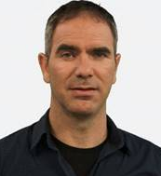
Yaniv Biton is Head of Mathematics Education at the Center for Educational Technology (CET), Tel Aviv, Israel. He also serves as mathematics teacher educator at the Shaanan Teachers’ College, Haifa, Israel. Dr. Biton’s research focuses on assessment and technology in mathematics education. Through his work with in- and pre-service teachers, he promotes effective and efficient integration of diverse innovative technologies in mathematics education. Dr. Biton has recently served as a mathematics teacher at the Israeli VHS that was launched by CET in 2012. He has co-authored several papers on the Israeli VHS, where he showcases the innovative pedagogical and technological design of this groundbreaking teaching and learning environment.


Sapir Fellus is a graduate of the Faculty of Health Sciences at the University of Ottawa and holds an Honours Bachelor of Health Sciences (BHSc). She has recently served as a research assistant in several ongoing research programs in medical sciences with a particular focus on women’s health and pregnancy-related research such as identification of molecular subclasses of preeclampsia (a hypertensive disorder of pregnancy) and obstetrical complications. Her interests include advancing medical education and promoting STEM education in high schools for all.


Dafna Raviv is Head of Science Education at the Center for Educational Technology (CET), Tel Aviv, Israel. She holds a PhD in Medical Science from Tel Aviv University. Dr. Raviv’s work focuses on promoting a sustainable integration of technology and pedagogy in various models including online teaching in the Israeli education system. She is the co-founder of CET’s online national campus for in-service professional development. She also served as the principal of CET's Virtual High School for STEM. As Head of Science Education at CET, Dr. Raviv is responsible for development and implementation of innovative programs in science education including printed and digital content for K-12.


Osnat Fellus is a PhD Candidate at the Faculty of Education, University of Ottawa. Her PhD work focuses on learning and teaching with a specific concentration in theories of identity in mathematics education and in learning English as an additional language. She has recently co-authored One is not born a mathematician: In conversation with Vasily Davydov where she discusses, together with her co-author Dr. Yaniv Biton, issues paramount to teaching and learning mathematics. Osnat currently serves as Editor of the AERA Educational Change SIG Lead the Change Series.

