Students’ Approaches to E-Learning: Analyzing Credit/Noncredit and High/Low Performers
Gwen Nugent* | University of Nebraska-Lincoln, Lincoln, NE, USA | gnugent@unl.edu
Ashu Guru | University of Nebraska-Lincoln, Lincoln, NE, USA | ashu.guru@unl.edu
Deana Namuth-Covert | The Ohio State University,  Wooster, OH, USA | namuth-covert.1@osu.edu
* Corresponding author

Abstract
Aim/Purpose | This study examines differences in credit and noncredit users’ learning and usage of the Plant Sciences E-Library (PASSEL, http://passel.unl.edu), a large international, open-source multidisciplinary learning object repository.
Background | Advances in online education are helping educators to meet the needs of formal academic credit students, as well as informal noncredit learners. Since online learning attracts learners with a wide variety of backgrounds and intentions, it is important understand learner behavior so that instructional resources can be designed to meet the diversity of learner motivations and needs.
Methodology | This research uses both descriptive statistics and cluster analysis. The descriptive statistics address the research question of how credit learners differ from noncredit learners in using an international e-library of learning objects. Cluster analysis identifies high and low credit/noncredit students based on their quiz scores and follow-up descriptive statistics to (a) differentiate their usage patterns and (b) help describe possible learning approaches (deep, surface, and strategic).
Contribution | This research is unique in its use of objective, web-tracking data and its novel use of clustering and descriptive analytic approaches to compare credit and noncredit learners’ online behavior of the same educational materials. It is also one of the first to begin to identify learning approaches of the noncredit learner.
Findings | Results showed that credit users scored higher on quizzes and spent more time on the online quizzes and lessons than did noncredit learners, suggesting their academic orientation. Similarly, high credit scorers spent more time on individual lessons and quizzes than did the low scorers. The most striking difference among noncredit learners was in session times, with the low scorers spending more time in a session, suggesting more browsing behavior. Results were used to develop learner profiles for the four groups (high/low quiz scorers x credit/noncredit).
Recommendations for Practitioners | These results provide preliminary insight for instructors or instructional designers. For example, low scoring credit students are spending a reasonable amount of time on a lesson but still score low on the quiz. Results suggest that they may need more online scaffolding or auto-generated guidance, such as the availability of relevant animations or the need to review certain parts of a lesson based on questions missed.
Recommendations  for Researchers | The study showed the value of objective, web-tracking data and novel use of clustering and descriptive analytic approaches to compare different types of learners. One conclusion of the study was that this web-tracking data be combined with student self-report data to provide more validation of results. Another conclusion was that demographic data from noncredit learners could be instrumental in further refining learning approaches for noncredit learners.
Impact on Society | Learning object repositories, online courses, blended courses, and MOOCs often provide learners the option of moving freely among educational content, choosing not only topics of interest but also formats of material they feel will advance their learning. Since online learning is becoming more prolific and attracts learners with a wide variety of backgrounds and intentions, these results show the importance of understanding learner behavior so that e-learning instructional resources can be designed to meet the diversity of learner motivations and needs.
Future Research | Future research should combine web-tracking data with student self-report to provide more validation of results. In addition, collection of demographic data and disaggregation of noncredit student usage motivations would help further refining learning approaches for this growing population of online users.
Keywords | learning object repository, learning approaches, noncredit learners, cluster analysis, web-tracking data

Introduction
Learning object repositories, online courses, blended courses, and MOOCs often provide learners the option of moving freely among educational content, choosing not only topics of interest but also formats of material they feel will advance their learning. Since online learning attracts learners with a wide variety of backgrounds and intentions, it is important to understand learner behavior so that e-learning instructional resources can be designed to meet the diversity of learner motivations and needs. Advances in online education are helping educators to meet the needs of formal academic credit students and informal noncredit learners, as well as targeting instructional needs of high versus low performers. Researchers have examined a variety of differentiated learner behaviors or characteristics of students participating in online learning. For example, research has shown that there are distinct differences between credit learners (those working towards an academic certificate or degree) and noncredit learners (those using online learning to advance their own understanding). In an online humanities course where some participants were working towards academic credit and others were taking it more like a MOOC for noncredit, the academic credit students earned significantly higher final grades (Almeda et al., 2018). Kursun (2016) found online credit students scored significantly higher on quizzes, intrinsic and extrinsic goal orientation, and perception of course value. Extrinsic goal orientation refers to the degree to which a learner is focused on obtaining rewards, grades, or positive evaluation from others. Intrinsic orientation involves the learner’s participation in an activity for reasons such as self-driven challenge, curiosity, or mastery (Pintrich, Smith, García, & McKeachie, 1991).
Other research has identified classifications of learners based on their patterns of engagement with video lectures and assessments (Kizilcec, Piech, & Schneider, 2013). The researchers classified these MOOC (Massive Open Online Courses) participants as completing, auditing, disengaging, and sampling. Completing learners are those who complete the majority of assessments; auditing are those who did assessments infrequently or at all; disengaging are those who did early assessments but then had a marked decrease in engagement; and sampling are those whose engagement with course materials was only evident early in the class. Research using both e-learning usage logs (Akçapınar, 2016) and self-report use of e-learning materials (Speth, Lee, & Hain., 2006; Speth, Namuth, & Lee 2007) has shown that academic students can be categorized as deep, strategic or surface. In the deep approach, the learner actively attempts to understand the material for the knowledge gain whereas in a surface approach the learner takes a passive participation to barely fulfill the academic or knowledge requirements (Biggs, 1987; Entwistle, 1977; Entwistle & Ramsden, 2015; Marton & Säljö, 1976). In a strategic approach, the learner takes an organized approach where the motivation is to score higher in assessments; learners modify their learning behavior based upon the assessment requirements (Gordon & Debus, 2002). In a noncredit situation, learners modify their learning behavior based on personal goals or external motivation for learning the material.
Student time on task in traditional face-to-face courses has historically been considered an important prerequisite for successful learning (Bransford, Brown, & Cocking, 2000; Stallings, 1980). Time variables also represent evidence of student engagement and effort with the material, which have been shown to be related to student learning in online courses (Kim, Park, Cozart, & Lee, 2015; Puzziferro, 2008). Previous research has examined student use of time across various MOOC course components, finding little use of discussion and most time spent on lecture videos (Breslow et al., 2013). Other research with learning object repositories found that most user time was spent on lessons, followed by animations and quizzes (Nugent et al., 2017). Time spent on quizzes (whether a score is part of a grade or the learner is using the quiz to self-assess knowledge) can also be considered a reflection of effort since the quiz is the element with the most overt connection to learning. A study examining the predictive levels of demographic, motivational, and usage data found that interaction with assessments was one of the few significant and consistent usage predictors of learning (Miller, Soh, Samal, Kupzyk, & Nugent, 2015). While understanding student and learner perceptions and uses of online education materials is important, little research literature exists regarding broader academic student outcomes in agriculture sciences that result from using these electronic education tools (Vickrey, Golick, & Stains, 2018). Even less is known for noncredit learners as most studies focus on course completion data (Albelbisi, Yusop, & Mohd Salleh, 2018).
In addition to considering learning approaches by credit and noncredit students, it is also important to consider the variety of ways online learning tools and materials are utilized. For example, learning object repositories contain small, portable educational materials that individually focus on a single learning objective and can be used in diverse educational settings including face-to-face courses/educational events, completely online offerings or a mixture (Koutsomitropoulos & Solomou, 2018; Namuth, Fritz, King, & Boren, 2005; Nugent et al., 2016; Simpson, 2016;). An entire course can also be completely online or a mixture of both online and face-to-face components (hybrid-delivered). In a pilot study addressing baseline statistics knowledge required of graduate level social work students, Davis and Mirick (2017) compared results of credit students who took a traditional full semester-long face-to-face course with credit students who took a shortened non-credit hybrid course. Results showed no significant differences in student statistical abilities, anxiety towards statistics, or belief about the importance of statistics in the social work profession.
The objective of this study is to examine differences in credit and noncredit users’ learning and usage of the Plant Sciences E-Library (PASSEL, http://passel.unl.edu), a large international, open-source multidisciplinary learning object repository. The primary study focus is on these usage differences, but secondary analyses identify and differentiate subpopulations of learners who scored high or low on quizzes.
Research questions were the following:
(1) What is the difference in usage of online instructional materials by credit and noncredit learners?
(2) What are the differences in usage between high and low quiz scoring credit and noncredit students?
(3) What learning approaches are being used by high quiz scoring credit and noncredit students? By low quiz scoring credit and noncredit students?
This paper will describe the e-learning repository content and outline the methodological and data collection/analysis approaches. Results comparing on-line learner behavior of credit and noncredit learners will be presented, along with cluster analysis results comparing high and low performers. The discussion section elaborates on these differences and suggests learning approaches for each of the four learner categories: a) high performing noncredit, b) low performing noncredit, c) high performing credit, and d) low performing credit. Finally, the summary and conclusions section outlines the contribution to the literature in this field, discusses limitations, and provided recommendations for both practitioners and researchers.

Methods

Research Approach
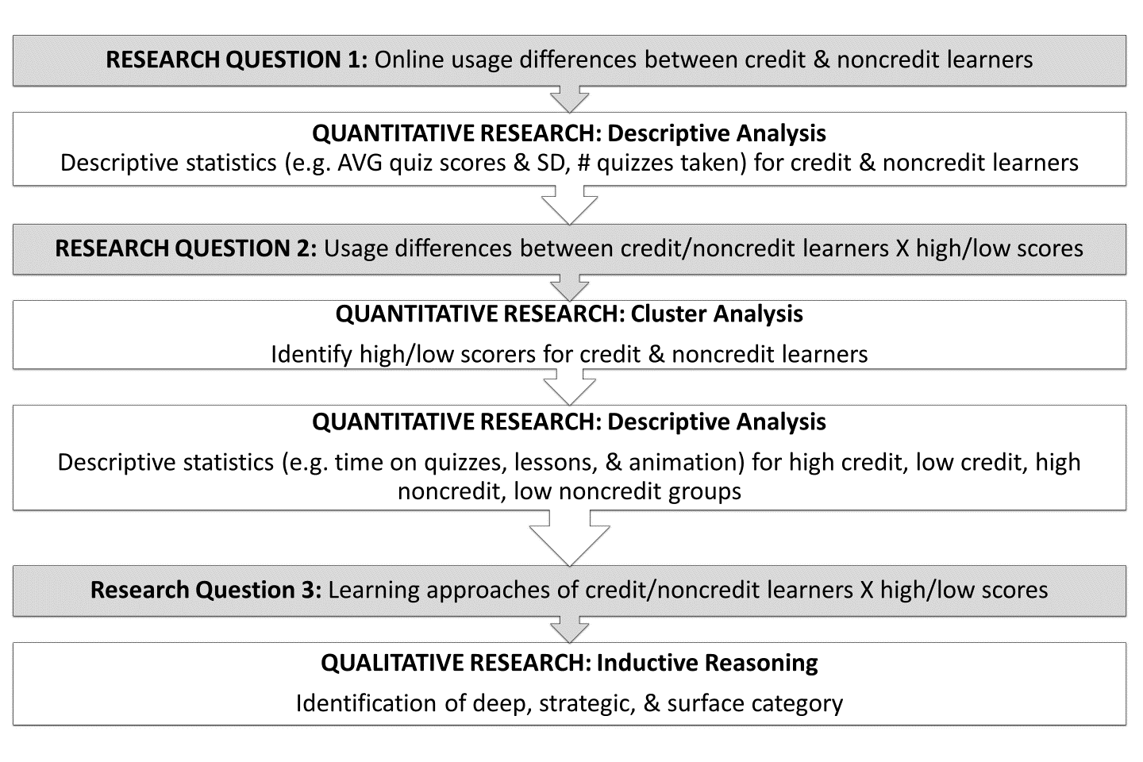
Figure 1. Flowchart of methods/approach
This research uses descriptive statistics to address the primary research question of how credit learners differ from noncredit learners in using an international e-library of learning objects. The study also uses cluster analysis to identify high and low credit/noncredit students based on their quiz scores and follow-up descriptive statistics to differentiate their usage patterns and to help describe possible learning approaches (deep, surface, and strategic). A flowchart showing the methods/approach is found in Figure 1.

E-Learning Repository Context
This research was conducted with an established learning object repository, the Plant and Soil Sciences eLibrary^{PRO} (PASSEL) (http://passel.unl.edu). This collection of short lessons, quiz banks, illustrative animations, and video clips has been used globally since 1999 in illustrating complex, applied scientific concepts to a variety of learners in academic settings as well as personal enrichment. Built using Open Source Technologies, PASSEL is the result of collaborations across several academic institutions and nonprofit and industry partners. Some of these include U.S. land grant universities such as University of Nebraska, The Ohio State University, Colorado State University, New Mexico State University, and Montana State University. Examples of international institutions and nonprofits include Universidad de Costa Rica, Salinas de Hgo, SLP, Mexico, Mykolayiv National Agrarian University, and the CGIAR Generation Challenge Programme–Integrated Breeding Platform. Two agricultural industry partners are Pioneer and Monsanto. Funding has been provided from sources such as American Distance Education Consortium, U.S. Department of Agriculture, and National Science Foundation. At the outset, content lesson authors recognized some of their learners required basic, introductory materials while others were ready for more advanced instruction. In addition, the educational goals of potential learners to the site vary considerably. Some learners could be at the high school level, others seek formal, academic credits to apply towards a graduate degree program or professional certification, and still others may simply be curious about a given subject area. Therefore, the learning object approach afforded the greatest flexibility in addressing this wide scope of learner needs.
At the time of the data analysis described later in this paper, PASSEL had 13 collaborating U.S./international universities, 131 lessons, and 128 animations. It operates under learner control, so that each student can spend as much time as required to reach mastery, as determined by a quiz score or one’s own internal confidence. Since the PASSEL database represents a rich learning environment that involves multiple topics, use in multiple courses, and use by a variety of international student and professional audiences, it represents an ideal source to study and characterize learner usage behaviors.

Data Collection Procedures
This research study used web-tracking data to address differences between credit and noncredit learners and between students scoring high and low on the quizzes. The study received institutional review board approval as a secondary data analysis. Usage was determined through time spent with the online material. Key variables analyzed in the research included time spent in an online session, as well as time spent with various content modality materials:
- Lessons: text plus pictures, discussion questions, and videos
- Glossary (hyperlinks)
- Animations (dynamic visuals with text showing relationships and processes)
- Quizzes
The PASSEL e-learning platform maintained logs of activity by recording data about learner clicks while the learner was logged in and using the platform. This study explores trace data (816,979 log entries) obtained from 803 registered users of the PASSEL repository for approximately 4.5 years from August 2010 through February 2015. Registered users had access to all PASSEL learning materials, including quizzes. Users accessed the material using a web browser (Google Chrome, Mozilla Firefox, Internet Explorer, etc.) connected to the Internet. The user access logs contain a time stamp, session identifier, a user identifier, and a text string, which is the web browser GET request to the web server. Parsing the GET string allowed extraction of the type and identifier of learning material accessed (e.g., lesson page, animation, glossary, and quiz question). In essence, this log maintained user data about every mouse click that loaded a new material in a user’s web browser. When a user was not in an active session, a new session identifier was used for logging during a learning session. The assigned session identifier was removed when the web browser was closed.
For purposes of this study, we categorized archived learner data as either credit learner or noncredit learner based upon the PASSEL class or community the user was enrolled in. A credit learner was someone who was enrolled in a college academic credit course that was utilizing the PASSEL resource. This could be an undergraduate or a graduate level course. Data were unavailable to know exactly how each academic course instructor chose to use the PASSEL materials, but we know from informal conversations that it varied widely, including:
- Providing students with a list of PASSEL learning objects to use simply as supplemental material (so not required of students);
- Using as practice quizzes, of which select questions would be used in graded quizzes;
- Using PASSEL quizzes as a certain percentage of the students’ course grade. Even when PASSEL quizzes were requirements of a student’s grade, most of the time students were given unlimited quiz tries and time to complete them in order to reach their desired score. Quizzes typically contain 10 multiple choice questions, drawing from quiz banks to allow students to see different questions each time they take a quiz.
A noncredit learner was someone who was not enrolled in an academic credit-leading course. These learners also varied greatly. They represented those participating in a professional development training (possibly to earn continuing education credit towards a professional license or even a simple certificate of completion). Other noncredit learning uses could include an instructor testing materials for possible use in a course they teach (credit or noncredit). Additional examples could be professionals looking for explanations on a science principle to help them with a challenge faced on their job, a student researching a concept for a class project, or someone merely interested in a topic for self-learning.
Classes or learning communities which were known to have both credit and noncredit learners were not included in this study, due to anonymity of individual student data and therefore inability to separate them based on credit-pursuing goals or lack thereof.

Data Analysis
Two different analysis approaches were used in this study. First, descriptive statistical analysis was done at a macro level to explore the online usage behavior of learners and define the baseline for the two types of learners (credit and noncredit). Looking at these two groups distinctly allows us to generalize our findings at the level of credit and noncredit learners and compare the overall differences between the two groups, addressing the first research question. Descriptive statistics were computed from the user logs for the time credit and noncredit learners spent in a session, lesson, animation, glossary, and quiz. Graphs of the time spent on task distributions were skewed by a very few large estimates (i.e., minutes), which we suspected represented learners taking a break and walking away from the computer. To account for this occurrence, median times are reported rather than averages. We also computed statistics for each learner average quiz score and number of quizzes taken.
Further, both credit and noncredit user groups were subdivided into clusters of learners based upon quiz performance measures (i.e., high quiz scores and low quiz scores). Clustering approaches for partitioning learners have been successfully used in past research to discover patterns reflecting user behaviors such as starting and replying to discussion forum threads and participating in chats (Talavera & Gaudioso, 2004), recognizing learner detrimental learning behaviors (Amershi & Conati, 2006), and identifying completing, auditing, disengaging, and sampling learners in MOOCs (Kizilcec et al., 2013). Talavera and Gaudioso (2004) focused on using clustering techniques for identifying patterns in collaborative behavior among learners using an online learning platform; Amershi and Conati (2006) used clustering for adaptive support for learner interaction with the online system. Kizilcec et al. (2013) used longitudinal patterns of engagement using video lectures and assessments as features to cluster engagement trajectories of learners.
We employed a widely used clustering algorithm known as k-means (Madhulatha, 2012) which identifies a given number of k clusters by minimizing the distance measure of the n-dimensional features. In our dataset, we used average quiz score, quiz score standard deviation, total number of quizzes taken, and number distinct lessons where the quiz came from for each learner recorded in PASSEL as clustering features. Using average quiz score and score standard deviation as features for clustering ensured grouping PASSEL users based on similar quiz scores and variability; adding the total number of quizzes enabled clustering learners who had similar number of quizzes from unique lessons. Since we could represent only three variables on the 3D diagram, we selected to use number of quizzes as the metric for visualization. This decision is supported by the moderately high (.59) correlation between the number of lessons and total number of quizzes.
The k value (number of clusters) was determined a priori by visually inspecting the k clusters by incrementing the values of k and qualitatively observing the k clusters. However, the qualitative method involves ambiguity and subjectivity. We used a common method, called the elbow method, to remove this subjectivity (Madhulatha, 2012). The simple idea behind the elbow method is to incrementally increase the value of k and for each incremental value compute the sum of squared error (SSE) between each member of the cluster and the cluster centroid. Plotting SSE against k will decrease the value of SSE as k is increased. At a certain value of k, the marginal decrease in the SSE will be very low and the curve will display an elbow effect. One may select the value of k at the hinge of the elbow. In this study, our goal was to choose a small value of k that has a low SSE. Figure 2 shows that while the method is not perfect and is prone to heuristic processes, one can definitely see a flattening out near eight clusters, and the elbow starting near eight clusters represents where we selected that the dataset has diminishing returns by increasing k.
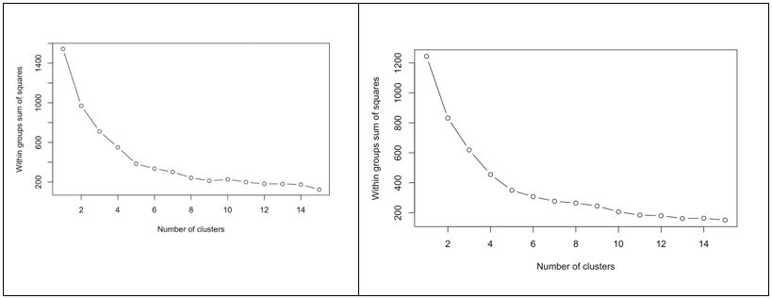
Figure 2. Sum of squared error plotted for the noncredit dataset (left)
and credit dataset right) with the mean quiz score, score standard deviation,
and total number of quizzes taken as data features.
Separate cluster analyses were run for credit and noncredit learners to identify high and low quiz scoring clusters. Finally, we used usage descriptive statistics for these high/low clusters to address research question 2 and as the basis to develop learning approach profiles (research question 3).

Results

Descriptive Statistics for Credit/Noncredit
In the first steps of analyzing the historic 816,979 log entries from 803 users, those who never took a quiz were removed, leaving 518 users with useable data. Next, descriptive analytics were run to gain an overall understanding of learner time spent on key learning objects, as well as quiz scores, to indicate an estimated measure of knowledge obtained. Table 1 presents overall descriptive statistics for credit and noncredit learners; there are 186 credit individuals and 332 noncredit. The table indicates each group’s average score and standard deviation on all quizzes they took. Also notice the median time each group spent in a session (from time user logged on until logged off), as well as median time on animations, glossary words, within lesson text pages and taking a quiz. Finally, the table indicates the number of quizzes taken by individuals within each group, which could be taking the same quiz multiple times or taking multiple quizzes a single time.
Table 1. Credit versus noncredit usage – Descriptive analysis
Cate-gory | n | Average Score / Standard Deviation (%) | Session Median (minutes) | Animation Median (minutes) | Glossary Median (minutes) | Lesson Median (minutes) | Quiz Median (minutes) | Number Quizzes Taken | Number Modules / Standard Deviation
Credit | 186 | 53.16 / 13.53 | 9.8 | 6.60 | .11 | 15.88 | 15.43 | 27.31 | 8.25 / 7.84
Non-credit | 332 | 44.31 / 10.69 | 18.93 | 8.37 | .13 | 11.38 | 13.88 | 9.49 | 3.54 / 4.55

In comparing credit versus noncredit users’ overall statistics, we find that credit students scored higher on quizzes (53%) than noncredit (44%), took quizzes more times (27 versus 9), and spent more time on lessons (15.88 min versus 11.38 min) and quizzes (15.43 min versus 13.88 min). However, noncredit spent much longer in a session (18.93 min) and more time in an animation (8.37 min). Neither group significantly used the glossary (only 0.1 min). To clarify, in general a session median length is 9.8 minutes for a credit learner. During this 9.8-minute period of time, a user may access an animation, a glossary word, read a lesson, and take a quiz or any combinations of these tasks. When the user is working on an intensive task, such as reading a lesson, their session length would be more than 9.8 minutes. However, there are also sessions when the user either did not visit any lesson or was simply browsing the lesson where their session time will be much shorter, which is all reflected in the median session length of 9.8 minutes. Therefore, median times reported for each task represent the general time a user spends on that task in a single session.
To better understand what might be leading to higher quiz scores (or not), cluster analysis on the credit and noncredit users was conducted in order to identify high and low scorers.

Cluster Analysis for Credit Learners
Figure 3 presents graphical results of the cluster analysis for credit learners which identifies Cluster #1 as being the high quiz scorers and Cluster #4 as those scoring low on quizzes, also taking into account two other variables (number of quizzes taken and the standard deviation of scores). In deciding between clusters with similar average quiz scores, we focused on the one with a lower standard deviation (suggesting less variation in scores) and lower numbers of quizzes taken (suggesting few repeats of quizzes). As an example, Cluster #4 was clearly the lowest scoring group, so we chose a high scoring cluster with comparable numbers for standard deviation and number of quizzes. Notice that the standard deviation of Cluster #1 is low, which shows each quiz taken by users in this group was high scoring compared with Cluster #6 where the average scores were high, but the standard deviations are higher. Clusters #8, #7, #3, #5, and #2 all have similar average quiz scores, but they separate into different clusters because of differences in standard deviation (#3 is lower compared with #5). Similarly, Cluster #8 users took fewer number of quizzes compared with Cluster #2. The average score value in each cluster is calculated by averaging the average quiz percentage score earned by individuals in that cluster. The standard deviation in each cluster is then the deviation of those averages among the cluster. The size of each bubble varies by the number of unique quizzes an individual person took.
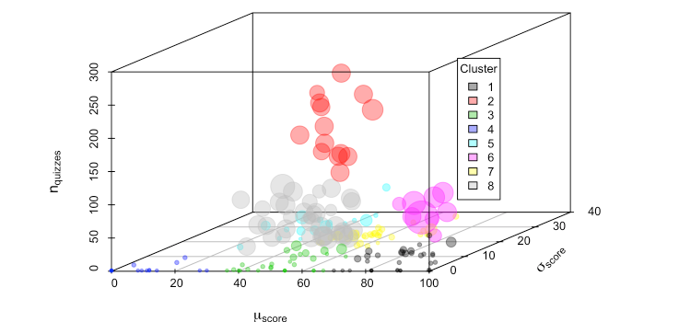
Figure 3. Cluster analysis of credit learners identifying high scorers (Cluster #1)
and low scorers (Cluster #4), where n = number of quizzes taken, μ = average score achieved
on those quizzes, and σ = standard deviation of the quiz scores. The size of each bubble
varies by the number of unique quizzes an individual person took.

Cluster Analysis for Noncredit Learners
Figure 4 presents graphical results of the cluster analysis for the noncredit learners, which identifies Cluster #5 as being the high scorers and Cluster #7 as the low scorers. Following selection procedures used with credit learners, the high scorers were selected based on the few number of quizzes taken and low standard deviation in scores.
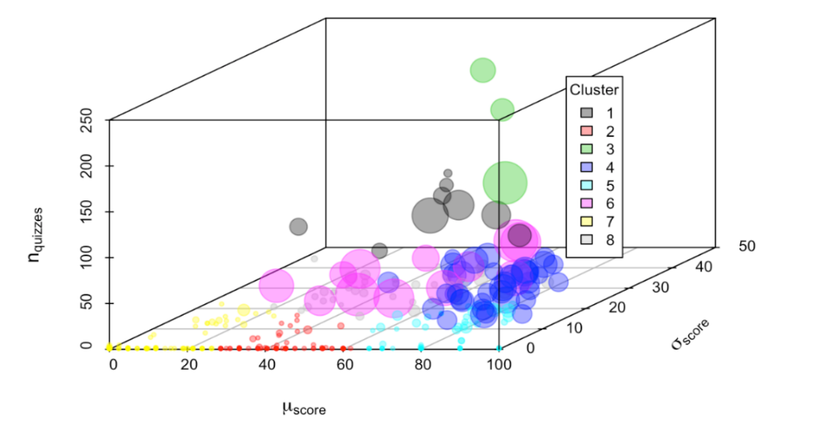
Figure 4. Cluster analysis of noncredit learners identifying cluster 5 as high and cluster 7
as low quiz scoring, where n = number of quizzes taken, μ = average score achieved
on those quizzes and σ = standard deviation of the quiz scores. The size of each bubble
varies by the number of unique quizzes an individual person took.

Descriptive Statistics for Credit and Noncredit High versus Low Quiz Scorers
Table 2 reports the average quiz scores, median time spent on learning objects, and number of quizzes taken for four subcategories of PASSEL users identified through the cluster analysis: credit students with high quiz scores, credit students with low quiz scores, noncredit with high quiz scores and noncredit with low quiz scores. The total population size of these subcategories was 201. There were similar usage statistics for high and low credit scorers in terms of time spent in a session, animation, and glossary. However, high scorers spent far more time on a lesson (26.32 min) in comparison to low scorers (14.43 min), and on a quiz (14.65 min vs. 2.84 min). Noncredit comparisons showed some differences in length of time in a session, with the low scorers actually spending more time (18.67 min/low vs. 13.68 min/high). Median time on a lesson was similar between the two (5.67/high vs. 6.05/low), as well as time on animation (9.42 min/high vs. 9.65 min/low). In contrast to the credit students, noncredit low scorers spent more time on the quiz than did the high scorers (5.53/high vs. 6.75/low).
Table 2. Credit and noncredit high versus low quiz scorers – Descriptive analysis
Category | Average Score / Standard Deviation | Cluster Number | n | Session Median (minutes) | Animation Median (minutes) | Glossary Median (minutes) | Lesson Median (minutes) | Quiz Median (minutes) | Number Quizzes Taken
Credit high | 83.57 / 8.76 | 1 | 33 | 6.68* | 3.52 | 0.05 | 26.32 | 14.65 | 4.03
Credit low | 10.47 / 9.36 | 4 | 15 | 5.32 | 3.62 | 0.13 | 14.43 | 2.84 | 1.27
Noncredit high | 78.08 / 10.42 | 5 | 56 | 13.68 | 9.42 | 0.05 | 5.67 | 5.53 | 2.50
Noncredit low | 10.84 / 8.50 | 7 | 97 | 18.67 | 9.65 | 0.27 | 6.05 | 6.75 | 2.00
* .68 represents fraction of the minute: 6 minute + .68*60 ~ 6 minutes 40 seconds

DISCUSSION

Credit and Noncredit Usage Differences
Little research has compared the online usage and learning approach of credit and noncredit learners. What has been done tends to look at data such as course completion or course final grades (Albelbisi et al, 2018; Almeda et al., 2018; Davis & Mirick, 2017). This research reports differences at a more micro-level of how the different learner types utilized the same learning objects. In comparing credit versus noncredit statistics, we find that credit students scored higher on quizzes than noncredit, which is in line with previous research (Almeda et al., 2018; Kursun, 2016). This result could be partially explained by the fact that they took the quiz more times and spent longer on lessons and quizzes. Credit students also spent more time on lessons than noncredit. However, noncredit learners spent much longer in a session (18.93 min) and more time in animation (8.37 min). This suggests that noncredit learners may spend more time searching for personally relevant material, while credit students use the syllabus and assignments to direct their allocation of time spent online. Credit learners use material required for the course; noncredit learners seek personally meaningful information. Noncredit learners’ extended time on animation suggests they value material that explains relationships and processes of more complicated and abstract material or provides a pictorial summary of material. In considering the wide variety of PASSEL noncredit users, we suggest that noncredit global learners gravitate towards highly graphical material and include teachers looking for something to use in their classes to help explain more complex relationships and processes. The fact that neither group used the glossary much mirrors research showing that the glossaries are used considerably less than other types of materials (Nugent et al., 2017).

Credit /Noncredit and High/Low Quiz Score E-Material Usage Differences
We further refined credit/noncredit differences by looking at high and low quiz scorers in each group. The descriptive statistics clearly showed that the high credit scorers spent more time on individual lessons and quizzes than did the low scorers. It could be logically expected that this more in-depth attention would translate into higher quiz scores and can be inferred that the motivation for understanding the material and receiving a good grade differed between the high and low scorers. In contrast, the most striking difference for the noncredit learners was in session times, with the low scorers spending more time in a session, suggesting more browsing behavior. The difference in time spent for high versus low scorers on a lesson and quiz for the high versus low quiz scorers was far less for noncredit than credit. It is also interesting to note that the two noncredit clusters spent less lesson and quiz time than the noncredit users overall, suggesting that the high performers had some prior knowledge of the material and required less time to review lesson and take the quiz. In contrast, the low scorers, with hypothesized less background knowledge, browsed or scanned the material.

Potential Learning Approaches in Using E-Materials—Learner Profiles
Using results of the cluster analysis and accompanying descriptive usage statistics, we developed suggested learner profiles for the four groups (high/low quiz scorers x credit/noncredit).

Profile of high quiz scoring credit students
Of all four groups this one had highest quiz score (84%), spent longest time on quiz (15 min), and took the quiz more times (4). This group also had the lowest standard deviation on the quiz score (8.76), meaning that there was relatively little difference in quiz scores among multiple attempts of each learner. The 26 minutes’ lesson usage is the highest of all four groups and higher than the estimated lesson time provided by project developers (20 min). These usage statistics and comparisons suggest that these learners are concerned with quiz scores and grades. They recognize the value of lesson material and spend needed instructional time processing the content, and they take the quiz multiple times to achieve good scores.
Learning approach: The characteristics seen in these users are similar to what we would expect in deep learners due to their high quiz scores and the long time they were spending on lessons. To recap the definition earlier, deep learners are motivated to learn material for the sake of gaining knowledge.

Profile of high quiz scoring noncredit students
These students scored somewhat lower than the credit high performers on the quiz (78% vs. 84%) and spent less time on the quiz (6 vs. 14 min) and lesson (6 vs. 26 min). They also took fewer quizzes. However, they spent more time in a session (14 min) and animation (9 min). Their relatively high quiz score (78%) and the fact that they took fewer quizzes than their high performing credit counterparts suggest that this group has some background knowledge that allowed them to maximize their time to view the lesson and complete the quiz. The long session times suggest that this group is spending time seeking material applicable to their career or particular situation. The longer use of animation implies that they value the animations’ depiction of relationships between more complex concepts and principles.
Learning approach: The characteristics seen in these users are similar to what we would expect in strategic learners as they appeared to select only those materials relevant to them personally or for their careers, rather than spending extended amounts of time on the lesson material as we would expect in a deep learner approach.

Profile of low quiz scoring credit students
This student group had a very low average quiz score (10%). They spent the shortest time in a session (5 min) of the four selected groups, little time on animation (4 min), and very short time on quiz (3 min). They typically took the quiz only once. However, they spent a reasonable amount of time on the lesson (15 min).
The usage statistics suggest that these learners focus on particular lesson material and spend a reasonable amount of time processing the content. They have little concern for a grade (as evidenced by little time on quiz and not re-taking quiz even with the low score). We characterize these learners as ones who will attend to particular relevant lesson material.
Learning approach: The characteristics seen in these users are perplexing but seem to best align with that of strategic learners because they spend a good amount of time in the lesson material. It may be that, for this group, the quiz did not directly account for a grade received in the academic course grade.

Profile of low quiz scoring non-credit students
The low performing non-credit students were similar to their credit counterparts in that they had very low quiz scores (11%). Of the four cluster groups, they spent the longest time in a session (19 min) and animation (10 min). Their relatively short time on a lesson (6 min) was basically the same as a high scoring noncredit student, providing additional evidence that the high scoring noncredit learners had some background knowledge. It is interesting that the noncredit low scorers spent more time on the quiz (7 min) than on the lesson. This suggests that, in contrast to their low scoring credit counterparts, they had some motivation to assess and increase knowledge and were perhaps hoping to score high enough to meet any grade requirements. It is also possible that they were seeking to use the quiz as a learning vehicle, valuing the feedback it provided, or for review, as suggested by Speth et al. (2007).
Usage results suggest that these students lack content background knowledge and spend considerable time looking for relevant material, using surfing strategies. They may also be seeking alternative avenues to learn content material such as animations (to more quickly grasp more complex relationships and processes) and quizzes (as a learning vehicle).
Learning approach: The characteristics seen in these users are similar to what we would expect in surface learners due to shorter time spent on lessons. The longer time in a session would suggest they are bouncing around the site without finding answers because their quiz scores are low.

Conclusions and Future Work
This research is unique in its use of objective, web-tracking data and its novel use of clustering and descriptive analytic approaches to compare credit and noncredit learners’ online behavior of the same educational materials. It is also one of the first to begin to identify learning approaches of noncredit learners. Our research adds to the research literature on learning approaches (Akçapınar, 2016; Speth et al, 2007). Most learning approaches instruments are geared to credit learners. For example, the Approaches and Study Skills Inventory for Students (ASSIST) (ETL Project, n.d.) uses language such as schoolwork, and the Study Process Questionnaire (SPQ) (Biggs, Kember, & Leung, 2001) makes reference to passing exams and assessments. By using behavioral as opposed to self-report data, we found that students appear to approach learning in various ways, with distinct differences between credit and noncredit learners. Use of behavioral web-tracking data, which logs student learning processes, has major advantages over self-report. However, comparing clustering approach profile designations with self-report data would provide more validation of results.
Another limitation is that demographic data is not available to know the background or prior knowledge of any PASSEL participant, credit or noncredit. Clearly future research using web-tracking data could benefit from more understanding of the learners themselves, including basic demographic data such as age, gender, school classification, as well as their reason for seeking out such online material. While existing research with credit students typically includes some of this critical information, the same is not necessarily true for noncredit students, who vary widely in their motivations, background knowledge, and intentions. Are they taking using the PASSEL materials for CEU (Continuing Education Unit) credit, as supplemental material, or for personal knowledge gain? What was their motivation for taking quizzes? Are they using the quiz as a self-check for their knowledge gain or as an overview to the material? It is also possible that the quiz is being used for basic learning by focusing on the feedback provided and retaking the quiz repeatedly rather than spending time only in the lesson. We also acknowledge that multiple choice quizzes are not the only measure of learning. Noncredit learners, in particular, may be more interested in developing particular skills that could be better measured by essay or performance measures. Understanding these underlying motivations of noncredit students will provide critical insight into their learning approach.
As a first step in looking more closely at credit and noncredit learners, we focused specifically on clusters of users who scored high and low on the quizzes. We believe that use of cluster analysis provides a way to make sense of large data generated in online learning object repositories by segmenting large learner populations, leading to more in-depth study of individual clusters. Looking at usage data from the original eight clusters, as opposed to the two high and low clusters, could provide a more comprehensive view of learner behavior and underlying learning approaches.
These results also provide some preliminary insight for instructors or instructional designers. For example, low scoring credit students are spending a reasonable amount of time on a lesson but still score low on the quiz. Results suggest that they may need more online scaffolding or auto-generated guidance such as the availability of relevant animations or the need to review certain parts of a lesson based on questions missed from the quiz.
In summary, this study capitalized on a large dataset of web-tracking usage data from an international learning object repository that was used by both credit and noncredit learners. This research made novel use of clustering and descriptive statistics to identify similarities of usage data with that of deep, strategic and surface approaches to learning. By using these data analytic approaches, we were able to discern usage differences in credit and noncredit learners (descriptive statistics) and identify sub-populations (cluster analysis) for additional analysis. By combining these two data analytic approaches, we were able to answer some basic questions regarding differences in credit and noncredit learners and students scoring high and low on online quizzes. The study also highlights areas for future research, including the need for more demographic data about the learners, as well as their motivations for seeking online material and how they define “success” in learning (it may not be completion of an entire course module and/or “passing” a quiz) (Albelbisi et al., 2018; Clow, 2013). This information could provide greater insight into the online behavior of noncredit learners, who vary widely in their reasons and motivation for pursuing online instruction. Future research could also benefit from the use of performance-based learning measures instead of objective assessments and a larger sample of credit and noncredit learners to provide validation of these results and improve generalizability of results.

Acknowledgements
This study was supported in part by the National Research Initiative Competitive Grants CAP project 2011-68002-30029 from the USDA National Institute of Food and Agriculture, administered by the University of California-Davis and the Agriculture and Food Research Initiative Competitive Grant no. 2011-68005-30411; and from the USDA National Institute of Food and Agriculture, administered by Iowa State University.
The authors wish to thank Ms. Amy Kohmetscher and Dr. Houston Lester for their assistance with collecting and analyzing some of the data used in this study.

References
Akçapınar, G. (2016). Predicting students’ approaches to learning based on moodle logs. In 8th International Conference on Education and New Learning Technologies (pp. 2347–2352). https://doi.org/10.21125/edulearn.2016.1473
Albelbisi, N., Yusop, F. D., & Mohd Salleh, U. K. (2018). Mapping the factors influencing success of Massive Open Online Courses (MOOC) in higher education. EURASIA Journal of Mathematics, Science and Technology Education, 14, 2995–3012. https://doi.org/10.29333/ejmste/91486
Almeda, V., Zuech, J., Utz, C., Higgins, G., Reynolds, R., & Baker, R. S. (2018). Comparing the factors that predict completion and grades among for-credit and open/MOOC students in online learning. Online Learning, 22(1), 1–18. https://doi.org/10.24059/olj.v22i1.1060
Amershi, S., & Conati, C. (2006). Automatic recognition of learner groups in exploratory learning environments. In M. Ikeda, K. D. Ashley, & T.-W. Chan (Eds.), Intelligent Tutoring Systems, Proceedings of the 8th International Conference, ITS 2006 (pp. 463–472). https://doi.org/10.1007/11774303_46
Biggs, J. B. (1987). Student approaches to learning and studying. Camberwell, Victoria: Australian Council for Educational Research.
Biggs, J. B., Kember, D., & Leung, D. Y. P. (2001). The Revised Two Factor Study Process Questionnaire: R-SPQ-2F. British Journal of Educational Psychology, 71, 133–149. https://doi.org/10.1348/000709901158433
Bransford, J. D., Brown, A. L., & Cocking, R. R. (2000). How people learn: Brain, mind, experience, and school. Washington, DC: National Academies Press.
Breslow, L., Pritchard, D. E., DeBoer, J., Stump, G. S., Ho, A. D., & Seaton, D. T. (2013). Studying learning in the worldwide classroom: Research into edX’s first MOOC. Research & Practice in Assessment, 8(Summer), 13–25.
Clow, D. (2013). MOOCs and the funnel of participation. In Proceedings of the Third International Conference on Learning, Analytics and Knowledge (pp. 185–189). https://doi.org/10.1145/2460296.2460332
Davis, A., & Mirick, R. (2017). Teaching statistics to MSW students: Comparing credit and non-credit options. Advances in Social Work, 18, 437–455. https://doi.org/10.18060/21448
Entwistle, N. (1977). Strategies of learning and studying: Recent research findings. British Journal of Educational Studies, 25, 225–238. https://doi.org/10.1080/00071005.1977.9973497
Entwistle, N., & Ramsden, P. (2015). Understanding student learning (2nd ed.). New York: Routledge.
ETL Project (Enhancing Teaching-Learning Environments in Undergraduate Courses). (n.d.). Approaches and Study Skills Inventory for Students (ASSIST) [Measurement instrument]. Retrieved from http://www.etl.tla.ed.ac.uk/publications.html
Gordon, C., & Debus, R. (2002). Developing deep learning approaches and personal teaching efficacy within a preservice teacher education context. British Journal of Educational Psychology, 72, 483–511. https://doi.org/10.1348/00070990260377488
Kim, C.-M., Park, S. W., Cozart, J., & Lee, H. (2015). From motivation to engagement: The role of effort regulation of virtual high school students in mathematics courses. Educational Technology & Society, 18, 261–272.
Kizilcec, R. F., Piech, C., & Schneider, E. (2013). Deconstructing disengagement: Analyzing learning subpopulations in massive open online courses. In D. Suthers, K. Verbert, E. Duval, & X. Ochoa (Eds.), Proceedings of the Third International Conference on Learning Analytics and Knowledge, LAK 2013 (pp. 170–179). New York: ACM. https://doi.org/10.1145/2460296.2460330
Koutsomitropoulos, D., & Solomou, G. (2018). A learning object ontology repository to support annotation and discovery of educational resources using semantic thesauri. IFLA Journal, 44, 4–22. https://doi.org/10.1177/0340035217737559
Kursun, E. (2016). Does formal credit work for MOOC-like learning environments? International Review of Research in Open and Distributed Learning, 17(3). https://doi.org/10.19173/irrodl.v17i3.2403
Madhulatha, T. S. (2012). An overview on clustering methods. IOSR Journal of Engineering, 2, 719–725. https://doi.org/10.9790/3021-0204719725
Marton, F., & Säljö, R. (1976). On qualitative differences in learning: I–Outcome and process. British Journal of Educational Psychology, 46, 4–11. https://doi.org/10.1111/j.2044-8279.1976.tb02980.x
Miller, L. D., Soh, L.-K., Samal, A., Kupzyk, K., & Nugent, G. (2015). A comparison of educational statistics and data mining approaches to identify characteristics that impact online learning. Journal of Educational Data Mining, 7, 117–150.
Namuth, D., Fritz, S., King, J., & Boren, A. (2005). Principles of sustainable learning object libraries. Interdisciplinary Journal of E-Learning and Learning Objects, 1, 181–196. https://doi.org/10.28945/419
Nugent, G., Namuth-Covert, D., Murphy, P., Kohmetscher, A., Guretzky, J., & Lee, D. (2016). Learning from online modules in diverse instructional contexts. Interdisciplinary Journal of E-Learning & Learning Objects, 12, 113-121. https://doi.org/10.28945/3511
Nugent, G., Lester, H., Guru, A., Kohmetscher, A., Namuth-Covert, D., & Jolly, S. (2017, July). Predictive analytics for learning and usage of the plant sciences e-library. In Proceedings of the IEEE 2017 Computing Conference, London, UK. https://doi.org/10.1109/SAI.2017.8252237
Pintrich, P. R., Smith, D. A. F., García, T., & McKeachie, W. J. (1991). A manual for the use of the Motivated Strategies for Learning Questionnaire (MSLQ). Ann Arbor, MI: University of Michigan, National Center for Research to Improve Postsecondary Teaching and Learning.
Puzziferro, M. (2008). Online technologies self-efficacy and self-regulated learning as predictors of final grade and satisfaction in college-level online courses. American Journal of Distance Education, 22, 72–89. https://doi.org/10.1080/08923640802039024
Simpson, S. (2016, June). History, context, and policies of a learning object repository. Paper presented to the Department of Educational Methodology, Policy, and Leadership, Eugene, OR.
Speth, C. A., Lee, D. J., & Hain, P. M. (2006). Prioritizing improvements in Internet instruction based on learning styles and strategies. Journal of Natural Resources and Life Sciences Education, 35, 34–41.
Speth, C. A., Namuth, D. M., & Lee, D. J. (2007). Using the ASSIST short form for evaluating a learning object library: Validity and reliability issues. Informing Science: The International Journal of an Emerging Transdiscipline, 10, 107–119. https://doi.org/10.28945/459
Stallings, J. (1980). Allocated academic learning time revisited, or beyond time on task. Educational Research, 9, 11–16. https://doi.org/10.3102/0013189X009011011
Talavera, L., & Gaudioso, E. (2004). Mining student data to characterize similar behavior groups in unstructured collaboration spaces. In R. López de Mántaras & L. Saitta (Eds.), Proceedings of the Workshop on Artificial Intelligence in CSCL at the 16th European Conference on Artificial Intelligence, Valencia, Spain (pp. 17–23). Amsterdam, The Netherlands: IOS Press
Vickrey, T., Golick, D., & Stains, M. (2018). Educational technologies and instructional practices in agricultural sciences: Leveraging the Technological Pedagogical Content Knowledge (TPACK) framework to critically review the literature. NACTA Journal, 62, 65–76.

Biographies

Dr. Gwen Nugent is a Research Professor of the Nebraska Center for Research on Children, Youth, Families and Schools at the University of Nebraska-Lincoln. Dr. Nugent coordinates development and research projects focusing on the impact of technology to improve student learning and teacher competencies and has led projects funded by the National Science Foundation and U.S. Department of Education. She has designed more than 300 multimedia projects in a variety of subject areas and for a variety of audiences. The majority of these projects are distributed nationally and internationally, and many have won national awards for their educational impact and effectiveness.

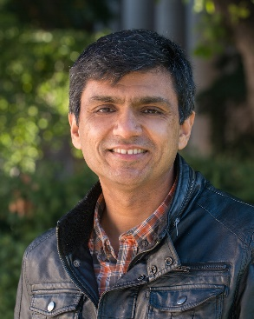
Dr. Ashu Guru is a computational scientist and educational researcher who focuses on curriculum development in both formal and non-formal educational settings. His expertise includes operations research, statistical modeling, simulation, systems thinking, and design. He has taught several graduate and undergraduate courses in Systems Engineering, Operations Research, and Business Analytics. Dr. Guru has previously served as the Director of Research Strategy at the Jeffrey S. Raikes School of Computer Science and Management at the University of Nebraska-Lincoln. In his current position, Dr. Guru is a faculty member with the Nebraska Extension at the University of Nebraska-Lincoln.


Dr. Deana Namuth-Covert has spent her entire career working with online education for both credit and non-credit/Extension audiences (18 years). Most recently in 2014, she joined The Ohio State University as a Professor at the OSU agricultural Technical Institute where she teaches online agronomy courses for undergraduate students. She also serves as the Director of Online Education and Outreach for the OSU College of Food, Agricultural, and Environmental Sciences.

