The Impact of Preservice and New Teachers’ Involvement in Simulation Workshop and Their Perceptions about the Concept of Conflict
in Education
Esmael Salman* | The Academic Arab College, Haifa, Israel | esmael@arabcol.ac.il
Amtiaz Fattum | The Academic Arab College, Haifa, Israel | amtiaz@arabcol.ac.il
* Corresponding author

Abstract
Aim/Purpose | In the modern world, simulation has become a new phenomenon in education, which conveys new and innovative ideas of curriculum, instruction, and classroom management. It makes certain of Aristotle’s words when he said that “The things we have to learn before we do them, we must learn by doing them”. One might think that simulation in education is one of these technologies.  This study examined preservice and new teachers’ perceptions about the concept of conflict and educational conflict management in a simulation workshop conducted at the Academic Arab College’s Simulation Center in Haifa, Israel.
Background | Simulation engages learners in “deep learning” and empowers their understanding. In other words, simulation provides an alternative real world experience.  As part of our work at the Educational Simulation Center in the Arab Academic College in Haifa, Israel, we examined the performance and contribution of educators who visit the center and participate in educational conflict management simulation workshops.
Methodology | A mixed methods study was conducted. A total of 237 participants of preservice teachers from diverse professions were divided into 15 groups to examine the research question: How does the experience of participating in a simulation workshop affect preservice teachers’ perception about the concept of conflict?
Contribution | This study seeks to contribute to simulation and conflict management in education. This contribution to the body of literature can help researchers, scholars, students, and education technology professionals to advance simulation research studies.
Findings | The study findings indicate that there is a high degree of satisfaction (more than 90%) among preservice teachers in participating in the workshop. It also indicates a positive and significant change in participants’ perceptions of the concept of conflict and the management of conflict situations.
Recommendations | In light of the study findings, it is recommended that new teachers be exposed to simulation workshops with a variety of scenarios dealing with different conflict situations. This exposure could contribute to their professional development and conduct in a more efficient and convenient manner in schools.
Keywords | conflict, satisfaction, simulation in education, simulation scenario

Introduction and Study Background
The importance of teaching methods and their contribution to the quality of learning has been shown to be widely relevant in several studies (Cobb, & Jackson, 2012; Davies et al., 2013).There is no doubt that in the near future, the training of professionals in various areas of knowledge in university will involve training that is appropriate to their specialization, in addition to acquiring skills and abilities for their own work in the field (Cropley, 2015).
Simulation is defined as a learning tool that enables the creation of ‘new connections’ between theoretical knowledge and practical knowledge as an event or situation in a particular defined context in a given professional field (Hargie, Boohan, & Murphy, 2010).
A simulation-based learning approach is used in different disciplines where students need to develop experience, especially in situations where experience involves high costs and/or risks. For example, medical simulators allow students to diagnose and treat puppets that can react in somewhat complex and realistic ways. Trainee pilots (and aeronautical students) use flight simulators to learn how the aircraft interacts in a variety of conditions. Thus, it can be assumed that the main purpose of simulation is to provide an experience as close as possible to “what is happening in the real world.” The advantage of using simulation lies in the ability to experiment and re-run a scenario based on alternative approaches and strategies. Simulation enables participants to develop and enrich their experience in dealing with specific situations while being exposed to different situations in a non-judgmental environment.
In most teacher educational colleges, the training model in the field is still taking place, and it is good that it remains so. The field of education deserves to be learned from the successful experience of using simulated models for training in nursing (Society for Simulation in Healthcare [SSIH], 2015), medicine and business administration (Dolvin, & Pyles, 2011). Hayden, Smiley, Alexander, Kardong-Edgren, and Jeffries (2014) believe that simulation can serve as an appropriate educational tool for training students in nursing and medicine. Albaqawi (2018) argues that simulation is an effective teaching strategy, and the inclusion of simulation increases student learning.
Simulation has been found to be a useful teaching strategy that contributes to learning, development of competencies, safety, and self-confidence (Norman, 2012). Simulation minimizes the variability of community based experiences, thereby providing a more consistent and predictable learning environment. The National League for Nursing (NLN) has endorsed simulation as a necessary teaching approach to prepare students for the demanding role of professional nursing (National League for Nursing, 2015). Nursing faculty use simulation as a way to provide valuable active learning experiences that can be substituted for real life clinical experiences.
In the field of teacher-training, traditional pedagogies are still the highest norms in the field in higher education institutes. Such training is usually based on imparting knowledge and skills through lectures by written, observable and audible texts (Sfard, 1998). This training style does not always provide teachers with the opportunity to apply their new knowledge to actual educational situations, and as a result, the gap between acquired knowledge and the knowledge required in the field is increasing (Raymond, 2010). Such educational situations cause considerable difficulties among many preservice teachers in determining the relevance of their learning, which increases the sense of a clear disincentive among these teacher students to learn in a successful, enjoyable and practical way their preoccupation with the teaching process in the field (Beck, 2015; Vaserman-Goteleg, 2017).
Over time, there is a growing expectation that teachers will conduct their work in the field as professionals. Professionalism, in this context, includes many components, such as professional knowledge in the field of teaching (Timperley, Wilson, Barrar, & Fung, 2007), use of appropriate authentic teaching tools, meeting accepted standards of conduct, leading students through clear moral processes, the ability to identify difficulties and the skills of students’ assessment of learning (Okas, van der Schaaf, & Krull, 2014).
This behavior of teachers involves ethical behavior, educating and ethical teaching (O’Neill, & Bourke, 2010; Barrett, Casey, Visser, & Headley, 2012). Teachers must make informed decisions about what to do in order to achieve the best for the learners (Aho et al., 2010). They are required to conduct a class that involves complex interactions between the current teaching context, past knowledge, and personal beliefs and values, with a variety of difficulties, such as difficulties with inappropriate behavior by individual learners (Confait, 2015).
The assumption in this study is that teachers, at all stages of their work, encounter difficulties and that a good understanding of the concept of educational conflict will enable them to function better in conflict situations through conflict management skills. This study was conducted in order to examine how participation in an educational simulation workshop will influence the perception of the concept of conflict among preservice teachers.
Simulative learning in the Educational Simulation Center is based on learning in four-hour workshops in groups of up to 15 participants. Facilitators trained in educational groups run the workshops. Along with the facilitator, one or more actors join the required roles in accordance with the conflict scenario discussed in the workshop with the participants. Three different scenarios are used in each simulation workshop. In each scenario, a different participant undergoes the experience. The experience lasts about six minutes, during which the experimenter is exposed to a practical experience of the scenario opposite a professional actor. The simulation is broadcast to the group members via a real-time video system. During the experience, only the actor and the experimenter are present in a separate studio. After the end of the experiment, a debriefing of the simulation is conducted by the facilitator and with the participation of the experimenter, the actor and all the group members.
The simulation workshop promotes and implements the “conflict management” approach, or, more accurately, the “transformation of conflicts” in the educational field. This approach enables the development of effective and meaningful learning by raising educators’ awareness of the importance of the adaptive use of communication skills, such as listening, empathy, assertiveness, good communication and collaboration.
Before participating, all the workshop participants sign consent forms to participate in the workshop and to be videotaped during the workshop, in addition to signing a form confirming the use of the workshop videos for educational purposes for the group members. After the debriefing stage, the facilitator holds a discussion to provide a summary feedback to the experimenter for preserving the successful skills as well as the behaviors that should be improved. Following this stage, the workshop moves to the next scenario.

Literature Review - Simulation in Education
There are different definitions for the concept of Simulation. In this study, we adopt the definition that sees the simulation as an active imitation of activities taking place in the real world and experimenting with them in a friendly, safe and non-threatening environment (Gaba, 2007; Lu, Hallinger, & Showanasai, 2014). The use of simulation opens possibilities beyond the education and training of individuals towards organizational development and process optimization (Rall, & Dieckmann, 2005; Rudolph, Simon, Dufresne, & Raemer, 2006; Small, 2007), and its usage, can be important to maximize learning and facilitating change on an individual and systematic level (Rall, Stricker, Reddersen, Zieger, & Dieckmann, 2008).
The purpose of simulation in education is to provide participants with educational situations as close as possible to “what is happening in the real world.” The advantage of using simulation lies in the ability to experiment and repeat a scenario several times based on alternative approaches and strategies (Kaufman & Ireland, 2015). Simulation enables participants to develop and enrich their experience in dealing with specific situations while exposing them to conflict situations in a friendly, supportive and non-judgmental environment. Education simulation workshops enable:
- Receiving educational feedback from experienced teachers, moderators and experts in the field
- Carrying out repeated experiments as needed
- Applying exposure to the curriculum in practical aspects
- Coping with learning content at different levels of difficulty and complexity
- Exposure to practical learning/teaching strategies
- The ability to learn in a friendly and supportive environment
- Learning experiences without negative results
- Achieving clear goals for defined results
- Learning experiences that are reproducible under standard conditions as they happen in reality.
Simulation allows encountering problematic situations, experiencing the results of decision making and actions, and practicing and modifying decisions repeatedly without the risk of ineffective actions or decisions (Kaufman & Ireland, 2015).
Conflict may occur in any organization and of course in school. Conflict management is an important skill and should therefore be imparted to teachers. The effectiveness of educational conflict management by the teacher determines the type of impact on the quality of teacher performance at school (Saiti, 2015). Training teachers in conflict management through simulation workshops exposes them to a variety of methods that help them manage educational conflicts successfully in the school through active experience. Cooperation and coherence are key factors in fostering a constructive strategy for managing conflict and improving the personal performance of the teachers in school.
In educational simulation workshops, the approach of “debriefing with good judgment” is a key factor to highlight the importance of instructors disclosing their judgment skillfully (Rudolph et al., 2006). This approach is based on theories and findings in behavioral sciences to improve professional efficiency through “reflective practice.” The approach adopts the self-reflection technique, which helps the participants identify, understand and solve dilemmas that arise in the simulation and according to the instructor’s judgment.
The reality encountered by new teachers in the field is significantly different from the way this reality was perceived by them during their training (Oppenheimer-Schatz, Maskit, & Zilbershtrom, 2011). The gap between training and reality in the field gives teachers the feeling that they are not ready to actually teach in front of a class. In order to reduce oppressive feelings among new teachers and preservice teachers, an increase was observed in the use of simulations aimed at training educational teams and developing collective cooperation in conflict scenarios. Training new teachers and preservice teachers using simulation could impart them with optimal communication and negotiating skills and provide them with important skills to manage conflict situations they may encounter in their classes.
In light of this, the background in the use of simulation in education is based on the possible contribution of simulation on several levels:
- Reducing the difficulties of adaptation and the professional shock of new teachers by equipping them with practical experiences.
- Bridging the gap between theory and practice, despite the fact that the students are equipped with traditional training.
Providing an experiential experience from the “real” world of teaching that was revealed to the teachers when they entered the school.

Research Methodology

Objectives and Research Approach of the Study
The study aims at investigating preservice teachers’ perceptions of the concept of conflict in the educational context. The mixed methods research approach was used. Mixed methods research began in the late 1980s and is being used increasingly by a growing number of researchers (Creswell & Clark, 2011; Dunning ,Williams, Abonyi, & Crooks, 2008). It is important to understand the perceived value of combining two different methodologies. Mixed methods research requires additional time due to the need to collect and analyze two different types of data (Johnson, Onwuegbuzie, & Turner, 2007). The combination of the two research approaches (quantitative and qualitative) is intended to illuminate the findings from different points of view, support them or express reservations about them. This combination is intended to strengthen the internal and external validity of the study (Salman, 2017). In this study, the integration is expressed in the level of performance when the combined qualitative and quantitative research tools fulfill the objective of the study and match its goal.

Participants
The study comprised of 15 groups of preservice teachers from diverse areas such as language education, science education, mathematics and computer science, childhood education and special education. A total of 237 preservice teachers participated voluntarily in this study and received no compensation of any kind, 196 (83%) females and 41 (17%) males. Ages ranged from 21 to 46 years.
Profession and gender aspects were not taken into account in the study.

Research Tools and Data Collection
Several tools were used in this study for the data collection such as:
- An online questionnaire about the perception of conflict as a symbol of negativity, aggressiveness and tension. The available answers were on a scale of 0 and 1 (0: agree with the statement, and 1: disagree with the statement). The questionnaire was distributed to the teachers prior to their participation in the workshop and again upon completion of the workshop. The participants had no experience in simulation in education.
- An online satisfaction questionnaire with a Likert 4-point scale (1: strongly disagree, 2: disagree, 3: agree, and 4: strongly agree). The questionnaire had four categories: the expertise of the workshop moderator; the quality of the scenarios dealt with in the workshop; the atmosphere during the workshop; and the organization of the workshop.
- Semi-structured interviews: 30 interviews were conducted during the study; two interviews were conducted upon completion of the workshop.
- Participant observations: 15 observations were conducted, one observation per workshop.

Participant Observations
Observation is a systematic recording of events, behaviors and objects in the social environment chosen for the study. It is used as a tool for collecting information observed in the natural environment of the interviewee. In this study, the researchers conducted participant observations of the participants in the simulation workshops.
Participant observation is very similar to regular observation whereby the researcher becomes part of the group being studied (Kawulich, 2005). Participant observation is a method for researchers to learn about activities of the participants in the study in a natural setting by observing and participating in those activities (Dewalt & Dewalt, 2002).
The observations in this study were designed to reflect on the participants’ learning process, paying attention to the methods of investigation, taking responsibility, participating in the discussions, teamwork, and the relationship between the participants and the facilitator, the actor and their colleagues in the workshop. The observations enabled us to examine the participants’ behaviors during their learning in the simulation workshop on the following two levels:
- Behavioral Level
To what extent do the participants invest time and effort, listen to the facilitator and their colleagues, participate in the discussions and express a position and opinion.
- Emotional level
To what extent do the participants show signs of interest, enthusiasm, optimism and desire to take part in the discussions, emotional signs such as satisfaction, joy, anger, pressure and pride.
The observations enabled collecting data that served to strengthen the quantitative findings.

Semi-structured Interviews
Thirty interviews were conducted during the study and two after each workshop. The interview questions were validated by experts; the researcher and two academic group facilitators examined the questions, and agreement between judges was obtained.
Following are examples of questions from the interviews in three categories:
The facilitator:
- To what extent was, the debriefing conducted by the facilitator good enough?
- Do you think the facilitator was convincing in leading the workshop?
- How satisfied were you with the facilitator?
The scenario:
- To what extent did the scenario reflect the reality on the field?
- To what extent were you satisfied with the quality of the scenario?
The climate in the workshop:
- How did you feel in the workshop?
- How comfortable were you in attending and participating in the workshop?
- Did the workshop atmosphere advance your learning?

Research Questions
In this study, the following two research questions were examined:
- How was the concept of educational conflict perceived by the teachers?
- How did participation in a simulation workshop affect teachers’ perceptions of the concept of educational conflict?

Findings and Discussions
As previously mentioned, quantitative and qualitative data were collected in this study. The quantitative data will be presented first, followed by the qualitative data.

Quantitative Findings
Findings from the questionnaire prior to the workshop showed that the majority of preservice teachers (215, 90.7%) who participated in the study perceived conflict as a negative concept. Findings following participation in the workshop showed an almost opposite picture of the concept of conflict among the participants. Only 41 (17.3%) of the workshop participants continued to perceive conflict as a negative concept. Most of the participants felt that the concept of conflict is not necessarily negative; it exists in educational situations and must be managed positively.
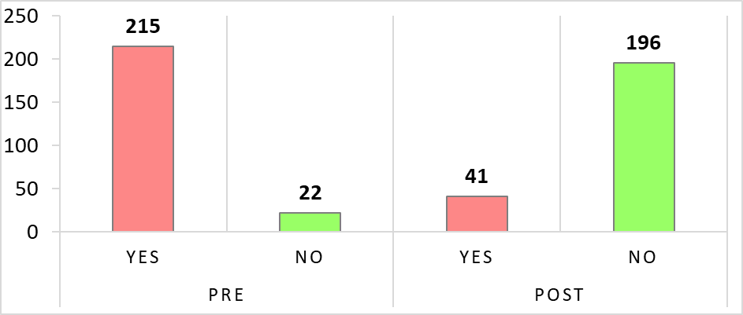
Figure 1: Participants’ perceptions of conflict as a negative concept prior to and
after their participation in the simulation workshop.
Findings prior to the workshop showed that more than 202 (85.2%) of the participants stated that the concept of conflict had a distinct symbolism of tension. Findings following participation in the workshop showed that only 88 (37.1%) of the workshop participants continued to perceive conflict as having a distinct symbolism of tension.
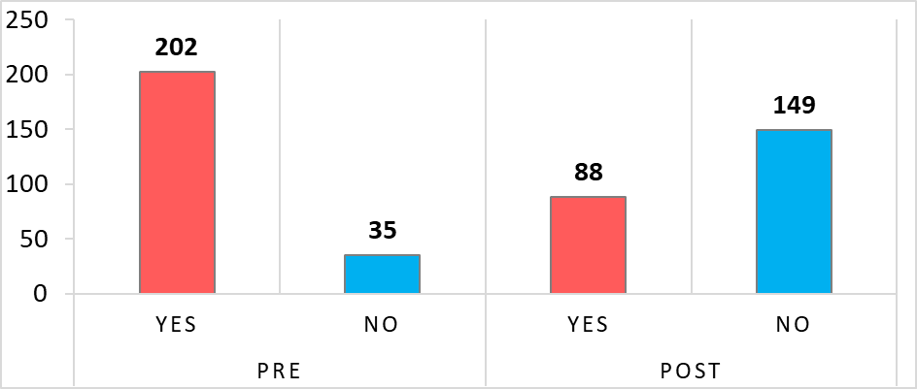
Figure 2: Participants’ perceptions of conflict as a symbol of tension prior to and
after their participation in the simulation workshop.
Prior to the workshop, 178 (75.1%) of the participants thought that the concept of conflict implied aggressiveness. Following participation in the workshop, only 93 (39.2%) of the workshop participants continued to perceive that the concept of conflict implied aggressiveness.

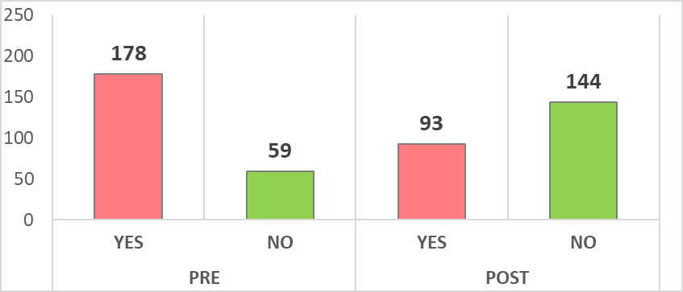
Figure 3: Participants’ perceptions of conflict as a symbol of aggressiveness prior to and after their participation in the simulation workshop.
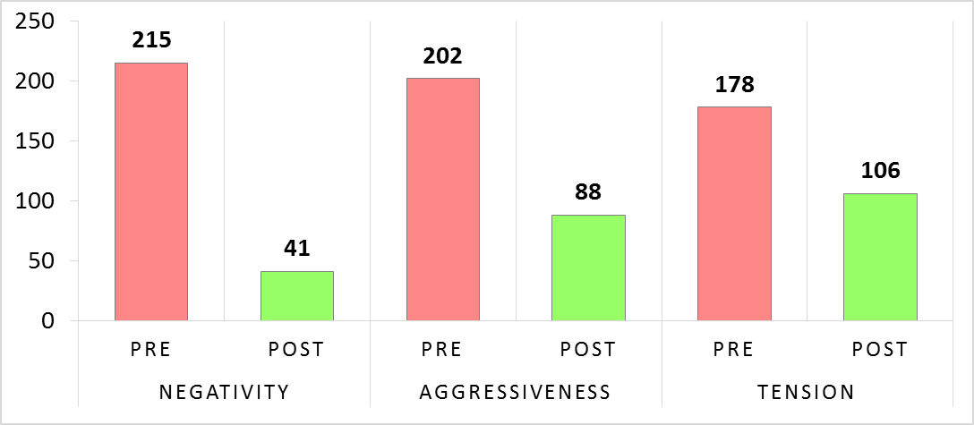
Figure 4: Participants’ perceptions of conflict as a symbol of negativity, aggressiveness and tension prior to and after participation in the simulation workshop.
In order to examine if the changes in preservice teachers towards the concept of conflict is significant or not, a series of independent t-tests was conducted.
Table 1 presents data about preservice teachers’ perceptions (mean and standard deviation) prior to and after their participation in the simulation workshop regarding the concept of conflict in aspects of negativity, aggressiveness and tension.
Table 1: Responses of preservice teachers: negativity, aggressiveness and tension (scale 0, 1)
Aspect | Pre workshop(n=237) |  |  | Post workshop (n=237) |  | t
Aspect | M | SD |  | M | SD
Negativity | 0.91 | 0.19 |  | 0.16 | 0.23 | 24.32
Aggressiveness | 0.85 | 0.26 |  | 0.37 | 0.28 | 12.33
Tension | 0.75 | 0.28 |  | 0.39 | 0.29 | 8.45
Table 1 show that there were statistically significant differences between preservice teachers’ perceptions about the concept of conflict in the three terms of negativity, aggressiveness and tension prior to and after the workshop. As shown in Table 1:
- A statistically significant difference was found between Pre (M=0.91, SD=0.19) and Post (M=0.16, SD=0.23) preservice teachers’ perceptions toward the negativity symbolism of the concept of conflict (t₍₄₇₂₎ = 24.32; p=.001).
- A statistically significant difference was found between Pre (M=0.85, SD=0.26) and Post (M=0.37, SD=0.28) preservice teachers’ perceptions toward the aggressiveness symbolism of the concept of conflict (t₍₄₇₂₎ = 12.33; p=.003).
- A statistically significant difference was found between Pre (M=0.75, SD=0.28) and Post (M=0.39, SD=0.29) preservice teachers’ perceptions toward the tension symbolism of the concept of conflict (t₍₄₇₂₎ = 8.45; p=.002).
The conceptual framework of the current study revealed a significant and imperative relationship between preservice teachers’ satisfaction and different educational offerings given during the simulation workshops and scenarios. Based on this evidence, the issues of the moderator’s expertise, the quality of the scenarios and the general atmosphere in the simulation workshop were examined regarding satisfaction of participants in the simulation workshop. Results show the vast majority (more than 90%) of participants in the study stated that these components greatly influenced their sense of satisfaction with the workshop.
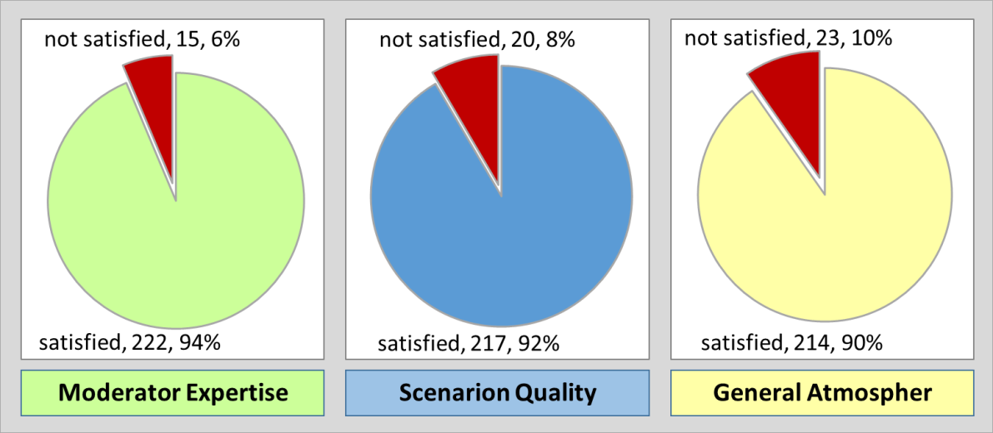
Figure 5: Participants’ satisfaction of the simulation workshop.
Figure 5 shows that:
- Most of the participants in the simulation workshop (94%, n=222, M=3.56, SD=0.665) reported that they were very satisfied with the moderator’s expertise in the workshop.
- Most of the participants in the simulation workshop (92%, n=217, M=3.46, SD=0.733) reported that they were very satisfied with the quality of the scenarios in the workshop.
- Most of the participants in the simulation workshop (90%, n=214, M=3.43, SD=0.771) reported that they were satisfied with the general atmosphere in the workshop.
In response to the question: To what extent do you intend to participate in similar simulation workshops in the future? The participants’ responses indicated great interest, where more than 95% (n=227, M =3.59, SD=0.629) of them expressed their desire to participate in future simulation workshops.

Qualitative Findings
Quality content analysis is a method used typically for quality data analysis; furthermore, it may be used in an inductive or deductive manner.
In this study, we used the deductive approach, which is based on a preconceived theory or model, focusing on the categories and/or concepts determined in advance by the researcher, moving from general to specific (Burns & Grove 2005; Schadewitz & Timothy, 2007).
The deductive data analysis approach according to predefined categories was used in this study.
In this section, we will refer to two qualitative data types:
- Findings from the observations conducted during the workshop.
- Findings of interviews conducted with some of the participants after their participation in the simulation workshop.

Findings of the Observations
The qualitative findings from the 15 observations conducted during the workshops relate to three main categories in this study:
- The facilitator
- The scenarios
- The climate in the workshop
The findings of the observations indicate that participants in the workshops had a positive attitude towards the facilitator, the scenario and the climate in the workshop. The findings also showed a positive interaction between the workshop participants and the moderator, and among themselves. This was expressed in cooperation, positive feedback, support and non-offensiveness, taking into consideration the performance of each participant during the workshop. The participants’ conduct and participation in the scenarios indicated a great deal of will and adaptation of the scenarios to their daily lives at school, as some of them noted during the workshops. The participants stated that they were very comfortable during the workshops. The general feeling of a non-threatening atmosphere as well as the support from the facilitator and the workshop participants provided a very good opportunity to foster partnership and support and understanding in a non-judgmental environment. It helped the participants realize the inherent potential in managing the scenarios in a “sterile” and non-threatening atmosphere.
The findings of the observations were reflected in the behavior of the participants during the workshops according to the data collected from the interviews with the participants after the workshops.

Findings of the Interviews After the Workshop
Analysis of the interview data also focused on the three categories: the facilitator, the scenarios, and the climate in the workshop.

The Facilitator
Regarding the facilitator, the participants positively noted the facilitator’s contribution to their understanding, increasing their involvement in the workshop, reinforcement of their self-confidence. For the most part, they positively noted the clarity and simplicity in presenting the workshop goals and objectives.
As evidence of this, some examples cited from the responses of different participants to questions about the workshop facilitator will be mentioned here. It is important to note that the examples were taken from the responses of different interviewees from various workshops.
T1:“Thanks to the moderator, the atmosphere in the workshop was very comfortable, I felt at home, not threatened or stressed ... everything was really good.”
T2:“At the beginning of the workshop, the facilitator explained exactly (in 10 minutes) what we were going to do. What forms should be filled in and why, what is videotaped and what is not, how to conduct the discussion in simple words with easy and practical concepts…It helped me to relax, focus and feel comfortable.”
T3:“The facilitator observed proper rules of conduct in the workshop. He made it clear that in this workshop, we do not come to judge each other, but rather learn one from the other’s experience... we all learn, we all win. The facilitator’s words and the way he behaved with a pleasant tone of voice and learning strategies were very helpful to us. I also learned from him methods to manage my class at school.”
T4:“I think that the facilitator conducted the workshop professionally and successfully; his pleasant and reassuring tone of voice, his use of simple and understandable terms, his respect and attitude encouraged me to take part in the workshop. He actually invited me to be involved throughout the workshop.”
T5:“I liked the facilitator’s method; I’m really going to adopt a large part of her way of managing the group. It is very pleasant; in almost every situation, even if it is difficult, she has a positive way of highlighting the good things, ignoring what is not positive and non-conducive to learning. Today, I really enjoyed good and successful modeling.”
T6:“The facilitator’s way of dealing with things and respect for us encouraged me to be involved in the workshop.”
As it can be seen from the above example of answers, the interview data indicate that most of the participants were generally satisfied with the facilitators of the workshops. Some of them related to different aspects of the facilitator, such as conversation management, invitation to share, assertiveness and harnessing, group cohesion, simplicity and clarity, positive attitude and modeling.

The Scenarios
Regarding the scenarios, the general view in the interviewees’ responses was that the scenarios were taken from daily life and largely reflect the reality they experience in the field. Some of them clearly noted that the scenario simulated an event that had actually happened to them at school. Some of the interviewees emphasized the professional actors’ contribution to the success of the simulation and the scenarios. Others mentioned that they learned several techniques from the scenarios on how to manage educational conflicts.
Following are some examples of the responses of selected interviewees:
T1:“For me, the scenario today in the workshop was excellent. It was really relevant for me.”
T2:“The scenario was taken from my school life; it was an event that had happened to me a few weeks ago in class. It is amazing how many options the moderator gives me for handling the event. It would have been great had I attended the workshop before. I’m sure I would have behaved differently and achieved better results.”
T3:“The scenario was good; the actor played the role quite nicely.”
T4:“My experience in the scenario exposed me to possibilities of managing difficult events in different ways! It is easier, safer, attracts greater partnership and connections, and is maybe much more successful...”
T5:“The scenario was clear, even though it revolved around a very difficult situation. The actor and the facilitator made it realistic; it was very relevant for me.”
It can be seen from the sample responses that almost all of the participants felt that the scenarios reflected reality on the field, and exposure to and experience with them strengthened their knowledge and confidence in dealing with similar situations at school.

The Climate in the Workshop
The analysis of the interview data showed that the overall atmosphere in the workshops was good and suited most of the participants. Some of the interviewees noted that the group comes from the same school and that preliminary acquaintance of the group members could create a situation of discomfort and reluctance to be exposed to colleagues. But the workshop’s successful management and atmosphere helped the participants to be open to themselves and to their colleagues.
Below are some response examples:
T1:“The atmosphere in the workshop was very good for me; no competition; there was no right or wrong. Everyone is trying to learn from the scenario. Each presents his knowledge and experience to others.”
T2:“We are a group of teachers from the same school, know one another and work together. It could have been difficult. No one wants to expose his weaknesses to his co-workers! However, the facilitator made the atmosphere very comfortable, supportive and constructive. Everyone understood that together we could learn more and sharing experiences could enrich us all. For me, it was a lot of fun. I got to know myself much better in the eyes of my co-workers.”
T3:“I loved attending the workshop; it was a lot of fun. Everyone was supportive and encouraging even when you were not doing as well as possible. The way the facilitator worked his wonders with the group was amazing. Suddenly they could all see the beautiful side, the attempts to do well, the efforts to succeed. The negative reviews and critical inspections suddenly disappeared, as if they no longer existed. The group moved forward to succeed and saw success as a common goal that could be achieved together. Even when criticism was given, it was given in a pleasant and harmless manner. I learned to take many things from the workshop-learning atmosphere to my school, to my students and to my co-workers.”
The atmosphere in the simulation workshops as reflected in the responses of the interviewees seems very positive. The atmosphere helped the participants open up to the group and share their experiences. The sense of support and encouragement helped the group converge around the goal of success in managing educational conflicts, and in understanding that sharing knowledge and experience is beneficial to all.
As a summary of the qualitative data, it can be noted that participation in the simulation workshops clearly indicated a significant change in the perceptions of the concept of conflict of the workshop participants. Some of the participants stated that their participation in the simulation workshop opened their eyes to a whole series of daily pedagogical events that they had done in an offensive manner without noticing. In addition, most of the workshop participants noted that their participation in the workshop caused a fundamental change in their perceptions of the concept of conflict. They, also, stated that their participation in the workshop gave them, tools and skills to manage conflict events they experience in their fieldwork, and they learned how to transform these events from challenging and uncontrolled situations into opportunities for nurturing support and collaboration, something that would be more thoughtful and nonjudgmental.
An analysis of the qualitative data indicates that they support the quantitative findings of the study. This study was designed to investigate whether the participation by preservice teachers and new teachers in a simulation workshop affected their perceptions of the educational concept of conflict.
The findings indicate that the vast majority of the participants reported, quantitatively and qualitatively, a fundamental change in their perceptions of the concept of conflict.
The literature indicated that the use of simulation provides several educational benefits. Findings of satisfaction of the workshop regarding the four main components (the moderator’s expertise, quality of the scenarios, general atmosphere of the workshop, and organization of the workshops) showed a great degree of satisfaction (over 90%). This finding is consistent with the findings of Hoban & Nielsen (2010) and Akpan (2001) regarding the importance of simulation in education and the contribution of simulation quality to the degree of satisfaction of the participants. Our findings expressed some aspects of implementing simulation models successfully in education as contributing to the participants’ motivation, providing opportunities to ensure deep learning, support for participants’ activity and creativity, and as a means for more effective education.
The findings of this study, similar to the findings of Henning, Lesperance and Harris (2007), showed that simulation in education helps participants experience a more positive view of events and conflict educational scenarios through practical experience based on critical thinking. Their participation in simulation workshop gives them a real-life experiential experience of the scenarios they encounter in the field of education. This experience provides the participants with important coping skills in real educational scenarios within guided, supportive and non-threatening contexts.
According to Zapko, Ferranto, Blasiman and Shelestak (2018), simulations can more readily satisfy the needs of learners by offering them various opportunities, repetition, and a tool to interact and deal individually with problems, educational events and unexpected situations during their work in the field. These findings are similar in nature to the findings of the current study.

Conclusion
Due to the inherent potential of the contribution of simulation workshops to the professional development of new teachers, we believe that optimal planning for the integration of simulations as part of the learning continuum in the professional development of teachers could leverage their practical knowledge and experience in the field. Hence, the preparation of scenarios based on the identification of needs and the integration of case studies of common interactions in the professional daily lives of the teachers participating in the workshop could further enrich their knowledge and experience.
Identifying strengths and challenges is an important component of research and can serve as a growing tool. Each simulation workshop must end with a reflective process of drawing conclusions and making decisions for the future. Effective planning of a final reflective process is a powerful and empowering foundation for the benefit of participating in the simulation workshop
Based on this, the following advantages of using simulation in teacher training can be noted:
- Training participants in making decisions, predicting possible behaviors, and developing the ability to cope with various educational situations and scenarios.
- The experience in the simulation workshops contributes greatly to preservice teachers’ experience and self-confidence.
- Making the concept of conflict a non-threatening concept as a means of producing hidden information so that its proper management leads to good results in the conduct of new teachers within the entire school system.
- The professional development of preservice teachers and new teachers based on learning that leads to change. Simulative learning enables this change, so that in simulations, the teacher’s hidden knowledge becomes open and declared knowledge, which strengthens, among other things, his self-confidence and thus his behavior in the classroom.

Contribution
Three different levels of contribution are possible for the current study:

Theoretically: Findings may constitute an additional dimension of the literature on the integration of simulation in education and the contribution of this combination to cope with the difficulties faced by preservice teachers. In addition, this study could contribute to the literature on the development of pedagogical knowledge of novice teachers and the gradual integration of a simulation-based experience in teacher training.

Methodologically: The study included a collection and analysis of a variety of quantitative and qualitative data regarding preservice teachers’ perceptions of the concept of conflict. The findings of the two research approaches complemented each other and created a clear picture of the concept of conflict.
Practically, the findings could contribute to the development, planning and implementation of simulation-based activities in the teaching process and their assimilation in schools.

References
Aho, E., Haverinen, H-L., Juuso, H., Laukka, S., & Sutinen, A. (2010). Teacher’s principles of decision-making and classroom management: A case study and a new observation method. Procedia Social and Behavioral Sciences, 9, 395–402. https://doi.org/10.1016/j.sbspro.2010.12.171
Akpan, J. P. (2001). Issues associated with inserting computer simulations into biology instruction: A review of the literature. Electronic Journal of Science Education, 5(3). Retrieved from http://ejse.southwestern.edu/article/view/7656/5423
Albaqawi, H. (2018). Achieving clinical judgment of nursing students through simulation: A quasi-experimental study. American Journal of Nursing Research, 6(3), 113-116.
Barrett, D. E., Casey, J. E., Visser, R. D., & Headley, K. N. (2012). How do teachers make judgments about ethical and unethical behaviors? Toward the development of a code of conduct for teachers. Teaching and Teacher Education, 28(6), 890-898. https://doi.org/10.1016/j.tate.2012.04.003
Burns N., & Grove S. K. (2005). The practice of nursing research: Conduct, critique & utilization. Elsevier Saunders, St Louis.
Beck, S. (2015). After-hiring support for new teachers: Facilitating their ongoing learning. In M. Nancy, & E. H. Blaine (Eds.), The complexity of hiring, supporting, and retaining new teachers across Canada (pp. 184-198). Canada: Canadian Society for Studies in Education.
Cobb, P., & Jackson, K. (2012). Analyzing educational policies: A learning design perspective. Journal of the Learning Sciences, 21(4), 487-521. https://doi.org/10.1080/10508406.2011.630849
Confait, S. (2015). Beginning teachers’ challenges in their pursuit of effective teaching practices. Cogent Education, 2(1), 991179. https://doi.org/10.1080/2331186X.2014.991179
Creswell, J. W., & Plano Clark, V. L. (2011). Designing and conducting mixed methods research (2nd ed.). Thousand Oaks, CA: Sage Publications, Inc.
Cropley, D. H. (2015). Promoting creativity and innovation in engineering education. Psychology of Aesthetics, Creativity, and the Arts, 9(2), 161. https://doi.org/10.1037/aca0000008
Davies, D., Jindal-Snape, D., Collier, C., Digby, R., Hay, P., & Howe, A. (2013). Creative learning environments in education: A systematic literature review. Thinking Skills and Creativity, 8, 80-91. https://doi.org/10.1016/j.tsc.2012.07.004
DeWalt, K. M., & DeWalt, B. R. (2002). Participant observation: A guide for fieldworkers. Walnut Creek, CA: AltaMira Press.
Dolvin, S. D., & Pyles, M. K. (2011). The influence of simulation performance on student interest. Journal of Economics and Economic Education Research, 12(3). 35-48.
Dunning, H., Williams, A., Abonyi, S., & Crooks, V. (2008). A mixed method approach to quality of life research: A case study approach. Social Indicators Research, 85(1), 145-158. https://doi.org/10.1007/s11205-007-9131-5
Gaba, D. M. (2007). The future vision of simulation in healthcare. Simulation in Healthcare: The Journal of the Society for Simulation in Healthcare, 2(2), 126-135. https://doi.org/10.1097/01
Hargie, O., Boohan, M., & Murphy, P. (2010). Current trends in communication skills training in UK schools of medicine. Medical Teacher, 32(5), 385-391. https://doi.org/10.3109/01421590903394603
Hayden, J. K., Smiley, R. A., Alexander, M., Kardong-Edgren, S., & Jeffries, P. R. (2014). The NCSBN National Simulation Study: A longitudinal, randomized, controlled study replacing clinical hours with simulation in prelicensure nursing education. Journal of Nursing Regulation. 5(2), 3–40. https://doi.org/10.1016/S2155-8256(15)30062-4
Henning, J. M., Lesperance, M., & Harris, J. D. (2007). Developing simulations for student assessment. Athletic Therapy Today, 12(3), 23-26. https://doi.org/10.1123/att.12.3.23
Hoban, G., & Nielsen, W. (2010). The 5Rs: A new teaching approach to encourage slowmations (student-generated animations) of science concepts. Teaching Science, 56(3), 33-38.
Johnson, R. B., Onwuegbuzie, A. J., & Turner, L. A. (2007). Toward a definition of mixed methods research. Journal of Mixed Methods Research, 1(2), 112-133. https://doi.org/10.1177/1558689806298224
Kaufman, D., & Ireland, A. (2015). The potential of simulation for teacher assessment. In N. Maynes, & B. E. Hatt (Eds.), The complexity of hiring, supporting, and retaining new teachers across Canada (pp. 113-128). Canadian Association for Teacher Education/Canadian Society for Studies in Education.
Kawulich, B. B. (2005). Participant observation as a data collection method [81 paragraphs]. Forum: Qualitative Social Research, 6(2), ART 43. https://doi.org/10.17169/fqs-6.2.466
Lu, J., Hallinger, P., & Showanasai, P. (2014). Simulation-based learning in management education: A longitudinal quasi-experimental evaluation of instructional effectiveness. Journal of Management Development, 33(3), 218-244. https://doi.org/10.1108/JMD-11-2011-0115
National League for Nursing (NLN) (2015). A vision for teaching with simulation, a living document from the national league for nursing. National League for Nursing Board of Governors. Retrieved from http://www.nln.org/docs/default-source/about/nln-vision-series-(position-statements)/vision-statement-a-vision-for-teaching-with-simulation.pdf?sfvrsn=2
Norman, J. (2012). Systematic review of the literature on simulation in nursing education. ABNF Journal, 23(2), 24-28.
O'Neill, J., & Bourke, R. (2010). Educating teachers about a code of ethical conduct. Ethics and Education, 5(2), 159-172. https://doi.org/10.1080/17449642.2010.516633
Okas, A., van der Schaaf, M., & Krull, E. (2014). Novice and experienced teachers’ views of professionalism. Trames, 4, 327-344. https://doi.org/10.3176/tr.2014.4.02
Oppenheimer-Schatz, O., Maskit, D., & Zilbershtrom, S. (Eds.). (2011). To be a teacher: On the path to teaching. Mofet Institute, TA.
Rall, M., & Dieckmann, P. (2005). Simulation and patient safety. The use of simulation to enhance patient safety on a system level. Current Anesthesia & Critical Care, 16(5), 273–281. https://doi.org/10.1016/j.cacc.2005.11.007
Rall, M., Stricker, E., Reddersen, S., Zieger, J., & Dieckmann, P. (2008). Mobile ‘in-situ’ crisis resource management training: Simulator courses with video-assisted debriefing where participants work. In R. Kyle, B. W. Murray, (Eds.). Clinical simulation: Operations, engineering, and management (pp. 565–581). Burlington: Academic Press.
Raymond, C. (2010). Do role-playing simulations generate measureable and meaningful outcomes? A simulation’s effect on exam scores and teaching evaluations’. International Studies Perspectives, 11(1), 37-51. https://doi.org/10.1111/j.1528-3585.2009.00392.x
Rudolph, J., Simon, R., Dufresne, R., & Raemer, D. (2006). There is no such thing as ‘‘nonjudgmental’’ debriefing: A theory and method for debriefing with good judgment. Simulation in Healthcare: The Journal of the Society for Simulation in Healthcare, 1(1):49-55. https://doi.org/10.1097/01266021-200600110-00006
Saiti, A. (2015). Conflicts in schools, conflict management styles and the role of the school leader: A study of Greek primary school educators. Educational Management Administration & Leadership, 43(4), 582-609. https://doi.org/10.1177/1741143214523007
Salman, E. (2017). Learning the principles of object oriented programming in a visual interactive 3D environment in a junior high school: Cognitive and affective aspects. (Unpublished doctoral dissertation). University of the Negev, Beer-Sheva, Israel.
Schadewitz, N., & Jachna, T. (2007). Comparing inductive and deductive methodologies for design patterns identification and articulation. In International Design Research Conference IADSR 2007 Emerging Trends in Design Research, 12-15 Nov 2007, Hong Kong. Retrieved from https://oro.open.ac.uk/15257/1/IASDR_PAPER_schadewitz_final.pdf
Sfard, A. (1998). On two metaphors for learning and the dangers of choosing just one. Educational Researcher, 27(2), 4-13. https://doi.org/10.3102/0013189X027002004
Small, S. (2007). Simulation applications for human factors and systems evaluation. Anesthesiology Clinics, 25(2), 237-259. https://doi.org/10.1016/j.anclin.2007.03.010
Society for Simulation in Healthcare (SSIH). (2015). About simulation in society for simulation in healthcare. Retrieved from http://www.ssih.org/About-SSH/About-Simulation
Timperley, H. S., Wilson, A., Barrar, H., & Fung, I. (2007). Teacher professional learning and development best evidence synthesis (pp. 7-10). Wellington: Ministry of Education.
Vaserman-Goteleg, T. (2017). The impact of experience in simulations on emotional literacy and focus control among pre-service teachers (Unpublished master’s thesis). Barelan University, The school of Education, Israel.
Zapko, K. A., Ferranto, L. G., Rachael, B., & Debra. S. (2018). Evaluating best educational practices, student satisfaction, and self-confidence in simulation: A descriptive study. Nurse Education Today, 60. 28–34. https://doi.org/10.1016/j.nedt.2017.09.006

Biographies
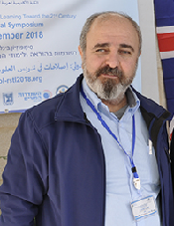
Dr. Esmael Salman is affiliated with the Arab Academic College – Haifa. Since 2008, he is the head of Computer Science Department, and the Chairperson of the Information, Communication and Technology (ICT) Center, since 2007. Co-founder and academic director of the SimuAR (The Simulation Center in Education) at the Arab Academic College – Haifa. He holds a Ph.D. in Computer Science Education from the Department of Science & Technology from the Negev University.

His research interests include the following: Design digital learning environments; Collaborative E-learning; Integrating ICT in Science and Math education; Computer Science education; Project-based learning; Simulative learning and innovative pedagogy; Effective and cognitive aspects of teaching and learning; Misconceptions in computer science; Mobile Teaching & Learning; Teaching and Learning in virtual environments; STEM Education (Science, Technology, Engineering & Mathematics).


Amtiaz Fattum is a Lecturer in the Computer Science Department at the Arab Academic College of Education in Haifa. A director of the Simulation Center in Education, a pedagogical trainer, instructor, expert on the development and assimilation of innovative pedagogical models in teaching and learning. She is also part of the Professional Development team for the school teachers.

Amtiaz completed her M.Sc. in Computer Science in Berlin, Germany. Her research focuses on pedagogical aspects of ICT in higher education, integration of ICT in Education and Computer Science education.

